Tracker Installation Notes
- Make sure both (1) Xuggle and (2) Video Experiements are installed too
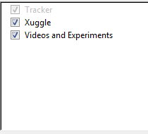
Make sure (1) Xuggle and (2) Videos and Experiments are ticked

- Make sure that Video and Experiments are installed in D:\TrackerExptVideo
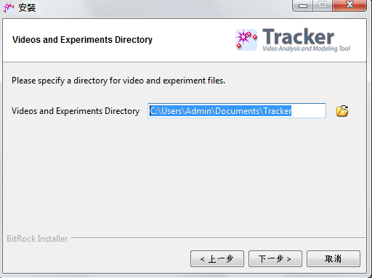
Change this to :
D:\TrackerExptVideo

