Name: _______________________________ ( ) Class: ______________ Date: __________

|  |  |  |
| --- | --- | --- |
| **Kinematics of a Falling Ball** | | |
| **Topic:** Kinematics |  | **Estimated Duration:** 2 hours |

**More information and extended learning material is available only at** [**http://iwant2study.org/ospsg/index.php/interactive-resources/physics/02-newtonian-mechanics/01-kinematics/36-free-fall**](http://iwant2study.org/ospsg/index.php/interactive-resources/physics/02-newtonian-mechanics/01-kinematics/36-free-fall)

* **Aim**To describe the motion of an object falling under gravity in terms of the graphs of its displacement and velocity with respect to time.
* **Description**

A ball is launched vertically upwards by a person’s hand (Figure 1). It eventually reaches a maximum height before falling back to the ground. *Note: upwards motion is taken as positive and downwards motion is taken as negative in this exercise.*

Positive direction



Figure 1

* **Key Questions**
* How do the graphs of motion of the ball tell us when it changes direction?
* How do the graphs of motion of the ball tell us when it is speeding up or slowing down?
* How is the displacement-time graph of the ball related to its velocity-time graph?
* **Materials**
* Worksheets
* Webpage <http://iwant2study.org/ospsg/index.php/interactive-resources/physics/02-newtonian-mechanics/01-kinematics/36-free-fall>   
  Materials such as Beginners’ Guide can also be found on the website.

|  |
| --- |
| **(A) SETTING UP** |

1. Launch the JavaScript Simulation by clicking on the picture with the play icon. The screen should look like this.

**Axes**

**Tape Measure**

**File Open**

**Clip Settings**

**Play**

**Frame number**

**Step back**

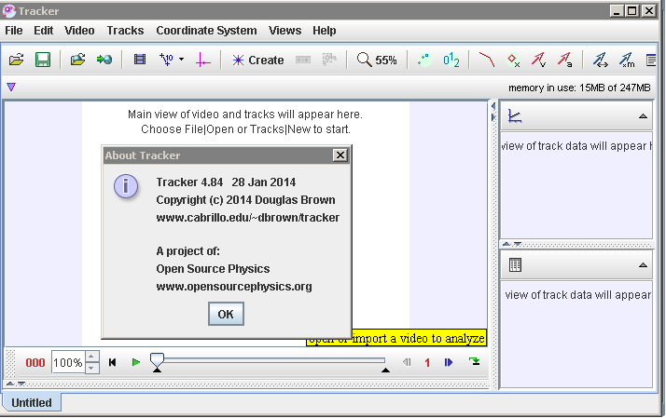

1. Click the **Open** button or File|Open menu item and select the video “BallTossUp” from the desktop.



1. **Select the display of the clip settings** by clicking the **clip settings** button . In the clip settings dialog, set the **Start** and **End** frames to define the range you wish to analyze. In this video, set the start frame to be “14” and end frame as “39” as shown below. Click on “OK” to proceed.

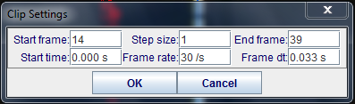

1. (optional) The ball maybe difficult to detect due to the quality of the frames, thus in this case, select the “Video|Filters|New|Deinterlace|Even” and close it after selection. This step may increase the visibility of the ball.

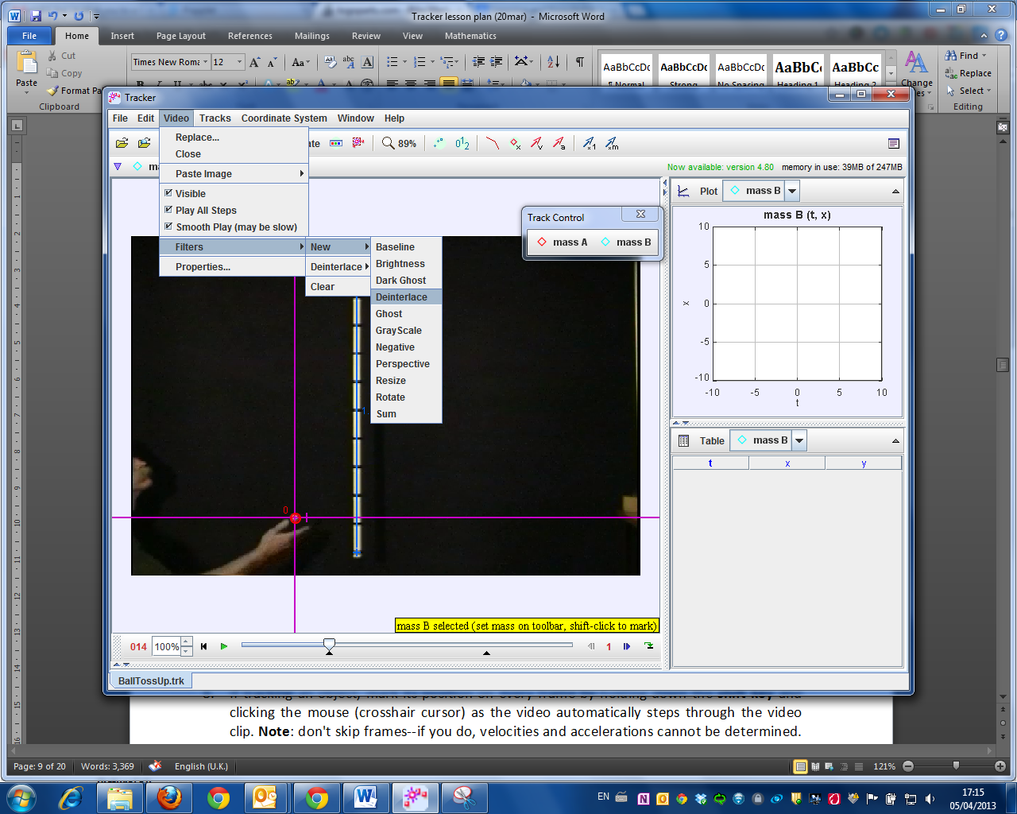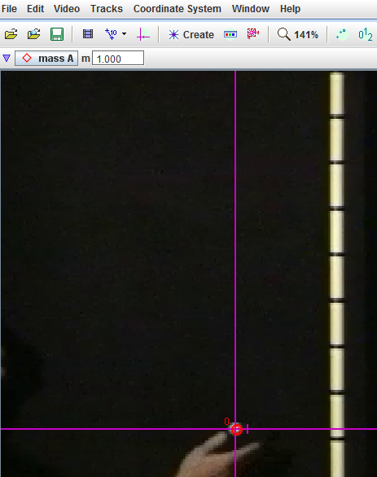

1. **Set the reference frame origin and angle.** Click the **Axes** button to show the coordinate axes. Drag the origin and/or x-axis to set the reference frame origin and angle. A common choice for the origin is the initial position of an object of interest.

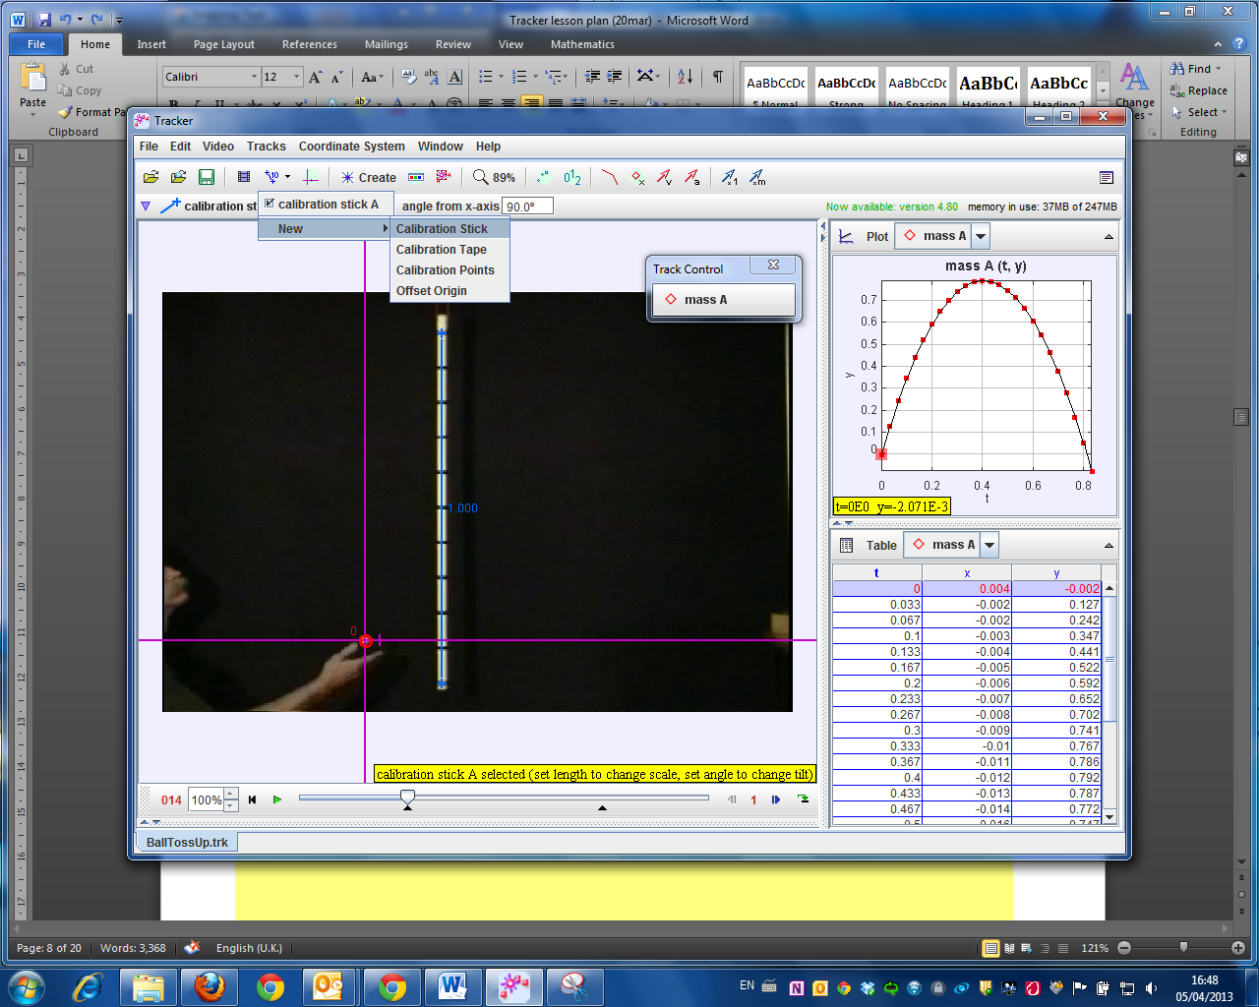

Initial position

1. To **calibrate the scale on the video,** click the **Tape Measure** button to show the tape measure. For this video, the 1.000 m metre rule is on the video, move it to capture the length as in the video.

1.000

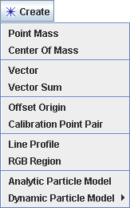

1. **Track objects of interest with the mouse or model them with particle models.** Click the **Create** button and choose a track type from the menu of choices. Most moving objects are tracked using a [**Point Mass**](http://www.cabrillo.edu/%7Edbrown/tracker/help/pointmass.html)**.**

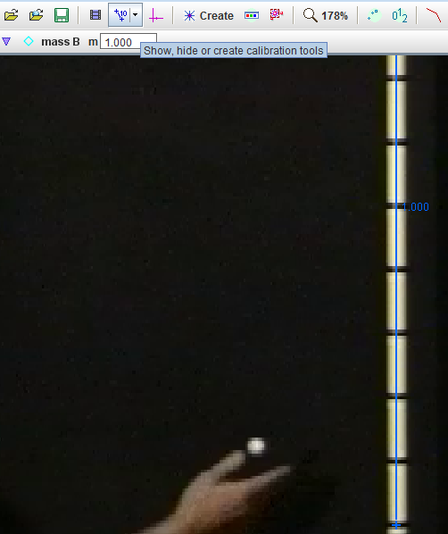

1. When tracking an object, mark its position on every frame by holding down the **shift key** and clicking the mouse (crosshair cursor) as the software automatically steps through the video clip. **Note**: don't skip frames--if you do, velocities and accelerations cannot be determined. Track the ball until end of frame.

Mouse over and click on object to be tracked

**+ left Mouse click**



1.000

1. **Plot and analyze the tracks.** The **Plot View** displays graphs of track data. To plot multiple graphs, click the **Plots** button and select the desired (3) plots number.

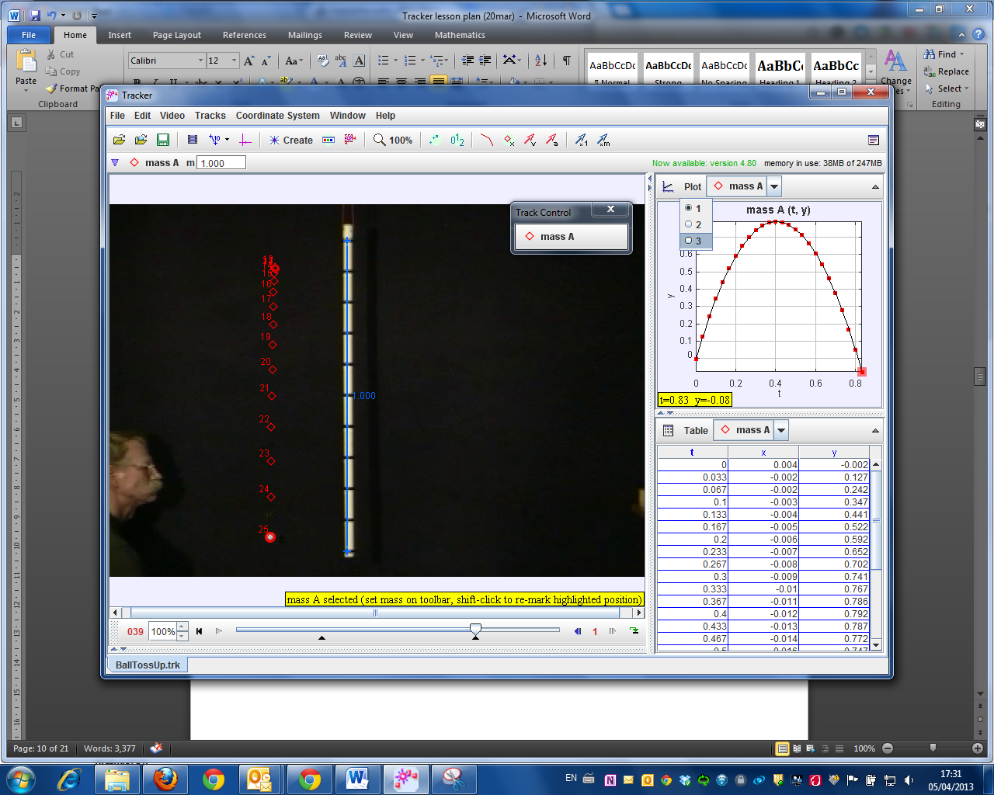

Select 3 Plots

1. Click the x- or y-axis label to change the variable plotted on that axis. In this video, choose *y* versus *t* and *vy* versus *t*. and *ay* versus *t*.

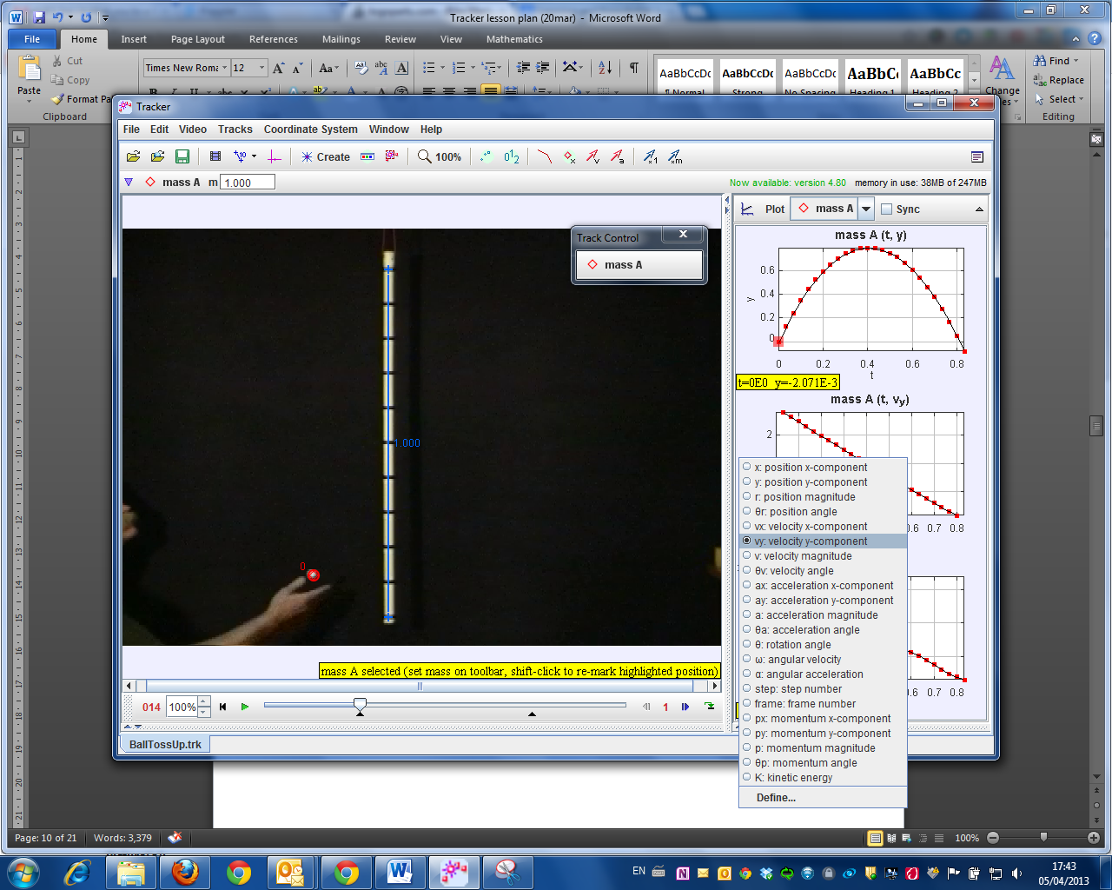

|  |
| --- |
| **(B) DISPLACEMENT IN Y DIRECTION AGAINST TIME GRAPH** |

1. In the right panel of y vs t, right click with the mouse and select Analyze.

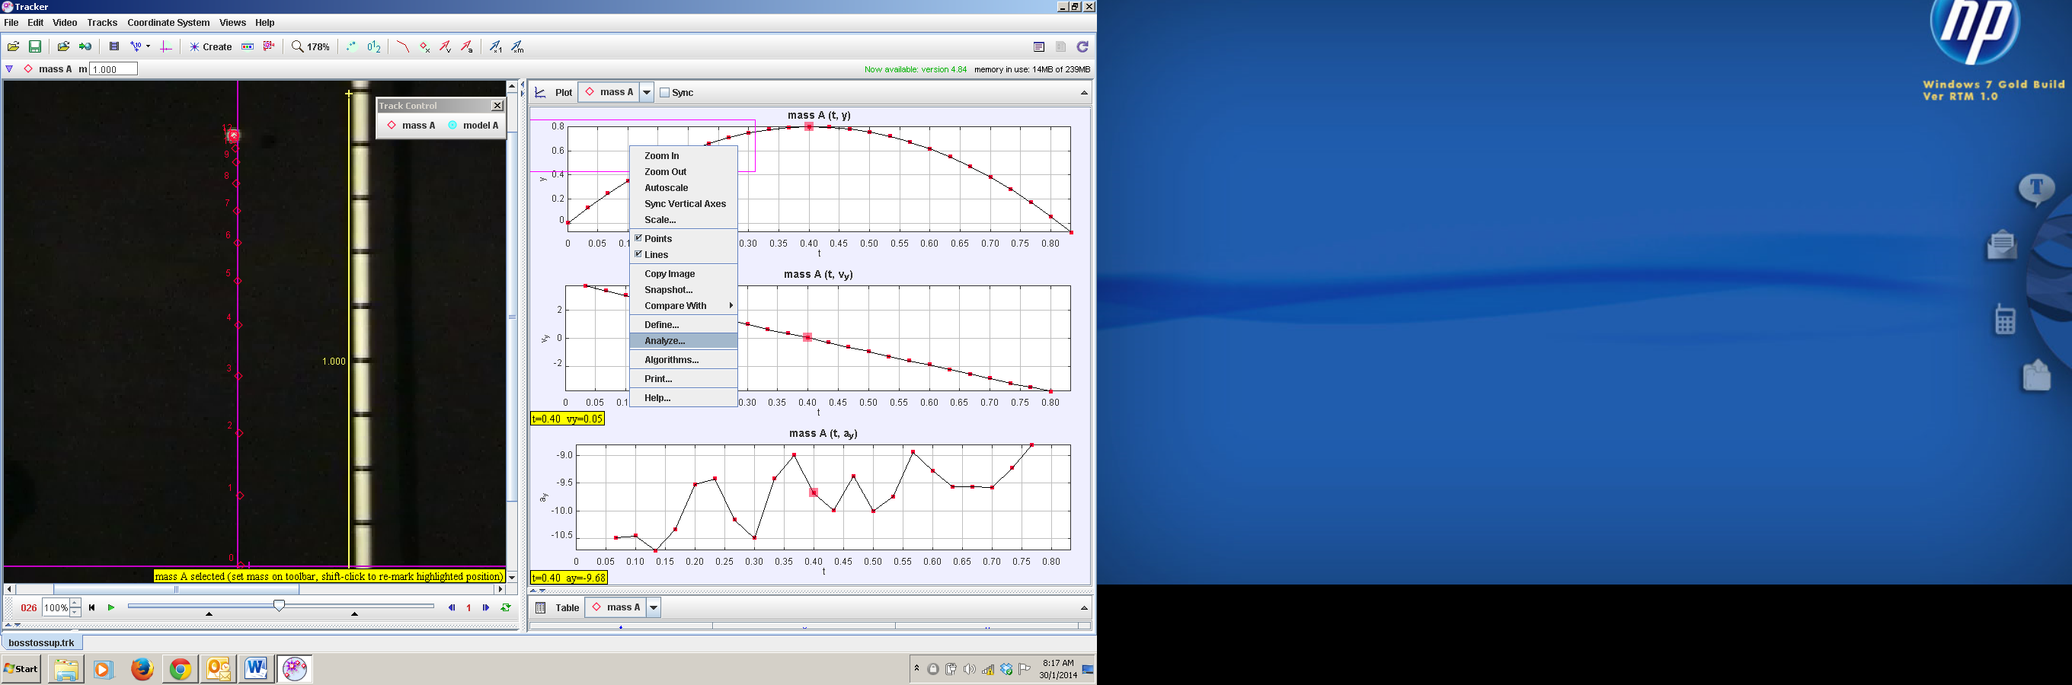

2. Select Measure – Slope and move the mouse to the respective point of interest and look at the slope values. Note: Slope = 1.98E0 is a representation for 1.98 x 10 0

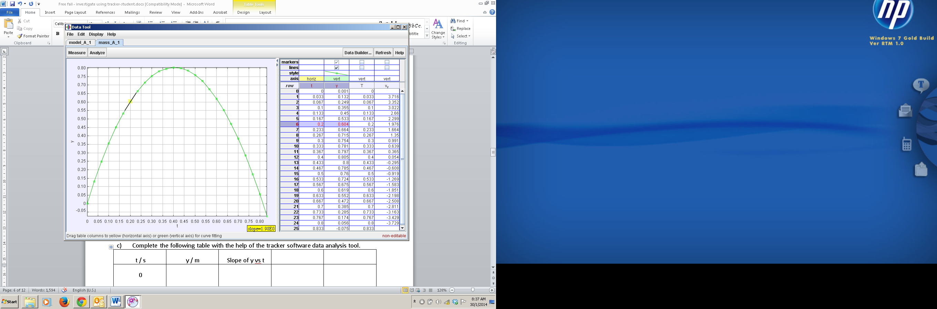

Figure 1

1. Figure 1 shows the displacement in y direction against time graph. In Figure 1, highlight the region for which the ball is

a) moving upwards and label this region **A**,

b) changing direction and label this point **B**,

c) moving downwards and label this region **C**.

1. Complete the following table with the help of the tracker software data analysis tool.

|  |  |  |  |  |
| --- | --- | --- | --- | --- |
| t / s | Region A, C or point B | y / m | Slope of y vs t / ms-1 | Direction of motion up, down, change direction etc. |
| 0.00 |  |  |  |  |
| 0.20 |  | 0.604 | 1.98 | up |
| 0.40 | B |  |  |  |
| 0.60 |  |  |  |  |
| 0.80 |  |  |  |  |

1. Discuss with your partner drawing from the evidences on the table collected, and circle the most appropriate answer.
2. When y is increasing, the direction of motion is upwards / downwards / change direction, the slope of the y vs t is decreasing / zero / increasing.
3. When y is at it’s highest, the direction of motion is upwards / downwards / change direction, the slope is y vs t is momentarily decreasing / zero / increasing.
4. When y is decreasing, the direction of motion is upwards / downwards / change direction, the slope of the y vs t is decreasing / zero / increasing.

|  |
| --- |
| **(C) VELOCITY AGAINST TIME GRAPH** |

1. Similarly, in the right panel of vy vs t, right click with the mouse and select Analyze.
2. Uncheck the y column and click and drag the vy column next to the t column as shown.

Figure 2

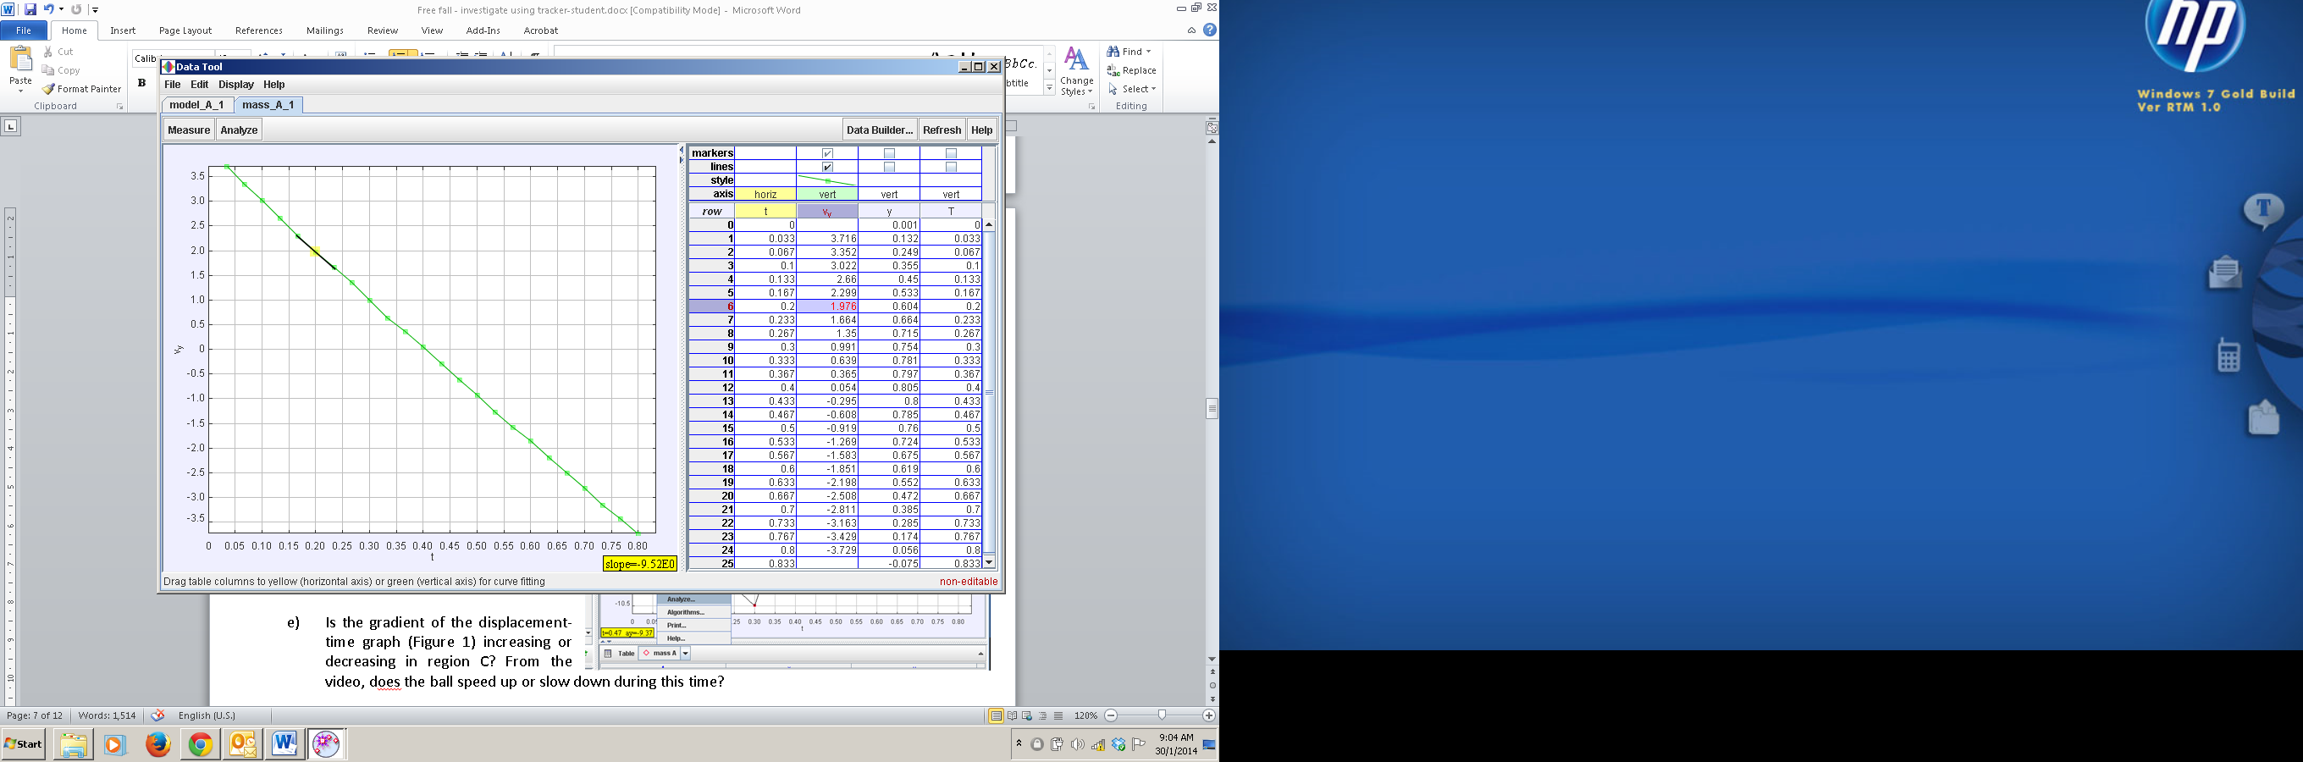

1. Figure 2 shows the velocity against time graph. In Figure 2, highlight the region for which the ball is

a) moving upwards and label this region **A**,

b) changing direction and label this point **B**,

c) moving downwards and label this region **C**.

1. Complete the following table with the help of the tracker software data analysis tool. Hint: |vy |can be found as a selectable variable on right graph.

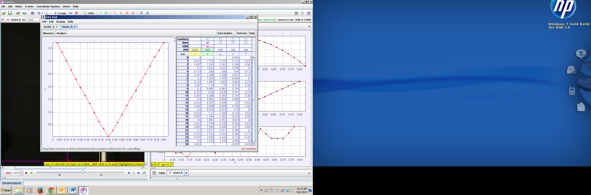

|  |  |  |  |  |  |  |
| --- | --- | --- | --- | --- | --- | --- |
| t / s | Region A, C or point B | vy / ms-1 | |vy |/ ms-1 | Slope of vy vs t / ms-2 | Direction of motion up, down, change direction etc. | |vy |speed up or slow down etc. |
| 0.00 |  |  |  |  |  |  |
| 0.20 | A | 1.976 | 1.976 | -9.52 | up | Slow down |
| 0.40 |  |  |  |  |  |  |
| 0.60 |  |  |  |  |  |  |
| 0.80 |  |  |  |  |  |  |

1. Discuss with your partner drawing from the evidences on the table collected, and circle the most appropriate answer.
2. When y is increasing, the direction of motion is upwards / downwards / change direction, the velocity vy is decreasing / zero / increasing but the magnitude of the velocity is |vy| is decreasing / zero / increasing .
3. When y is at it’s highest, the direction of motion is upwards / downwards / change direction, the velocity vy is decreasing / zero / increasing but the magnitude of the velocity is |vy| is decreasing / zero / increasing .
4. When y is decreasing, the direction of motion is upwards / downwards / change direction, the velocity vy is decreasing / zero / increasing but the magnitude of the velocity is |vy| is decreasing / zero / increasing .
5. By comparing the columns of vy and ,the slope of y vs t or otherwise, suggest a mathematical equation involving and .



_________________________________________________________________________

1. Describe the gradient at point **B** and hence state the instantaneous velocity of the object at **B**.

_________________________________________________________________________

1. Using the completed data in column Slope of vy vs t, calculate the average of Slope of vy vs t, showing your working clearly.

_________________________________________________________________________

|  |
| --- |
| **(D) ACCELERATION AGAINST TIME GRAPH** |

1. Similarly, in the right panel of ay vs t, right click with the mouse and select Analyze.
2. Uncheck the unnecessary columns such as y, vy, |v|and and click and drag the ay column next to the t column as shown. Uncheck the slope and now select the Analyze – Statistics as shown.

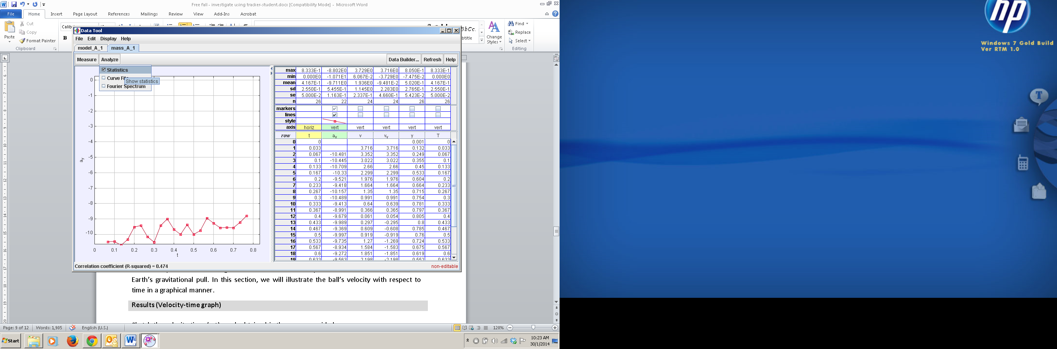

1. Record down the value of mean of ay ___________________________and suggest the significance of the acceleration in y direction means in real life on earth.

**_________________________________________________________________________**

1. By comparing the value found in average of Slope of vy vs t (C8 above) with the mean of ay (D3 above), suggest a mathematical equation involving and .



**_________________________________________________________________________**

1. Suggest the type of error **(none / random / systematic / all of the choices) that** is associated with measurement/calculation of ay that results in an equal chance to fluctuate between the true value.

**_________________________________________________________________________**

1. **Go to the tracker world view and change the calibration value from the correct value of 1.000 m to say 1.5 m (overestimation of the correct measurement of one metre ruler), record down the value of the ay now.** Reset back the calibration length to 1.000 m for the extend learning part.

1.500

Figure 4

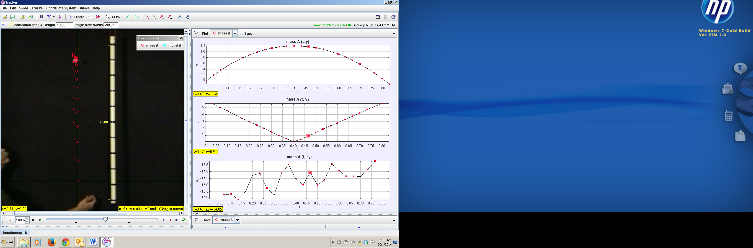

1. **In this case of a constant overestimation of the correct measurement, what is the sign (positive / negative) and name of this kind of error (none / random / systematic / all of the choices)?**
2. Test yourself: At the highest point of the motion point B, the velocity is momentarily (negative / zero / positive) and its acceleration is (zero / non-zero).

|  |
| --- |
| **(E) EXTENDED LEARNING** |

To model throwing of a larger force on the same mass ball, create a dynamic model with a higher initial speed.

1. Go to Tracker Select Create – Dynamic Particle Model – Cartesian and a new Model A is generated.

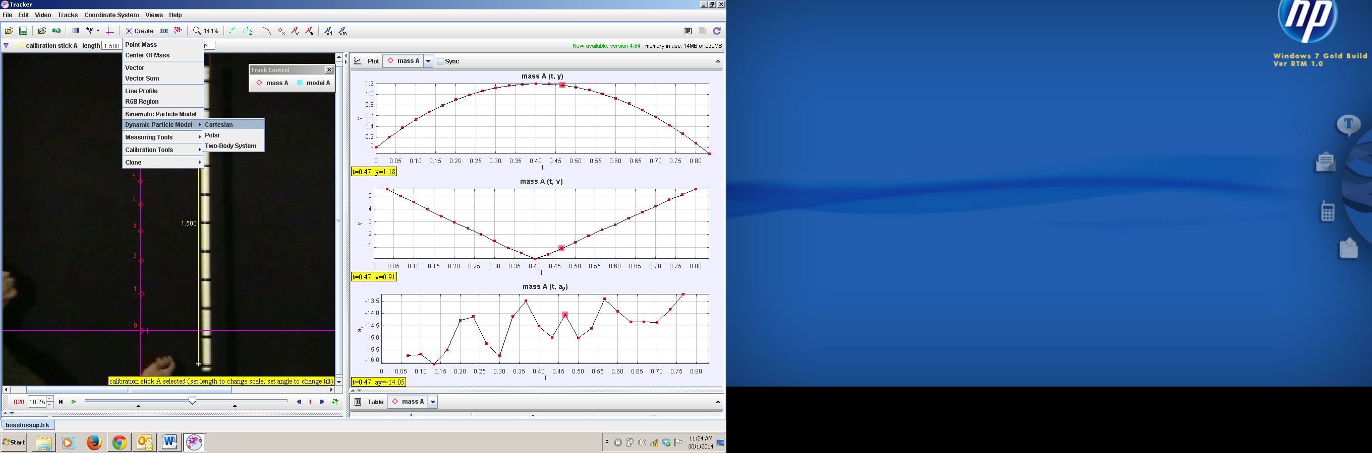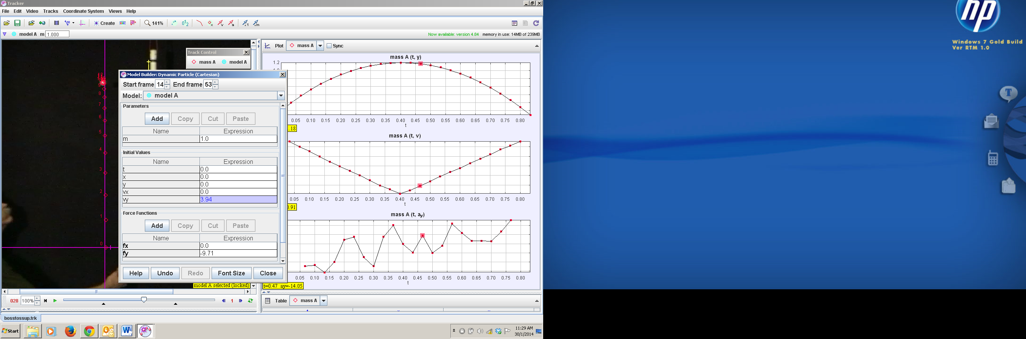

1. Key in the values as shown which is initial velocity in y direction vy = 3.94 and Force in the y direction fy = -9.71. recall Newton’s 2nd Law: F = ma, when m = 1 kg, Fy = ay
2. Key in a slightly larger initial vy say = 5 and run the video and observe the result motion in the world view as well as the vy versus t graph. Note to reset back the calibration length to 1.000 m. To get the view as shown, right click on the right panel as select compare with Model A for all three Plots.

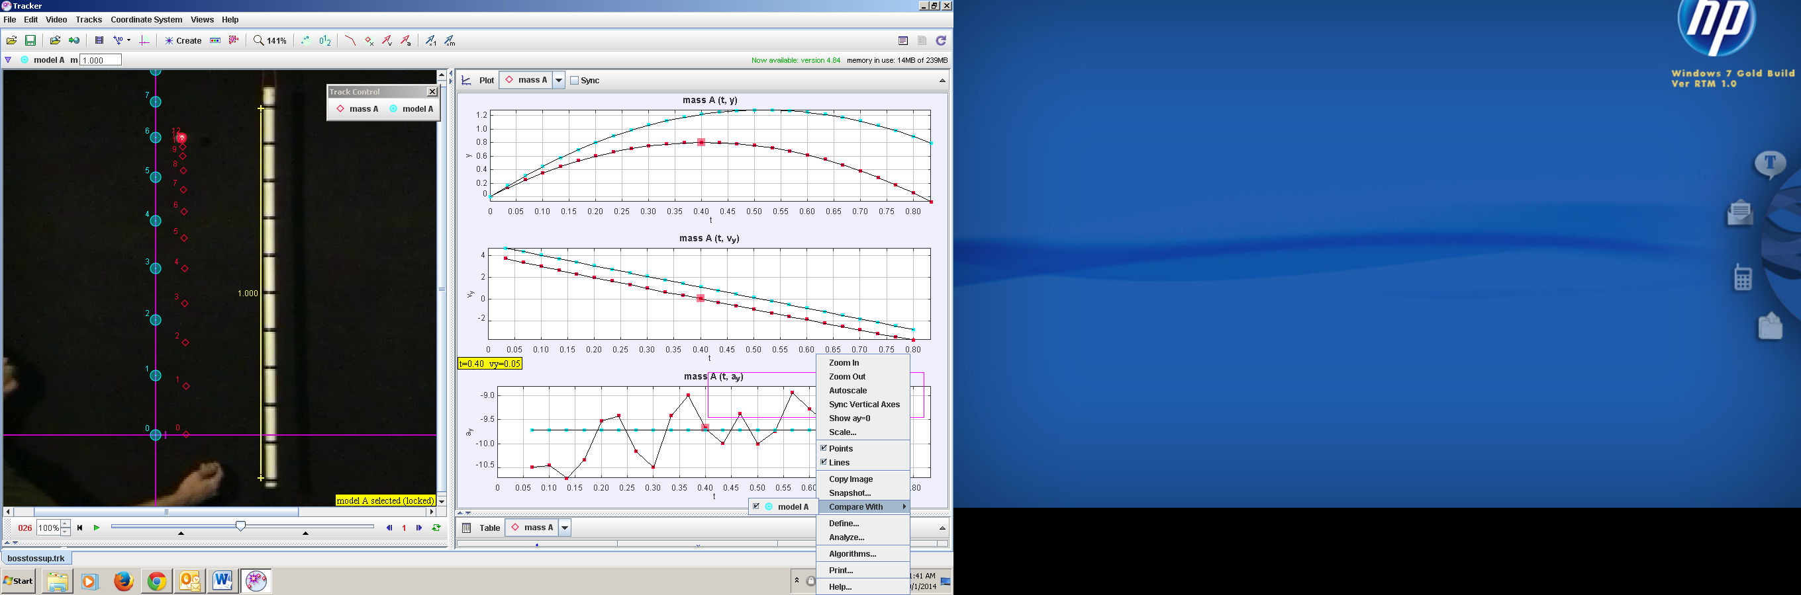

Hence or otherwise, describe the graph of vy vs t for the case when the initial vy is larger than 3.94 ms-1 ( the actual ball) throwing the same ball upwards with larger force? Explain your answer.

_______________________________________________________________________

1. To model the gravity on Moon g = 1.67 ms-2, let’s key in this value into the force in the y direction of this dynamic particle motion A. Run the video and observe the result motion in the world view as well as the vy versus t graph. Check that the calibration length to 1.000 m. To get the view as shown, right click on the right panel as select compare with Model A for all three Plots.

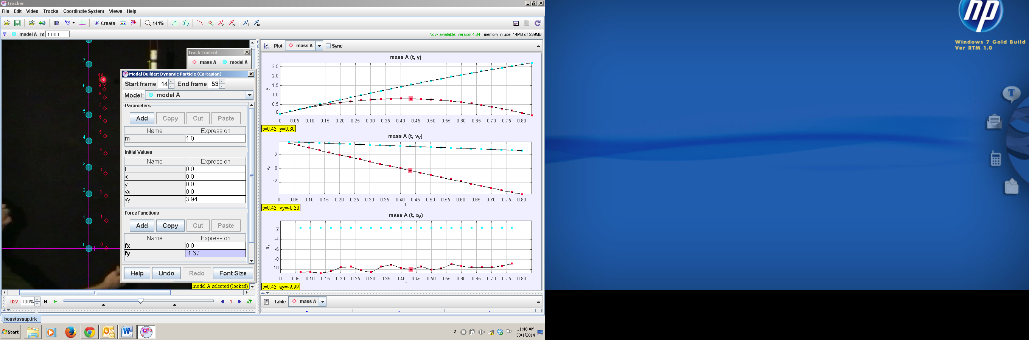

Hence or otherwise, describe the graph of vy vs t for the case when this same ball is thrown on the surface of the moon (the actual ball) throwing the same ball upwards with same force? Explain your answer.

______________________________________________________________________________

* **References**

The Tracker software, sample videos and Beginners’ Guide for Tracker <http://www.cabrillo.edu/~dbrown/tracker/>

* **Acknowledgement**

This lesson package is crafted in collaboration with Educational Technology Division-Curriculum & Planning Division- Evergreen Secondary-National JC.