**Practical Worksheet 5: Understanding Projectile Motion using video tracker**

Name: __________________________________ CTG: ______ Date: ______________

**AIM**: To understand the vertical and horizontal motion of a projectile through video analysis and modelling (pair work)

|  |  |
| --- | --- |
| Equipment: | 1. BallTossOut.mov Quick-Time video movie file of an object being projected at an angle above the horizontal, can be found C:\Documents and Settings\USER\My Documents\Tracker\videos\ 2. Laptop with “Video Tracker” software installed |

**A Setup**

1. Launch the software “Video Tracker” by double clicking on the [*tracker.jar*](http://www.cabrillo.edu/%7Edbrown/tracker/webstart/tracker.jar)file or when install go to menu START-All Programs – Tracker - Tracker. After the software is launched, the screen should look like this:

**File Open**

**Play**

**Clip Settings**

**Frame number**

**Axes**

**Tape Measure**

**Step back**

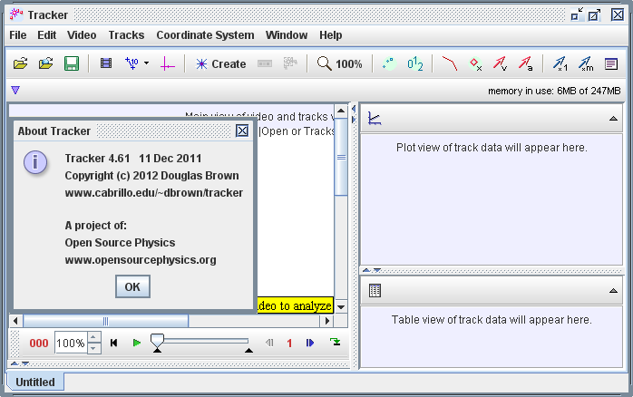

1. Click the “File Open” button and open “*BallTossOut.mov*” file or your own QuickTime video (*.mov file*).
2. Save the file under your class and names (*eg. class_studentname1_studentname2.trk*)
3. Click the “Play” button and observe the projectile motion. Decide on the first frame that marks the start of the projectile motion and the last frame that marks the end of the projectile motion.

**Start** frame number: __________ **End** frame number: ___________

1. Click the “Clip Settings” button and set the **Start** & **End** frames to define the range you wish to analyze. Click **OK** to proceed.

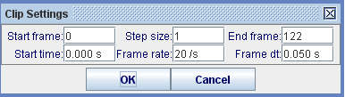

1. Play the projectile motion a few times to ensure that the start and end of the motion is correct. Otherwise, repeat step 5. Once ready, “step back” the video to the start frame.
2. Click the “Calibration **Tape”** button to calibrate the scale on the video. Drag the “tape” to fit the ruler in the video and key in the scaled length (in metres).

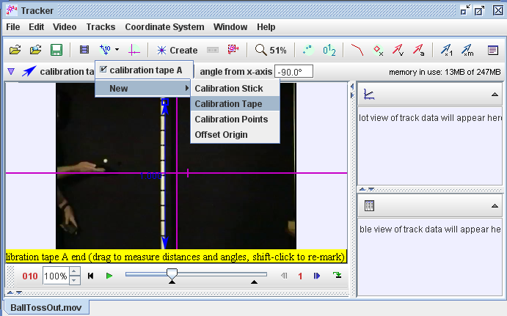

1. Click the “**Axes”** button to set the reference frame origin and angle. Click and hold on the intersection of the axes and drag the intersection to the start position of the object.

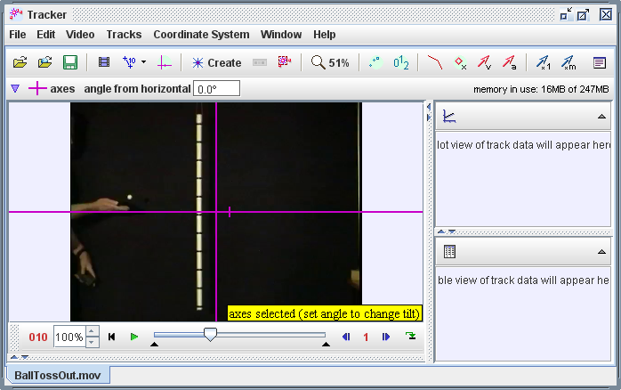

Do not drag the marker as it rotates the axis reference.

1. Click the “**Create”** button and choose “Point Mass” to track the object of interest. To start tracking, hold down the **Shift key** and click on the “centre of the object”. As the video automatically steps through the clip, keep clicking on the centre of object while holding down the **Shift+Ctrl key**. **Do not** skip frames - if you do, velocities and accelerations cannot be determined. Track the object until the last frame.

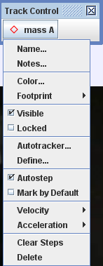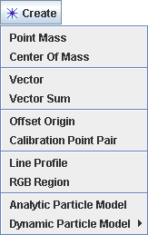

Advanced Optional: you can try to Autotracker…, skip missing point say frame 17 and go back to that frame with missing data points to manually **Shitft+Control+left mouse click**.

1. To view the graphs of track data, click the “left” arrow near the vertical scroll bar on the right, as shown below. Click the “Plot” button and select the desired (3) plots number.

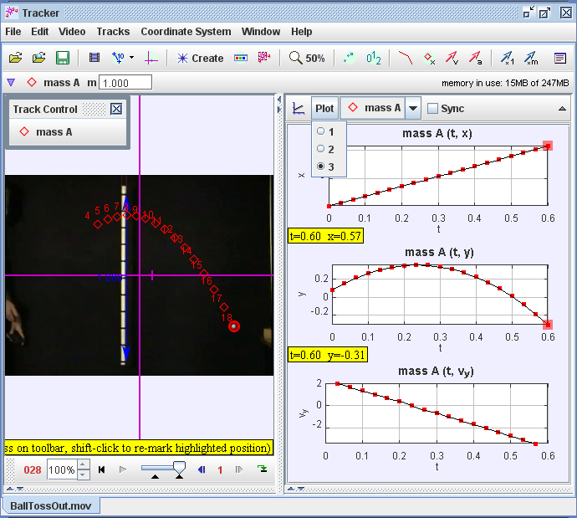

1. Left click on the three vertical axis labels and select as shown above:
   1. “x: Position – x component” for the first graph
   2. “y: Position – y component” for the second graph
   3. “vy: Velocity – y component” for the third graph

**B *Analysing the x* - *t* graph** (horizontal displacement – time graph)

1. Double-click on the x-t graph and a “Data Tool” page should pop up and look like this:

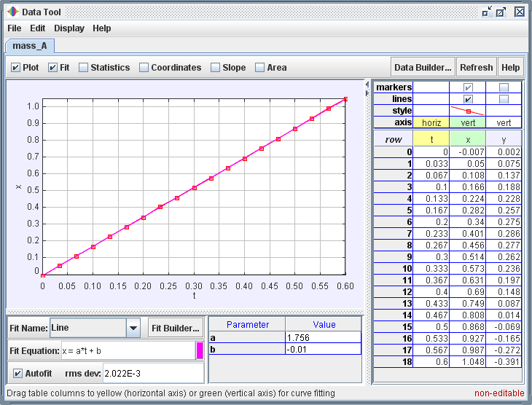

Choose “Fit” on the top left hand checkbox to plot best fit line/curve. Select a suitable fit shape (“**Line**”, in this case) and click on “Autofit” checkbox.

1. Sketch the shape of the best fit line below and label the axes:

**x / m**

**t / s**

1. Describe what this best fit line tells you about the motion of the object. Play the video clip to further explore.

______________________________________________________________________

1. Fill in the values displayed (in standard forms) and their units (in the bracket provided) for the “Line” Fit Equation:

**x = ________ ( ) * t + _______ ( )**

Compare the values with kinematics equation: ***s = ut + ½ at2***

1. Hence determine the horizontal velocity of the object.

______________________________________________________________________

1. Deduce the horizontal acceleration of the object and explain your deduction.

______________________________________________________________________

______________________________________________________________________

**C *Analysing the y* – *t* graph** (vertical displacement - time graph)

1. Double-click on the y-t graph to retrieve the “Data Tool” page.
2. Choose “Fit” on the top left hand checkbox to plot best fit line/curve. Select a suitable fit shape (“**Parabola**”, in this case) and click on “Autofit” checkbox.
3. Sketch the shape of the best fit curve below and label the axes:

**y / m**

**t / s**

1. Describe what this best fit curve tells you about the motion of the object.

______________________________________________________________________

______________________________________________________________________

1. Fill in the values displayed (in standard forms) and their units (in the bracket provided) for the “Parabola” Fit Equation:

Hint: if Fit Equation is y = a*t^2 + b*t + c, compare it with the values with kinematics equation: ***sy = uyt + ½ ayt2***

**y = _________ ( ) * t2 + ________ ( ) * t + ________ ( )**

1. Hence determine the initial vertical velocity of the object.

______________________________________________________________________

1. Deduce the vertical acceleration of the object, showing clear working.

______________________________________________________________________

1. Deduce the direction of the vertical acceleration and justify why.

______________________________________________________________________

**D *Analysing the vy*– *t* graph** (vertical velocity - time graph)

1. Double-click on the y-t graph to retrieve the “Data Tool” page.
2. Choose “Fit” on the top left hand checkbox to plot best fit line/curve. Select a suitable fit shape (“**Line**”, in this case) and click on “Autofit” checkbox. [The y-t graph may appear on the same screen. Uncheck data like x and y if not in use, do not get confused.]
3. Sketch the shape of the best fit line below and label the axes:

**vy / m s-1**

**t / s**

1. Describe what this best fit line tells you about the motion of the object.

______________________________________________________________________

______________________________________________________________________

______________________________________________________________________

1. Fill in the values displayed (in standard forms) and their units (in the bracket provided) for the “Line” Fit Equation:

**vy = _________ ( ) * t + ________ ( )**

Compare the values with kinematics equation: ***v = u + at***

1. Hence determine the initial vertical velocity of the object.

______________________________________________________________________

1. Deduce the vertical acceleration of the object, showing clear working.

______________________________________________________________________

1. Deduce the direction of the vertical acceleration.

______________________________________________________________________

1. Compare these values with the values deduced in the y-t graph.

______________________________________________________________________

1. Suggest what the “true” value of the vertical acceleration should be.

______________________________________________________________________

1. Compute the percentage error of this vertical acceleration.

______________________________________________________________________

______________________________________________________________________

1. Suggest one random error and one systematic error that may occur in the determination of the vertical acceleration.

______________________________________________________________________

______________________________________________________________________

______________________________________________________________________

**E Kinetic Energy, Potential Energy and Total Energy**

1. You will now verify that the tracker internal calculation for K kinetic energy is correct. Click on one of the y-axis label to activate a drop-down menu as shown. Click on the Define… option to start the Data Builder window. Write down the equation for kinetic energy.

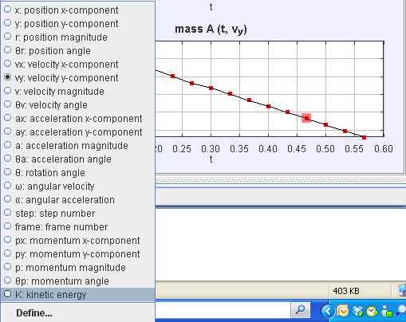

1. Your Data Function may look something like this. Suggest a reason whether the tracker’s kinetic energy K is correct.

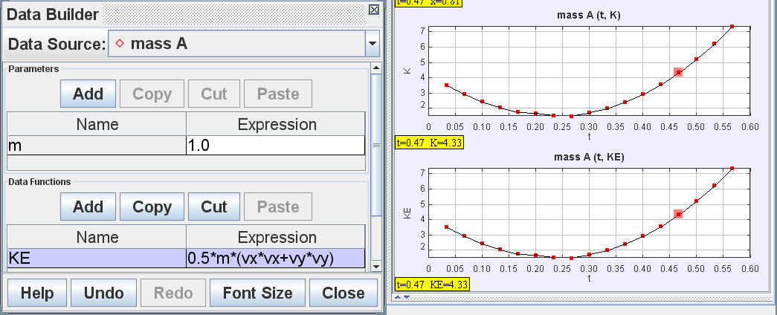

1. Write down the equation for potential energy and continue to add on to the Data Parameter(s) and Data Function to construct your own potential energy PE.
2. Now move the axes to a lower point on the video, what change did you observe in the PE graph? Explain your observation in terms of the values of PE and KE and the shape of the graphs.
3. Write down the equation for total energy and implement it in the Data Builder and explain what does the total energy graph is suggesting.

Hint: you may refer to the figure below and discuss with your classmates.

______________________________________________________________________

______________________________________________________________________

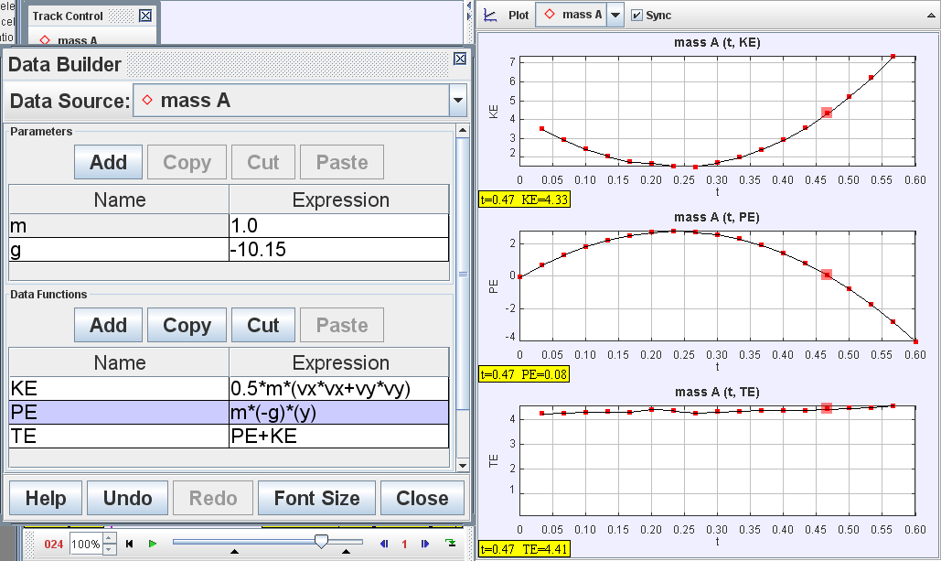

**F *Modelling as performance of learning***

1. Your task is to create a model that follows the motion path of this object exactly. First click “Create” – “Dynamic Particle Model” – “Cartesian”. The “Model Builder” should pop out.
2. You may double-click on the following cells to amend their values and press the keyboard “Enter” to input the field:
   1. x: initial x-position
   2. y: initial y-position
   3. vx: initial velocity in x-direction
   4. vy: initial velocity in y-direction
   5. fx: force in x-direction
   6. fy: force in y-direction

Hint: all the quantities in 44 are actually found in the **B**, **C** & **D, do not trial and error☺**.

1. After each value is amended, click “Play” to see the motion path of the model. If it does not match the motion path of the object, amend the values again until the match is completed. Fill in your numbers as determine in **B**, **C** & **D** in the empty field/boxes below on the Model Builder Dynamic Particle.

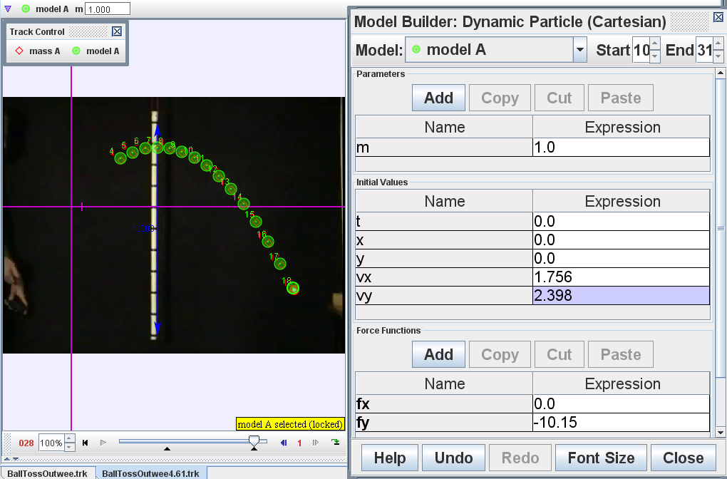

--- End ---