Name: _______________________________ ( ) Class: ______________ Date: __________

Newton’s Laws
Student’s Handout
Topic: Mechanics |  | Estimated Duration: 1 hour

- Aim
In this activity, you will learn to identify action-reaction forces acting on two interacting bodies, as well as the characteristics of action-reaction forces.

Part I
Indicate with arrows the action and reaction forces for each of the examples below. Label each arrow with the phrase “Force exerted by __________ on ____________.”

- A table tennis bat hitting a ping pong ball
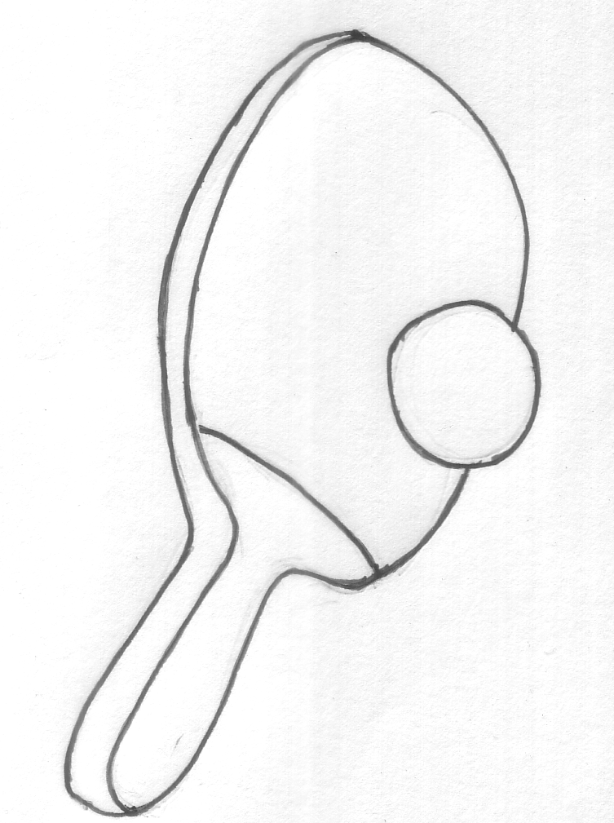

- A kayak paddle pushing back on the water to propel the kayak forward.
Direction in which kayak is moving.
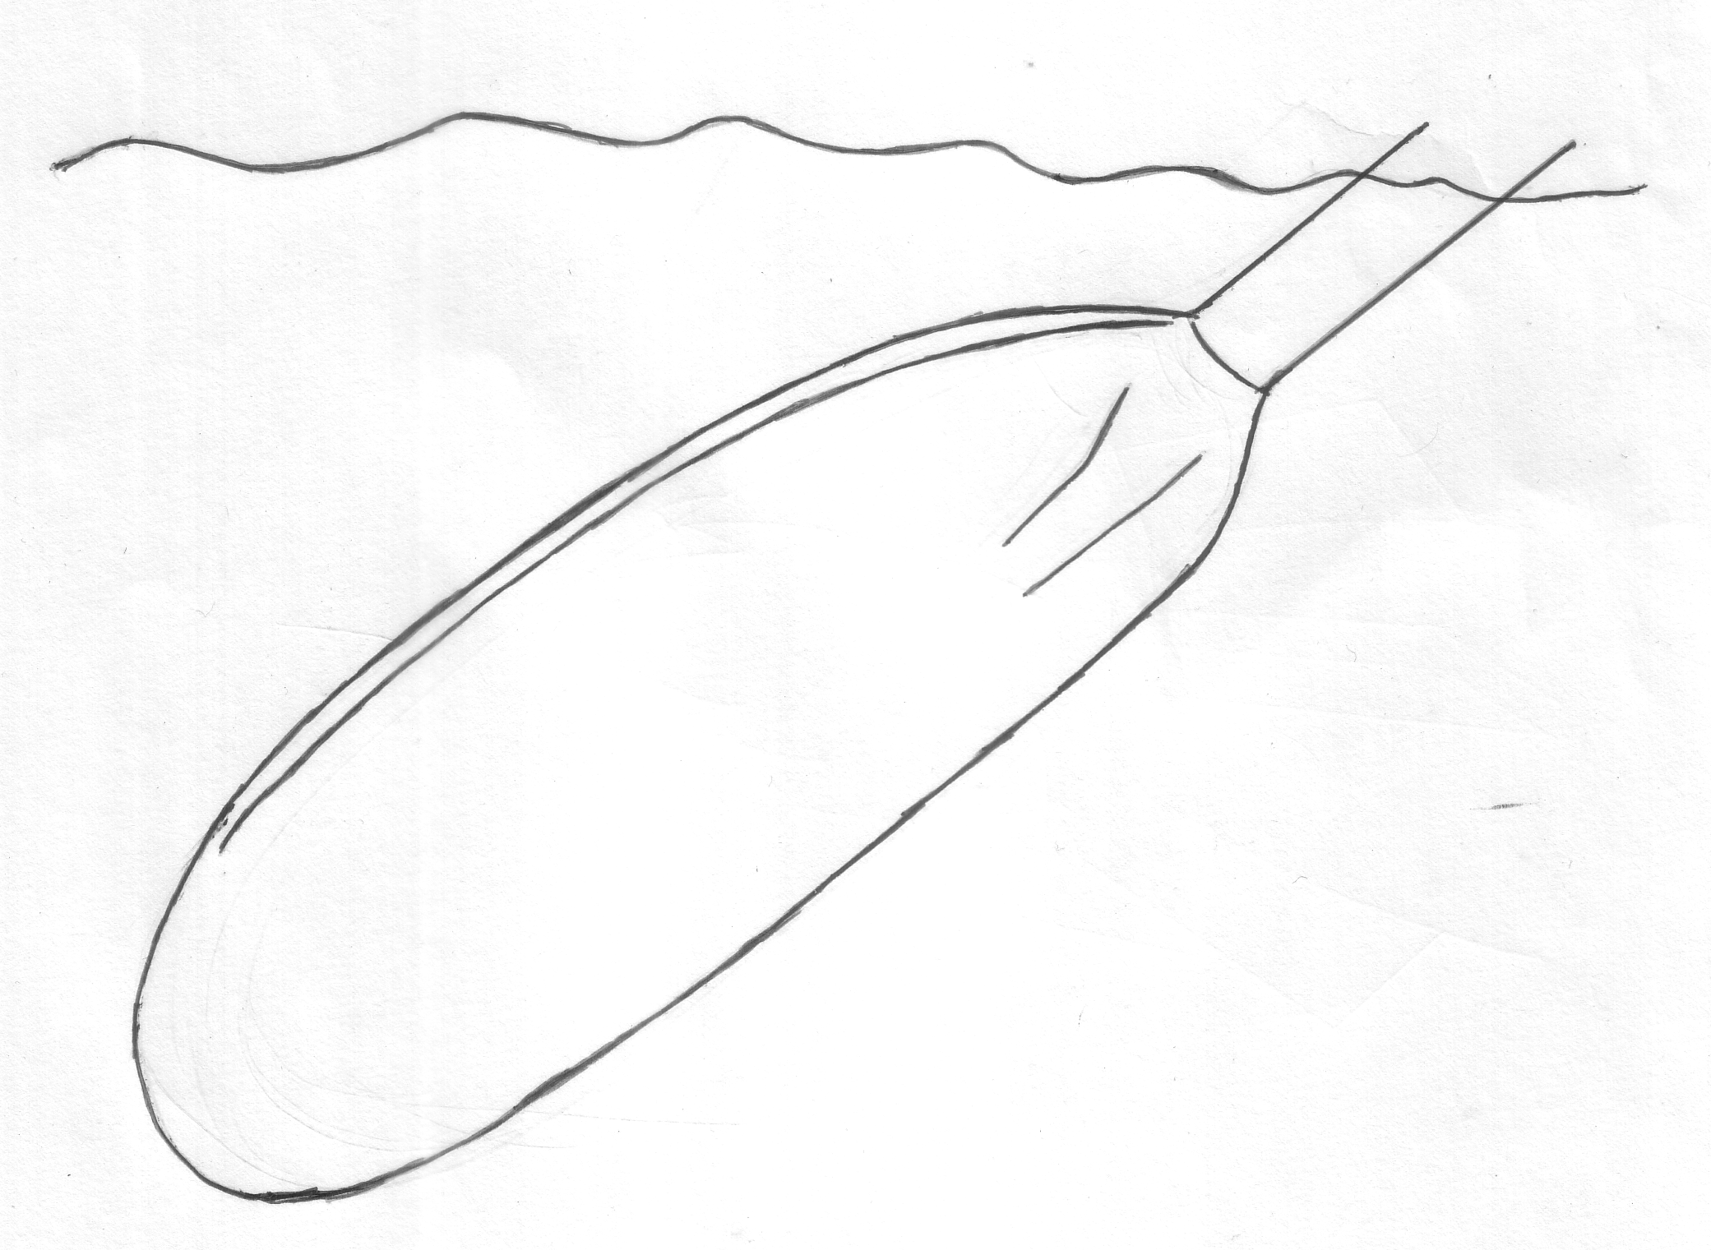

- A car tyre driven by an engine.
Direction in which car is moving.

- A bird flapping its wings to keep itself in flight.

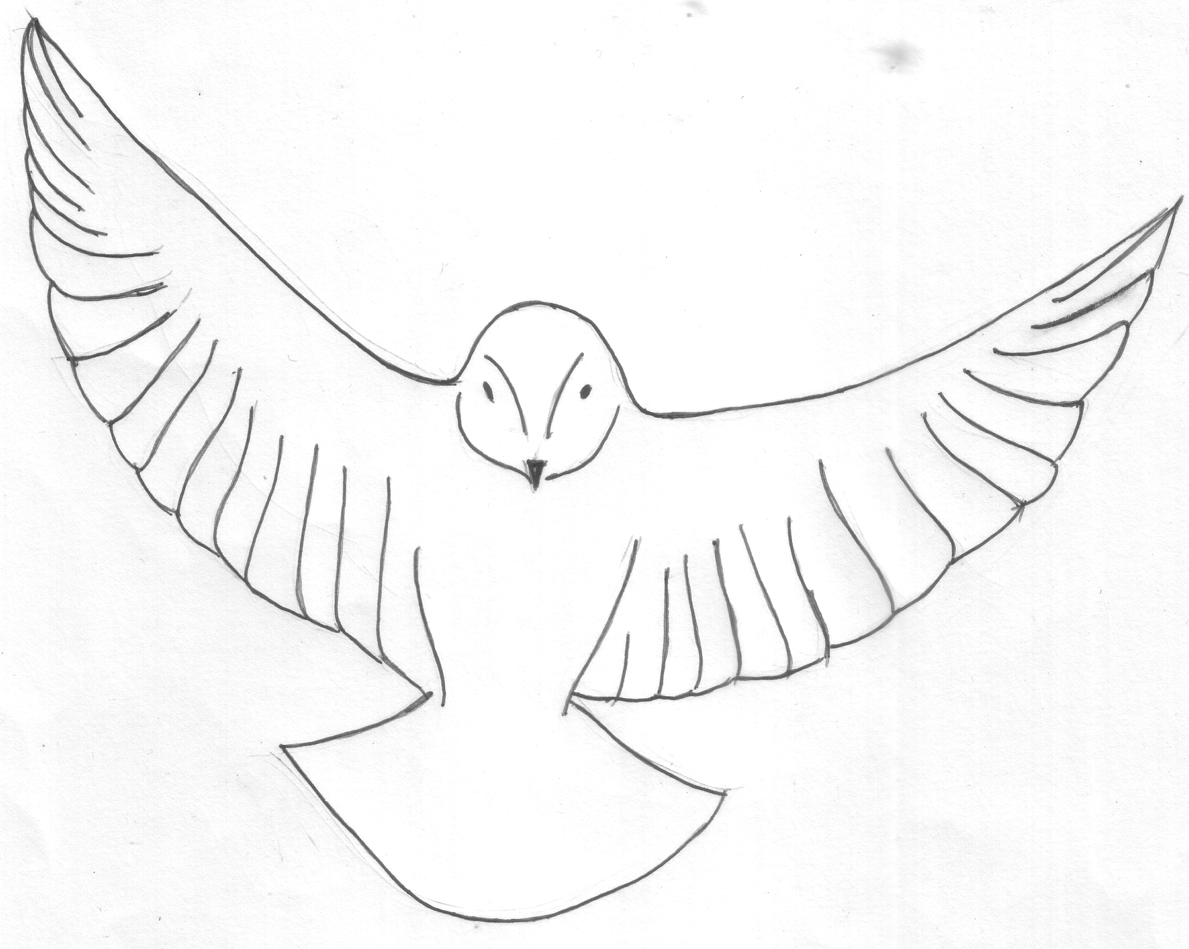

- A ball dropping from a height.

- A rocket propelled by exhaust gas.

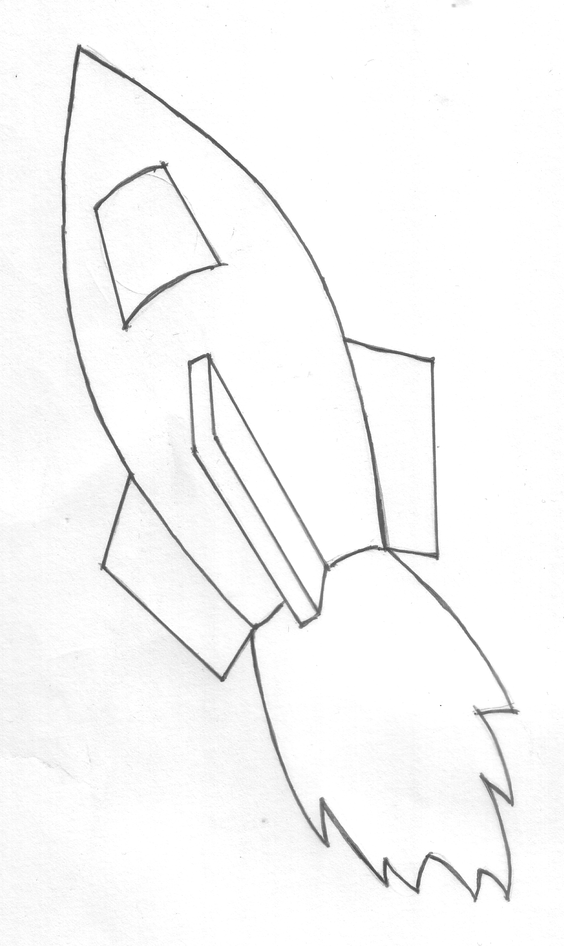

Part II
Answer the following questions using the space provided. You may choose to draw diagrams to aide your explanations.

- Which force is greater, the Earth’s pull on the moon, or the moon’s pull on the Earth?

- A high-speed bus and a mosquito had a head-on collision. The force of the bus squashed the mosquito over the windshield.
- Comparing the force exerted by the mosquito against the windshield and by the windshield against the mosquito - does the mosquito exerts greater, less or the same force as the windshield?
- Is the resulting deceleration of the bus greater than, less than or the same as that of the mosquito? Why?

- A computer rests on the table. Name the action-reaction pairs of forces acting on the system.

- Your car battery went dead and you must push the car to get it started. Why can’t you push the car by remaining comfortably inside and pushing against the dashboard?

Newton’s Laws
Teacher’s notes
Stream: Express |  | Topic: Mechanics |  | Estimated Duration: 2 lessons of 1 hour each

- Description of activity
There are two lessons in this package. Lesson 1 uses a simple demonstration to introduce to students the idea of action-reaction forces, and that these forces are equal in magnitude and opposite in direction. Contexts are then introduced through discussion questions to help students learn to identify action-reaction pairs. Lesson 2 uses visualization to address the preconception that inanimate and rigid objects are unable to exert a force in reaction to an applied force.

- Key Idea
If one object exerts a force on a second object, the second object exerts an equal and opposite force on the first object.

- Aim
This activity allows students to identify action-reaction pairs acting on two interacting bodies, and to understand that action and reaction forces are opposite in direction but equal in magnitude. It also helps to address their preconception that forces can be exerted only by living things and non-rigid surfaces.

- Objectives
- Related Syllabus Learning Outcomes
This lesson exemplar addresses the following learning outcomes:
- Apply Newton’s Laws to identify action-reaction pairs acting on two interacting bodies
- Identify forces acting on an object and draw free body diagram(s) representing the
forces acting on the object (for cases involving forces acting in 2 dimensions)
  - Skills and Processes
Students observe, compare and subsequently infer the key characteristics of action-reaction forces using a series of hands-on activities and demonstrations.

- 21CC
CIT – Sound Reasoning, ICS – Management of Information:
Lesson 1
Students have to draw conclusions, from observation of a spring-balance demonstration, to identify action-reaction forces acting on two interacting bodies and to deduce the key characteristics of action-reaction forces. They also have to explore the responses of their classmates and teacher to the worksheet discussion questions, and integrate these to develop new understanding.
Lesson 2
The demonstrations provide scaffolds for students to make observations and form understanding of the behavior of rigid and non-rigid objects. They have to construct relationships between the behaviour of the rigid and non-rigid object, and extend their conclusions about action-reaction forces from one to the other.

- Prior knowledge
Students have learnt to apply Newton's Laws to:
  - describe the effect of balanced and unbalanced forces on a body, and
  - describe the ways in which a force may change the motion of a body
(Note: Some teachers may prefer to introduce the third law before the other two laws, there is no prescribed order).

In lower secondary, under the theme “Interactions”, students have learnt that interactions occur through the transfer of energy and/or matter, as well as the application of forces.
- Materials
Lesson 1
  - Rope with a spring balance attached to each end
  - Student’s handout (Action-Reaction Pairs)
Lesson 2
  - Spring (One for each student)
  - Hard sponge or foam (One for each student)
  - The following demonstrations are to be set up before the lesson. Figure 1 is to be set up either on a rigid table (a table that does not show any obvious deformation when loaded) or on the floor. The light from the laser reflected off the mirror must be able to be seen on a distant wall or screen. A heavy weight (about 400N, you can use your body weight) placed near the mirror should cause the spot of light to be visibly displaced. Figure 2 is similar to Figure 1 except that the sponge is removed.

Light to be projected on a distant wall or screen
mirror
Laser pointer clamped
to retort stand
sponge
Figure 1

mirror
Laser pointer clamped
to retort stand
Figure 2

- Suggested lesson guide

Lesson One
Assessment indicators | Lesson Activity | Pedagogical Considerations
Evidence of learning is shown when students are able to….  conclude that the two interacting forces are equal in magnitude.  conclude that the forces are acting in opposite directions.  conclude that the forces are acting on mutually opposite bodies. | Lesson Introduction ..  Class demonstration:  Teacher uses a piece of rope with a spring balance attached to each end.  - Ask two student volunteers (preferably different in build) to pull on the spring balances on the opposite ends of the rope.  - Show that there is no way that different readings can simultaneously occur on the scales however the ends are pulled. This shows that the force applied on each end is equal in magnitude.  - As this demonstration involves 3 bodies, zoom in on 2 bodies i.e. one of the spring balances and its end of the rope. Questions for discussion (Constructive challenge):  - what is the direction of the force acting on the spring balance?  - What is the direction of the force acting on the other body, the rope?  - What can we conclude about the forces acting on these two bodies?  - What are the two bodies in this part of the system? (points to the other spring balance and its end of the rope)  - If the forces are acting in opposite directions, how should these two objects or bodies be orientated / positioned with respect to each other?  - Summarize that when one object exerts a force on a second object, the second exerts an equal and opposite force on the first object. The forces act on mutually opposite objects. Introduce this as one of Newton’s Laws. | This is a simple and yet crucial demonstration as most students have the pre-conception that it is possible for action-reaction forces to be different in magnitude, especially when the two bodies are of different sizes. It is also an effective way to demonstrate the characteristics of action-reaction forces.  21CC:  From the observations and discussion questions, students have to be able to reason and conclude about the key characteristics of action-reaction forces, such as their magnitude and direction.
Evidence of learning is shown when students are able to….  identify the pair of action-reaction forces acting on the two interacting bodies in each of these examples involving contact forces.  Evidence of learning is shown when students are able to….  identify the pair of action-reaction forces in this example involving non-contact force.  explain why rockets are able to move in space even though it is a vacuum.  Evidence of learning is shown when students are able to….  verbalise that the magnitude of the action and reaction forces are equal regardless of the size of the two interacting bodies.  identify the two interacting bodies and the pair of action-reaction forces acting on the bodies. | Lesson Development ..  Distribute student’s handout (Action-Reaction Pairs) for further development of the concept of action-reaction pairs of forces. Refer them to part I of the handout. Think-Pair-Share can be used for this discussion:  - Ask students to work individually on their worksheets. They are to indicate the action-reaction pair of forces for each diagram (Think).  - Once students have completed their worksheets, they are to share their answers with their shoulder partners and make improvements, if necessary (Pair).  - Finally teacher can pick students with varying answers to share their diagrams with the rest of the class (Share).  - Discussion of the examples on the students’ handout:  - Contact forces:  - Ping pong bat exerts a force on the ping pong ball, and ping pong ball exerts a force equal in magnitude and opposite in direction on the bat.  - A kayak paddle exerts a force on the water, and water exerts a force equal in magnitude and opposite in direction on the paddle.  - The car tyre exerts a force on the road and the road exerts a force equal in magnitude and opposite in direction on the tyre.  - A bird pushes down on air with its wings, and the air pushes up on its wings with a force that is equal in magnitude and opposite in direction.  - Non-contact forces:  - A falling ball exerts a gravitational force on the earth, and the earth exerts a gravitational force on the ball.  - An example that involves a common misconception:  - Rocket pushes on expelled exhaust gas, and expelled gas pushes on the rocket.  - Refer students to Part II for further development of the concept of action-reaction pairs of forces. Again, Think-Pair-Share can be used for this activity.  - Discussion of the questions on Part II of the students’ handout:  - Which force is greater, the earth’s pull on the moon, or the moon’s pull on the earth?  - A high-speed bus and a mosquito had a head-on collision. The force of the bus squashed the mosquito over the windshield.  (i) Comparing the force exerted by the mosquito against the windshield and by the windshield against the mosquito - does the mosquito exerts greater, less or the same force as the windshield?  (ii) Is the resulting deceleration of the bus greater than, less than or the same as that of the mosquito? Why?  - A computer rests on the table. Name the action-reaction pairs of forces acting on the system.  - Your car battery went dead and you must push the car to get it started. Why can’t you push the car by remaining comfortably inside and pushing against the dashboard? | Active learning:  This think-pair-share activity and the subsequent discussion is an active learning strategy that gets students to perform higher-order thinking. A variety of context (e.g. contact forces, and non-contact forces) is used to help students generalise and deduce the key features involved.  Eliciting pre-conceptions:  From students’ answers on their worksheets and the ongoing conversations, the teacher will be able to elicit students’ preconception; this will serve to inform teachers’ instructions and to feed back into the rest of the lesson.  Symbolic representation:  Teacher can also choose to introduce the symbolic representation here. E.g. F_{PW} and F_{WP} to represent force by paddle on water and force by water on paddle respectively.  Students tend to hold doubts about an object exerting a gravitational force on the earth. This can be addressed through use of other forms of non-contact force. For example, the demonstration of two magnets of different sizes repelling each other show that non-contact forces exist and both bodies are responsible for the force produced.  This example is introduced as there is a common misconception that a rocket is propelled by the impact of exhaust gases against the atmosphere. In fact, at the beginning of the 19th century, it was commonly thought that sending rockets to the moon was impossible because of an absence of atmosphere.  (The solution can be found in the Annex.)  Questions 7 and 8 are extensions of the demonstration at the start of the lesson. They re-emphasize the fact that regardless of the size of the bodies, action and reaction forces are equal in magnitude. [Note: Qn 8ii requires knowledge of Newton’s Second Law. This can be a recap or extension question depending on whether the Law has been introduced.]  Questions 9 and 10 provide scenarios for discussions that involve more than two bodies.
Lesson Closure ..
If one object exerts a force on a second object, the second object exerts a force that is equal in magnitude and opposite in direction on the first object. The forces act on mutually opposite objects.
Lesson Two
Assessment indicators | Lesson Activity | Pedagogical Considerations
Evidence of learning is shown when students are able to…. | Lesson Introduction ..  - Recap of previous lesson: If one object exerts a force on a second object, the second object exerts a force that is equal in magnitude and opposite in direction to the first.  - Simple demonstration:  - Ask students to stand or place heavy objects on a rigid table surface.  - Questions for discussion:  - Ask students if they can feel that the floor is exerting a force on them as they stand at their seats.  - Does the table top appear that it is exerting a force on the heavy object?  - How then can we be sure that the floor exerts a force in reaction to the applied force?  - Inform students that the following activity explores if rigid objects are able to exert a force in reaction to an applied force. | The questions asked in this introductory discussion aim to direct students to question if an inanimate and rigid object such as a table top can exert a force on an object, which will be explored in the following series of activities.
verbalise that as the applied force acts on the object, there is a force that reacts in the opposite direction.  Evidence of learning is shown when students are able to…  conclude that as the applied force acts on the sponge, the sponge also exerts a force that reacts in the opposite direction to the applied force.  Evidence of learning is shown when students are able to….  conclude that the table is not completely rigid. Hence, this shows that seemingly rigid objects such as the table top are also able to exert a force in reaction to an applied force. | Lesson Development ..  Spring and sponge to demonstrate forces that react to an applied force:  - Distribute a piece of spring and a sponge to each student.  - Ask students to exert a force on the spring using their hands and fingers and then release the applied force.  - Ask students to do the same for the sponge.  - Questions for discussion:  - What can you feel as you press on the spring and sponge?  - What do you observe when you release the force that you applied on it?  - What are some deductions that we can made about the forces that are acting between the object and your hand?  A further demonstration to study the behavior of a non-rigid object:  Using set-up Figure 1,  Light to be projected on a distant wall or screen  mirror  Laser pointer clamped  to retort stand  sponge  Figure 1  - The light from the laser pointer reflected off the mirror should point at a distant spot on one of the walls of the classroom or laboratory. Ask students to observe the spot in the following scenarios:  - Press on the sponge.  - Gradually release the applied force on the sponge.  The spot will be observed to shift in accordance with the application and release of force on the sponge.  - Questions for discussion (Constructive challenge):  - What can be observed as the force is applied and released?  - What is the direction of the force applied?  - Can you indicate the other force that is acting in reaction to the applied force?  - What is the direction of this reaction force?  - What can we conclude from our observations of the action and reaction forces?  A further demonstration to study the behavior of rigid objects:  Using set-up Figure 2,  Laser pointer clamped  to retort stand  mirror  Figure 2  - The light from the laser pointer reflected off the mirror should point at a distant spot on one of the walls of the classroom or laboratory. Ask students to pay attention to this spot.  - Place a heavy weight on the table top. Ask students to observe what happen to the reflected spot (The reflected spot should be observed to shift as the weight is placed on the table).  - Questions for discussion (Constructive challenge):  - The spot is observed to be lowered before shifting back to its original position, what does this indicate about the table?  - How is this behavior similar to that of the sponge?  - What are some conclusions that we can make about rigid objects, such as the table top, when a force is applied onto the table? | This hands-on activity makes use of the elastic properties of the spring and sponge to demonstrate to students that a non-living, inanimate object is able to exert a force in reaction to an applied force.  The demonstration shown in Figure 1 is an important discussion to prepare students to compare their experiences of an elastic, non-rigid object with that of a rigid object. If the rigid object can be shown to behave in the same manner as the elastic object, students may be more ready to accept that rigid objects are able to exert a force in reaction to an applied force.  The demonstration shown in Figure 2 (on the next page) is an effective visualisation to show that rigid objects also experience deformation and an ability to return to its original state after deformation; this helps create the conceptual link to the fact that rigid objects are hence able to exert a force in reaction to an applied force.  Power of visualization:  “Students need explicit help and guidance to visualize effects that elude direct sense perception. The deformation of apparently rigid objects in this context is usually the first opportunity in a physics course, and its importance should not be underestimated…The sequence of visualization and concept building is best initiated at this crucial, starting point.” (Arons, 1997).  21 CC:  Students are required to construct relationships between the essential elements of the various observations: From the observation of the behavior of the point of light reflected from the mirror and projected on the wall, they have to conclude that the rigid surface experiences a deformation and a return to its original shape. From this conclusion, they have to infer that a rigid surface, just as the sponge and spring, exerts an opposite and equal force in reaction to an applied force acting on it.  Note:  This experiment can be repeated using the floor.
Lesson Closure ..
This lesson reinforces the concept that “If one object exerts a force on a second, the second exerts a force that is equal in magnitude and opposite in direction on the first object”, and shows that rigid objects are able to exert a force in reaction to a force applied to it.

- Additional notes for teacher
Some common students’ misconceptions
Students often think that:
- only active agents (usually living things) exert forces and cause motion, whereas passive forces by inert objects (e.g. table and the floor) do not exist.
- action and reaction forces must be contact forces.
Refer to Handbook for Teaching Secondary Physics (Chapter 6) for more on the teaching of Mechanics.
- Suggested answers
See Annex on the following page.
- References
            - Arons, A.B. (1997). Teaching Introductory Physics. United States: John Wiley & Sons, Inc.
            - Camp, C & Clement, J. (1994). Preconceptions in Mechanics: Lessons Dealing with Students’ Conceptual Difficulties. Kendall/Hunt Publishing Co.
            - Hewitt, P.G. (2002). Touch This! Conceptual Physics for Everyone. United States: Addison Wesley.
            - Ministry of Education and Academy of Singapore Teachers. (2011). The Handbook for Teaching Secondary Physics. Singapore: Ministry of Education.
- Acknowledgement
            - This lesson was developed with feedback from Mdm Ning Hwee Tiang (LT/National JC), Physics Subject Chapter (AST) Zonal Rep (South)] and Mr Ong Chee Wah [ST/Innova JC, Physics Subject Chapter (AST) Zonal Rep (North)]
            - This lesson was also developed with contribution and feedback from Mr Yap Boon Chien (LT/Tanjong Katong Girls’ School)

Suggested answers
Part I
Annex

- A table tennis bat hitting a ping pong ball.

Contact force exerted by bat on ball
Contact force exerted by ball on bat

- A kayak paddle pushing back on the water to propel the kayak forward.

Direction in which kayak is moving.
Contact force exerted by water on paddle
Contact force exerted by paddle on water

- A car tyre driven by an engine.

Direction in which car is moving.

Contact force exerted
by the ground on the wheel
Contact force exerted by the wheel on the ground.

- A bird flapping its wings to keep itself in flight.

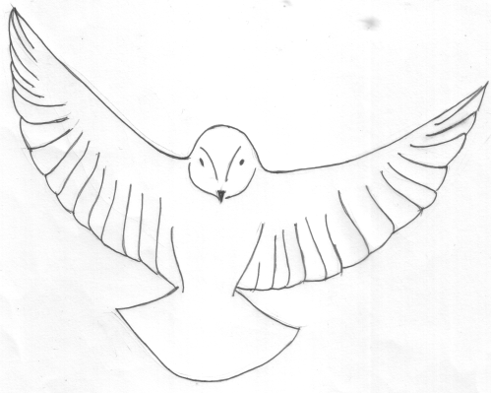
Contact force exerted by air on wing
Contact force exerted by wing on air

- A ball dropping from a height.

Gravitational force exerted by the earth on the ball

Gravitational force exerted by the ball on the earth

- A rocket propelled by exhaust gas.

Contact force exerted by exhaust gas on rocket

Contact force exerted by the rocket on the exhaust gas.

Part II

- Which force is greater, the earth’s pull on the moon, or the moon’s pull on the earth?

Action and reaction forces are equal in magnitude.

- A high-speed bus and a mosquito had a head-on collision. The force of the bus squashed the mosquito over the windshield.
- Comparing the force exerted by the mosquito against the windshield and by the windshield against the mosquito - does the mosquito exerts greater, less or the same force as the windshield?
- Is the resulting deceleration of the bus greater than, less than or the same as that of the mosquito? Why?

- The mosquito exerts the same force as the bus.
- The resulting deceleration of the bus is much smaller because it has a much larger mass.

- A computer rests on the table. Draw the diagram, label and name the action-reaction pairs of forces acting on the system.

The computer exerts a contact force on the table, and the table exerts a contact force on the computer.
The computer exerts a gravitational pull on the earth, and the earth exerts a gravitational pull on the computer.
The table exerts a gravitational pull on the earth, and the earth exerts a gravitational pull on the table.

- Your car battery went dead and you must push the car to get it started. Why can’t you push the car by remaining comfortably inside and pushing against the dashboard?

To get the car to move, the tyre has to turn to exert a force on the ground. The force exerted by the ground on the tyre in reaction will cause the car to move. For this to happen, the applied force exerted at the beginning has to be applied onto the body of the car so that the tyre can, in turn, exert a force on the ground.

When a force is exerted against the dashboard, the dashboard exerts a force in reaction in the opposite direction. However, both these action and reaction forces will not cause the tyres to move in any way.

