Worksheet (Newton’s Second Law Motion) Using Interactive Simulation

Dep. Of Applied Physics and Astronomy University of Sharjah

Name: ID#:
This activity consists of two parts.
Part one: Newton’s second law (constant mass system).
Part two: Newton’s second law (constant force system).

To be familiar with Newton’s second Law (Atwood Machine), hanged masses, added masses to change the force acting, calculate the acceleration of the system. Control friction and others Using an interactive simulation kindly, open the following link and play with it.

https://iwant2study.org/lookangejss/02_newtonianmechanics_3dynamics/ejss_model_AtwoodMachine2wee/AtwoodMachine2wee_Simulation.xhtml

Objectives:

In this experiment we are going to:
- Investigate the relationship between force, mass, and acceleration.
- Verify Newton’s Second Law.

Theory:

Newton’s first law explains what happens to an object when the resultant forces on it is zero: it either remains at rest or moves with constant velocity. Newton’s second law answers the question of what happens to an object that has a nonzero resultant force acting on it.
Newton observed that the acceleration of an object is directly proportional to the resultant force acting on it if the mass is constant, and the acceleration of an object is inversely proportional to its mass if the net force is constant. These observations are summarized in “Newton’s Second Law”:

The acceleration of an object is directly proportional to the net force acting on it and inversely proportional to its mass

Thus, we can relate force, acceleration, and mass through the following mathematical statement:

Σ F = ma ………………….. Eq.(1)

It is important to note that the net force (ΣF) in this equation includes only the external forces.
Equation (1) is a vector expression. It is equivalent to a set of three equations, one for each component:

ΣF_{x} = ma_{x} ΣF_{y} = ma_{y} ΣF_{z} = ma_{z} …………………… Eq. (2)

The SI unit of force is the newton (N), which is defined as the force that, when acting on a 1kg mass, produces an acceleration of 1 m/s²,. (1N ≡ 1 kg.m/s² )

To verify equation (1), consider a glider of mass (M) accelerated by means of a light string attached to it. The string passes over a mass-less, frictionless pulley and the other end is connected to a small hanging mass (m) as in Figure 1.
The forces on (M) and (m) are shown in the free-body diagrams of Figure 1. In the absence of friction, the net force on mass (M) that accelerates it to the right is the tension T in the string. Applying Newton’s second law to (M) gives

Σ F = T = Ma ………………..Eq. (3)

The falling mass (m) is pulled downward by gravity (or weight, w = mg) and upward by the tension T in the string. Thus, applying Newton’s second law to (m) gives

Σ F = mg – T = ma
or
w – T = ma ……………….. Eq. (4)

Eliminating T from Equations (4) and (5) gives:

w = (m + M) a ……………….. Eq. (5)
or
a = w/(m+M) ………………..Eq. (6)

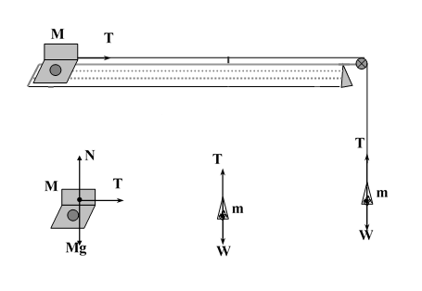

Figure 1

Since we have assumed the validity of the Second Law in deriving Equation (6), we can consider this equation to be a prediction of the Second Law. Your experiment seeks to verify this specific prediction and thereby provide evidence for the validity of Newton’s Second Law.

Part I
By keeping the total mass of the system constant so that the relationship between F and a can be examined by using Equation (6).

To Study Newton’s second law using an interactive simulation, do the following:
- Open the following link:

https://iwant2study.org/lookangejss/02_newtonianmechanics_3dynamics/ejss_model_AtwoodMachine2wee/AtwoodMachine2wee_Simulation.xhtml

- From the home page of this link, click on both, you will see on the same window the Atwood machine and the graph that relates the position versus time graph of the system motion.
- Use the mass controller of the hanging object (m) and adjust it at 0.05Kg.
- Use the added mass to the cart controller to add 0.3Kg on the cart. (The mass of the cart is constant and equal 0.25Kg).
- Record the total mass of the system in table 1. (m +M + the added mass to the cart 0.6 Kg).
- Press on store data button and then, press on play/pause button to get the first graph that show you the system acceleration. Record your data in table 1.
- Press the store data button and then, remove 0.05kg from the cart and add it to the hanging mass (to keep the total mass of the system constant), press on play/pause button to get the second graph that show you the system acceleration. Record your data in table 1.
- Repeat steps 7 for at least five shifted masses and record the data in table 1.

Data Analysis: (Part I)

- Calculate the weight (Force) of the hanging object for each trial.
- Record your results in table (1).
- Plot a graph of (F=W) versus (a) with F as the ordinate (y-axis) and a as the abscissa (x-axis). Attach the graph to your lab report.
- Calculate the slope of the line then find the total mass of the system
- Calculate the percentage error (δ%) in the mass of the system.

Table 1

Total mass m+M+Added mass = ……….. kg

m (kg) | F=w=mg (N) | a (m/s²)

Slope = ………………… Total mass = ……………….

δ% = …………………………………………

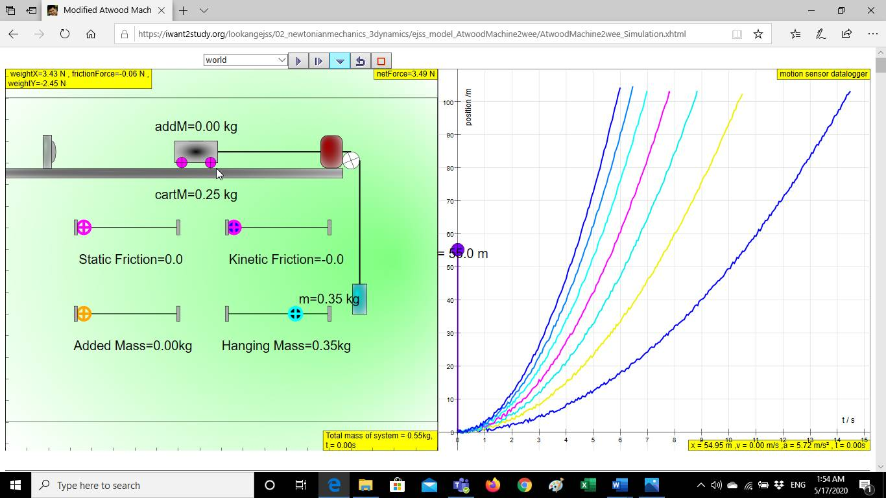

Part II
By keeping the force acting on the system constant so that the relationship between the total mass of the system and a can be examined by using Equation (7).

To Study Newton’s second law using an interactive simulation, do the following:
- Open the following link:

https://iwant2study.org/lookangejss/02_newtonianmechanics_3dynamics/ejss_model_AtwoodMachine2wee/AtwoodMachine2wee_Simulation.xhtml

- From the home page of this link, click on both, you will see on the same window the Atwood machine and the graph that relates the position versus time of the system motion.
- Use the mass controller of the hanging object (m) and adjust it at 0.30Kg (keep it constant).
- press on play/pause button to get the first graph that show you the system acceleration. Record your data in table 2.
- Use the added mass to the cart controller to add 0.05Kg on the cart. (The mass of the cart + added mass is 0.3Kg).
- Press on store data button and then, press on play/pause button to get the second graph that show you the system acceleration. Record your data in table 2.
- Repeat steps 5 and 6 for at least five added masses to the cart and record the data in table 2.

Data Analysis: (Part II)

- Calculate the weight of the hanging object which is constant in this part.
- Calculate the reciprocal value of the total mass 1/(m+M).
- Record your results in table (2).
- Plot a graph of (a) versus 1/(m+M) with (a) as the ordinate(x-axis) and 1/(m+M) as the abscissa (y-axis). Attach the graph to your lab report.
- Calculate the slope of the line then find the weight of the hanger from the slope.
- Calculate the percentage error (δ%) in the weight of the hanging object.
Table 2

Weight of the hanging mass = …………. N
M (kg) | m + M (kg) | a (m/s²) | 1/(m+M) (kg)⁻¹
0.25 | 0.55
0.30 | 0.60
0.35 | 0.65
0.40 | 0.70
0.45 | 0.75
0.50 | 0.80

Slope = ……………………………………..W = …………………………………….……

δ% = ………………………………

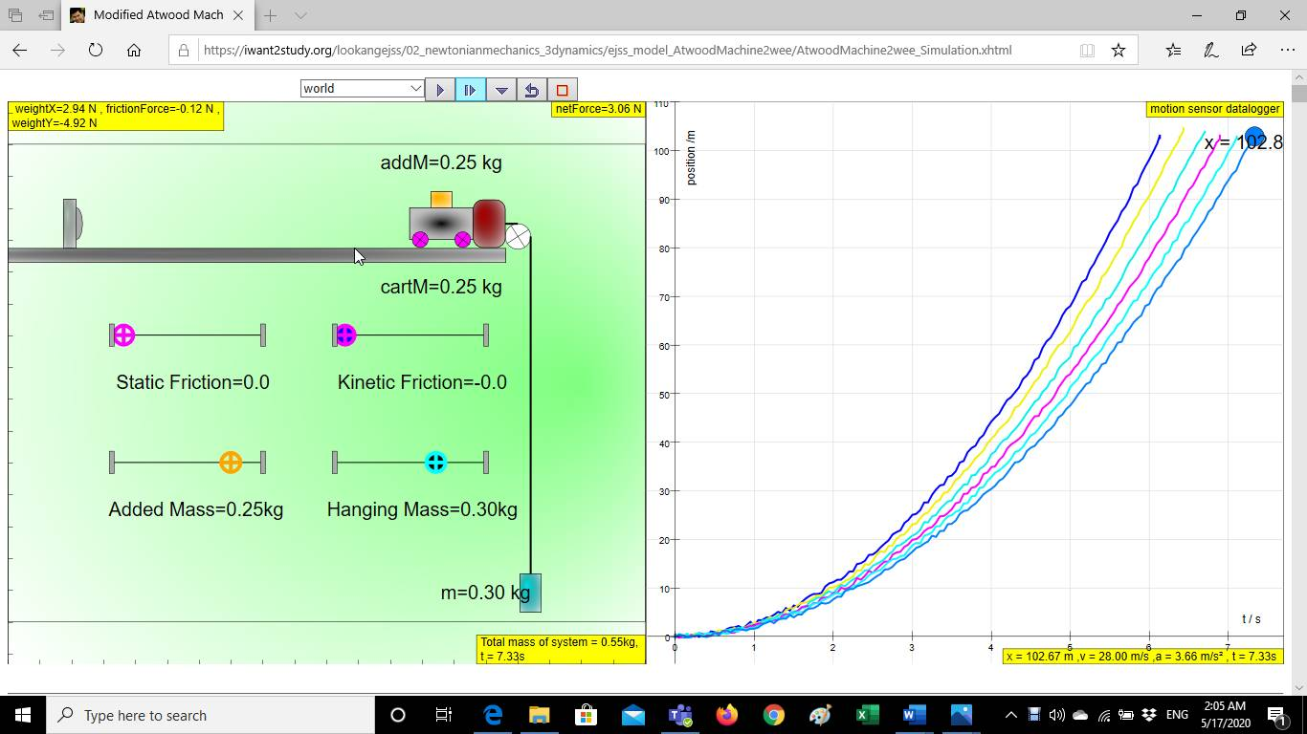

Questions:
1) In Part (II), If you double the value of the hanging mass (m) will the acceleration double? Explain your answer.

2) Should your data lines pass through the origin? Why?

M
θ
m
3) Suppose you could tilt the track as shown. If m = 150 g and M = 750 g.
a- Draw the free-body diagrams of m and M.

b- What elevation angle θ will give the system an acceleration of zero?

………………………………………………………………………………………………………

………………………………………………………………………………………………………

………………………………………………………………………………………………………

c- What is the tension in the string?

………………………………………………………………………………………………………

………………………………………………………………………………………………………

………………………………………………………………………………………………………

