Subject: | Physics – Secondary and Primary | Time: 90 mins
Worksheet Title: | Kinematics of a rolling a double cone and a rod on a inclined V-shaped rail–plane – Tracker Video Analysis

Aim: To investigate the kinematics and energies of a rolling double cone and a rod

Apparatus: Computer Lab with
Tracker by Prof. Douglas Brown, Workshop by Wee_Loo_Kang@moe.gov.sg
Windows Installer Tool: http://www.cabrillo.edu/~dbrown/tracker/installers/Tracker-4.70-windows-installer.exe
Webstart Tool : http://www.cabrillo.edu/~dbrown/tracker/webstart/tracker.jnlp
Tracker is free software; you can redistribute it and/or modify it under the terms of the GNU General Public License
Internet Help http://www.cabrillo.edu/~dbrown/tracker/tracker_help.pdf or http://www.cabrillo.edu/~dbrown/tracker/help/frameset.html
Video
PD video http://www.youtube.com/watch?v=cuYJsnhWXOw
http://www.youtube.com/watch?v=WSG1x3klkH0

Background:
Worksheet for Inquiry-Based Lesson using 5E Learning Cycle as a General PCK Strategy for Inspiring Teaching, Engaged Learning in Science.
Concepts in mechanics which include speed, velocity, acceleration, and energy conversion and conservation are explored in this lesson. You should be able to conduct your own inquiry video basic analysis and for advanced learners’ computer modeling that deepens learning.

Procedure:
Setup Tracker
- Launch the software by selecting Start – All Programs – Tracker – Tracker on the Windows Menu on the bottom left corner. The screen should look like this.
File Open
Play
Clip Settings
Frame number
Axes
Tape Measure
Step back
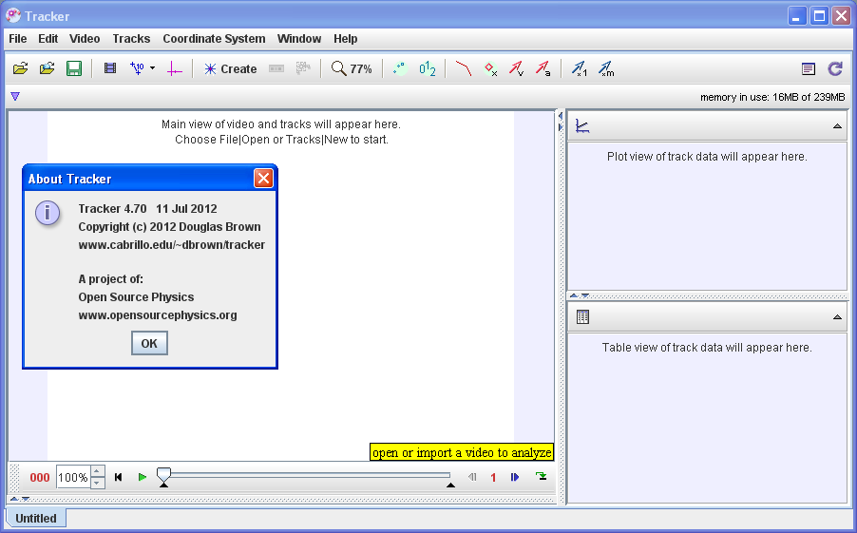

Selecting the video for double cone
- Click the Open button or File|Open menu item and select a video (.mov) or tracker file (.trk) to open it. Import the video of your choice for example “Double cone rolling up ametal slope HD480.mov” and save the project as a filename of your choice for example “Double cone rolling up ametal slope HD480.mov.trk”
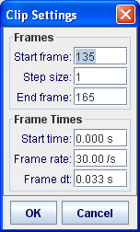
Select the display of the clip settings by clicking the clip settings button at the right end of the player as shown.
In the clip settings dialog, set the Start and End frames to define the range you wish to analyze. In this video, set start frame to be 135 while the 165. Click on OK to proceed. Note that the dark triangle (picture below) pointer on the time slider can also be used to control the clip setting

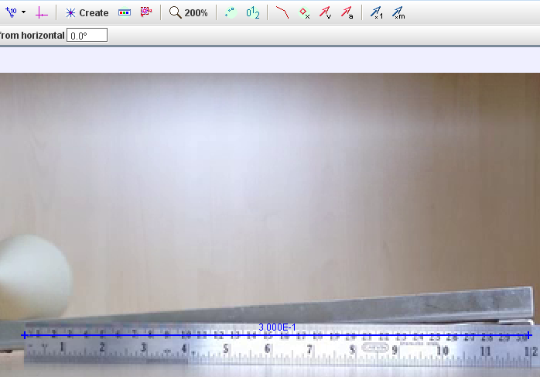
- To calibrate the scale on the video, click the Tape Measure button to show the tape measure. For this video, the 0.30 m metre rule is on the video, move it to capture the length as in the video.

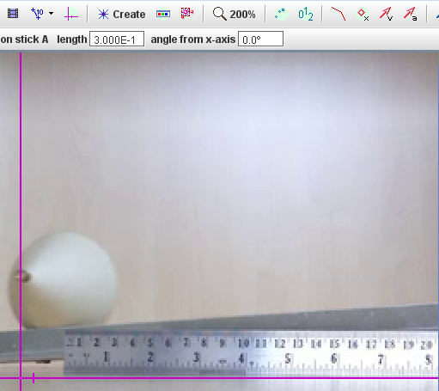
- Set the reference frame origin and angle. Click the Axes button to show the coordinate axes. Drag the origin and/or x-axis to set the reference frame origin and angle. A common choice for the origin is the initial position of an object of interest.

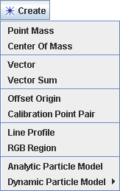

- Track objects of interest with the mouse or model them with particle models. Click the Create button and choose a track type from the menu of choices. Most moving objects are tracked using a Point Mass.

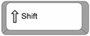
- 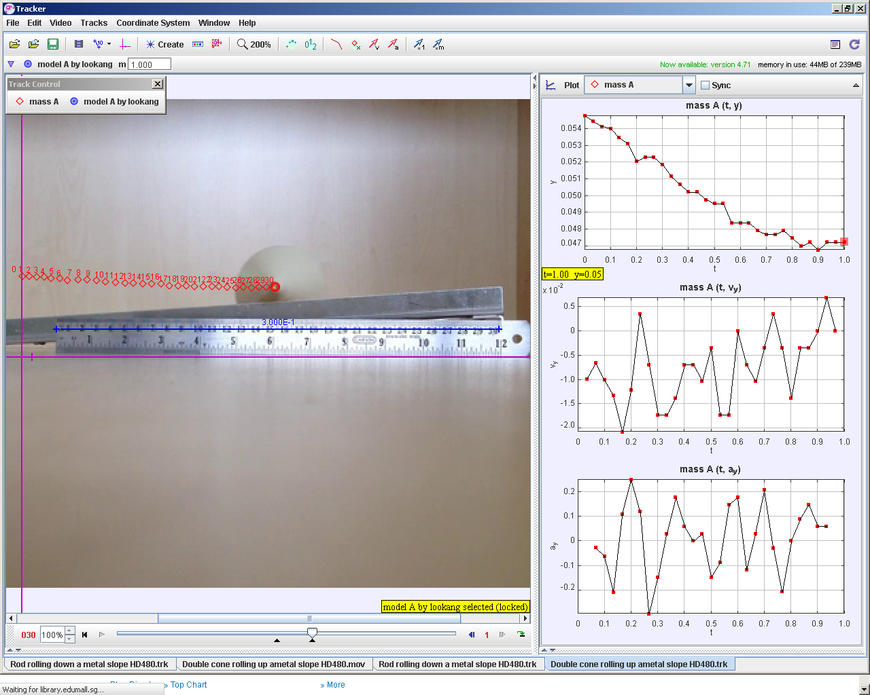If tracking an object, mark its position on every frame by holding down the shift key and clicking the mouse (crosshair cursor) as the video automatically steps through the video clip. Note: don't skip frames--if you do, velocities and accelerations cannot be determined. Track the ball until end of frame. Plot and analyze the tracks The Plot View displays graphs of track data. To plot multiple graphs, click the Plots button and select the desired (3) plots number. Click the x- or y-axis label to change the variable plotted on that axis. In this video, choose y versus t, vy versus t & ay versus t.
+ mouse click

- In your groups, discuss and make sense of the shape y versus t, vy versus t & ay versus t. Highlight one initial idea or learning point for each plot.

Y vs t , graph of y displacement versus time of the rolling double cone is decreasing from
t = 0.0 s y = 0.055 m to t = 1.0 s, y = 0.047 m

vy vs t , graph of velocity in y direction versus time, is small negative value and decreasing in magntiude (require analysis to determine value), giving evidence that the double cone is moving lower in y.

ay vs t graph of acceleration in y direction versus time, is slightly positive, giving evidence that the double cone is moving lower in y with roughly 0.0126 m/s^2 (require analysis to determine value).

- 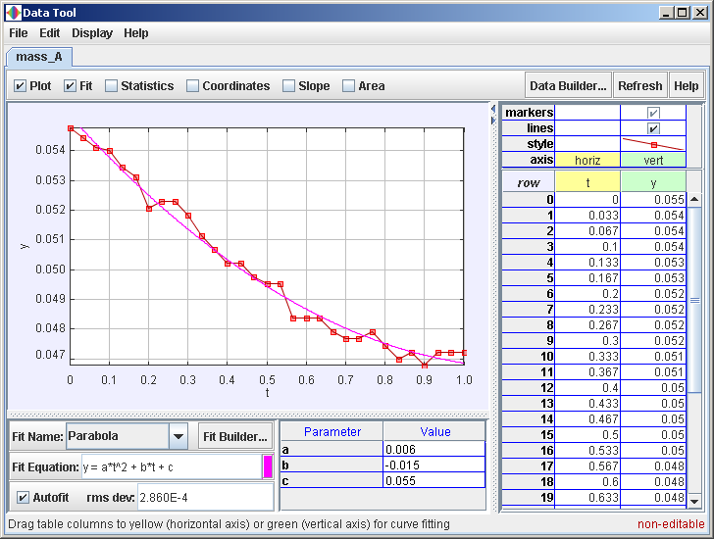Right-click on a plot (y versus t) to access display and analysis options in a popup menu. Select the various options as shown in the figure.

- For time t =0 to 1.0 s, write down your values for the “Parabola” Fit Equation of the form y = a*t^2 + b*t + c, your data analysis values.
Coefficient parabola fit, a = ___0.006______________ and units ___m/s^2_______
Coefficient parabola fit, b = ___ -0.015______________ ____m/s_______
Coefficient parabola fit, c = ___0.055______________ ______m______

- Hence by comparing to EOM s = u*t + 0.5*a*t² or otherwise, suggest an equation for the graph of y(t)= __0.055 – 0.015*t + 0.5*(0.012)*t^2______________________ and units _________m____

Thinking about Random and Systematic Errors like real scientist

- Suggest with reason, what is random error here how to reduce the random error?
The human measurement of each position of the double cone, consistently take the middle of the blur centre of the double cone as reference.

- Suggest with reason, what could be a source of systemic error here and how to reduce the systemic error?

The ruler axes could be not vertically downwards in the direction of the gravitational field due to off axis video taken

The ruler could be off the calibrated length, need to recalibrate against longer length

Planning Kinetic Energy (KE), Potential Energy (PE) and Total Energy (TE) Analysis

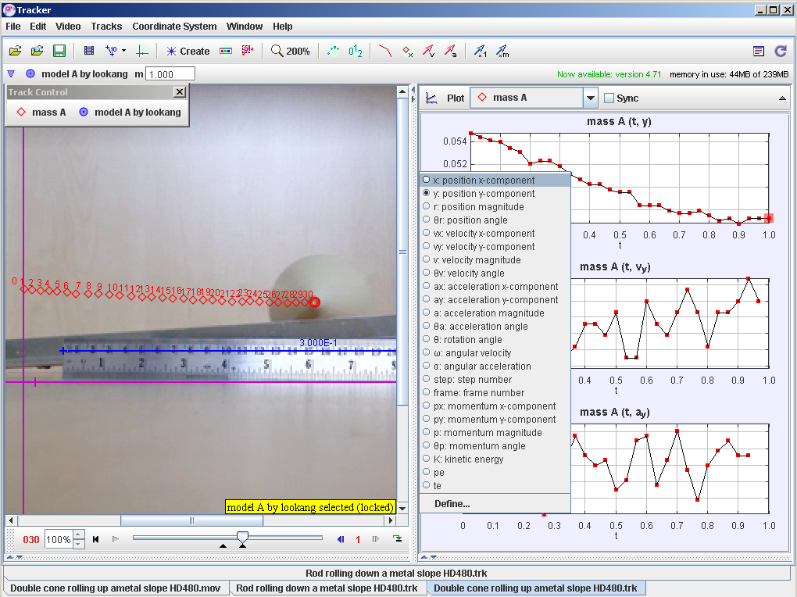
- Click on the graph y axis to toggle a drop-down menu of variables that can be used. Since we are interested to investigate the energy variables like KE, PE and TE, tracker allows users to define these self determined quantities. Select “Define…” and key in the variables.
Hint: typical formulae are as follows:
KE = 0.5*m*v^2
PE = m*g*h
TE = KE+PE

- 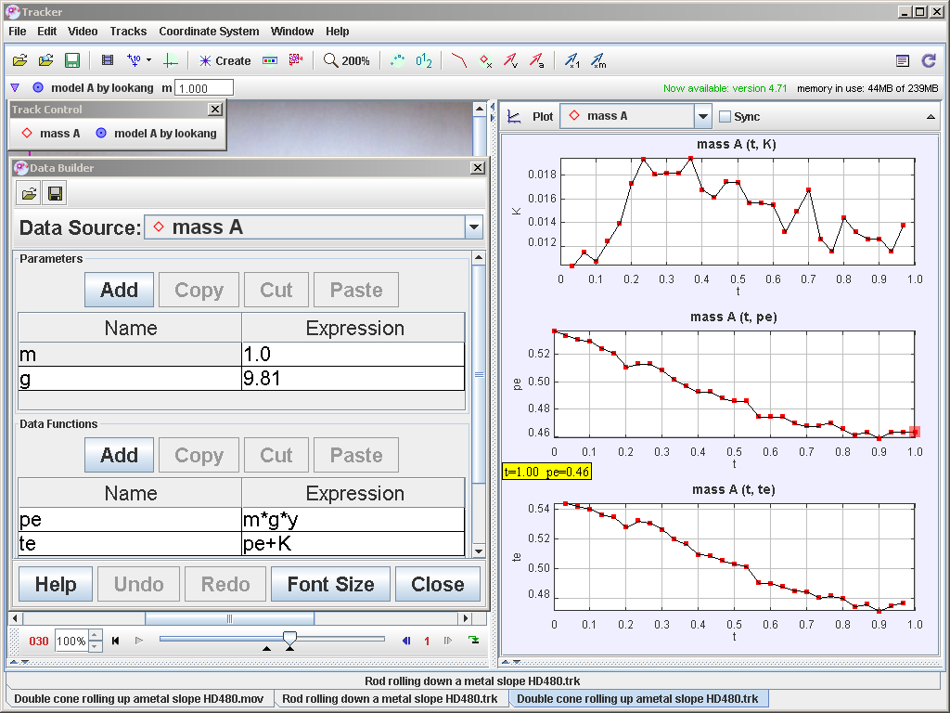By defining potential energy, kinetic energy and total energy, hence show the analysis as shown.

- Suggest what evidence(s) indicate that the total energy is NOT conserved and for which part of the motion?

The total energy is NOT conserved when the double cone is moving on the V-shaped rail, but towards the end of the motion t = 0.8 to 1.0 s, the TE seems to be fairly constant, this evidence suggests the TE is NOT conserved when there is motion ( retarding fricitional forces exist) but fairly constant if the double is not moving

Understanding PE is arbitrary

- Now click and drag the axes of the World View at any y position. What did you observe? What conclusion(s) can you draw about the determination of potential energy with respect to a reference level?
The PE is arbitrary set depending on the reference level (axes of y )

Selecting the video for rod
- Repeat steps 2 to 15 for the video on the rolling rod (cylinder) down the V-shaped rail.
- In your groups, discuss and make sense of the shape y versus t, vy versus t & ay versus t. Highlight one initial idea or learning point for each plot.
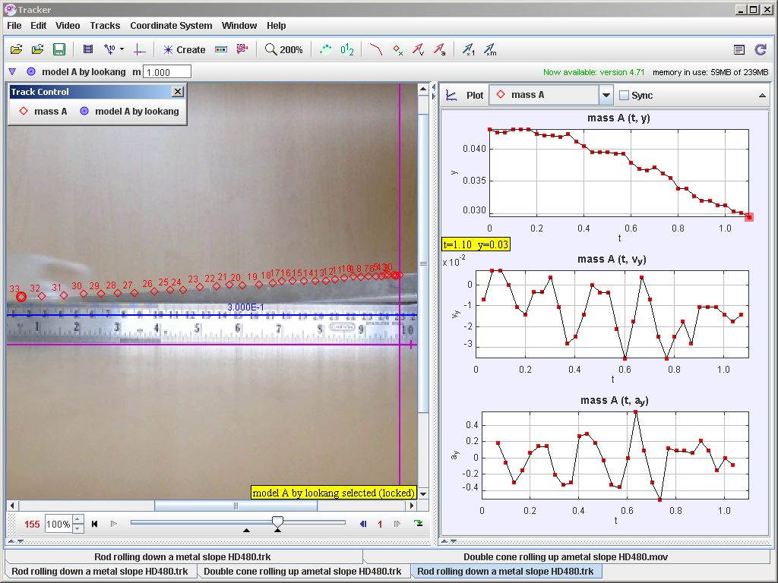

Y vs t , graph of y displacement versus time of the rolling double cone is decreasing from
t = 0.0 s y = 0.040 m to t = 1.1 s, y = 0.030 m

vy vs t , graph of velocity in y direction versus time, is small negative value, giving evidence that the rod is moving lower in y.

ay vs t graph of acceleration in y direction versus time, is small negative value, giving evidence that the rod is moving lower in y with acceleration downloadwards.

- 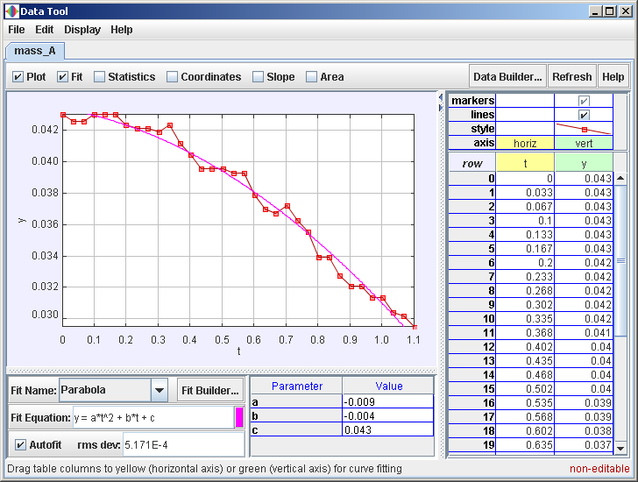Right-click on a plot (y versus t) to access display and analysis options in a popup menu. Select the various options as shown in the figure.

- For time t =0 to 1.1 s, write down your values for the “Parabola” Fit Equation of the form y = a*t^2 + b*t + c, your data analysis values.
Coefficient parabola fit, a = ___-0.009______________ and units ___m/s^2_______
Coefficient parabola fit, b = ___-0.004______________ ____m/s_______
Coefficient parabola fit, c = ___0.043______________ ______m______

- Hence by comparing to EOM s = u*t + 0.5*a*t² or otherwise, suggest an equation for the graph of y(t)= __0.043 – 0.004*t + 0.5*(-0.018)*t^2______________________ and units _________m____

Planning Kinetic Energy (KE), Potential Energy (PE) and Total Energy (TE) Analysis

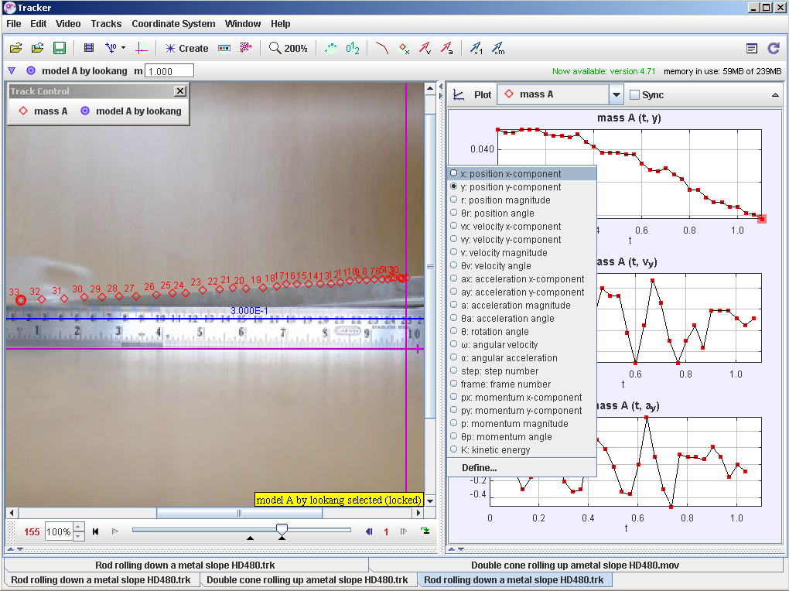
- Click on the graph y axis to toggle a drop-down menu of variables that can be used. Since we are interested to investigate the energy variables like KE, PE and TE, tracker allows users to define these self determined quantities. Select “Define…” and key in the variables.
Hint: typical formulae are as follows:
KE = 0.5*m*v^2
PE = m*g*h
TE = KE+PE

- 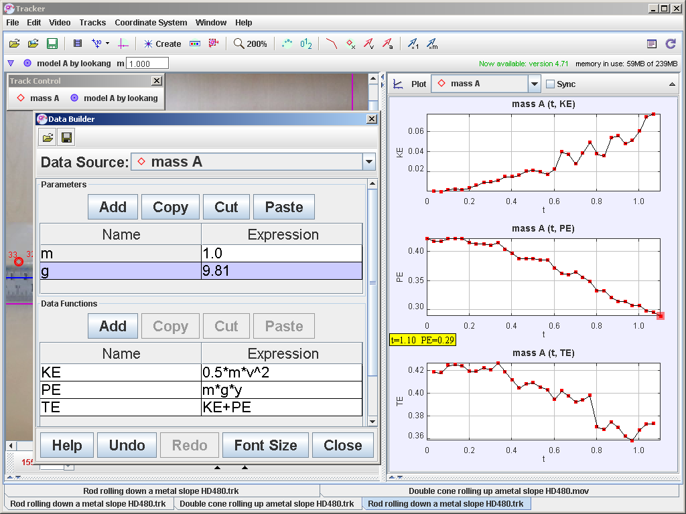By defining potential energy, kinetic energy and total energy, hence show the analysis as shown.

- Suggest what evidence(s) indicate that the total energy is NOT conserved and for which part of the motion?

The total energy is NOT conserved when the double cone is moving on the V-shaped rail, but towards the end of the motion t = 0.8 to 1.0 s, the TE seems to be fairly constant, this evidence suggests the TE is NOT conserved when there is motion ( retarding fricitional forces exist).

