P09 – Gravitational Field Simulation-based Practical
(Pre-lecture Activity)

http://iwant2study.org/ospsg/index.php/interactive-resources/physics/02-newtonian-mechanics/08-gravity

Please use Chrome to run all applets,
Simulation 1 – Geostationary Satellites (What’s that? Can eat or not?)

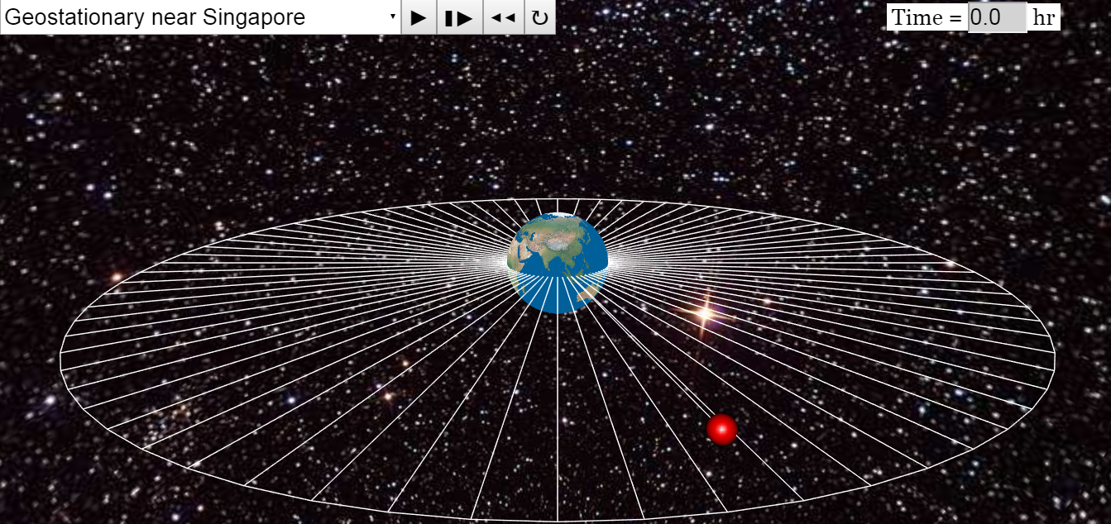
You may zoom in to view better or click on any point, drag up and down to change perspective.
https://tinyurl.com/y7udothb
teacher’s copy

- Click and observe the motion of a geostationary satellite near Singapore.

Note the period of the orbit.
- Click on after every run to reset the simulation before selecting another option.
- Use the drop down menu to run two other geostationary orbits.

After observing all three geostationary orbits, I can safely conclude the

period of geostationary orbits is ……………………

- Click on to reset the simulation. Use the drop down menu to run other non-geostationary orbits. Remember to reset after every run.

After observing different orbits including polar orbits, identify three other characteristic of geostationary satellites.

1.

2.

3.

- Suggest possible applications for geostationary satellites. (Why are we studying them?)

Simulation 2 – If Superman Throws a Ball Fast Enough…?!
https://tinyurl.com/y735eygl
Graphs of KE (kinetic energy), PE (gravitational potential energy) and TE (total energy) are plotted against separation from the surface of the Earth.
- Use the drop down menu to select the initial horizontal speed of a ball projected from the top of a tall mountain.
- Select v=2000 and click to run the simulation.

- Click on to reset the simulation. Use the drop down menu to select v=4000 and click to run the simulation.

State and Explain the main difference between the paths of the two projectile motions.

- Click on to reset the simulation. Use the drop down menu to select v=6000 and click to run the simulation.

How would you explain what is happening here?

- What is one question you have after running this simulation?

- Click on to reset the simulation. Use the drop down menu to select v=8000 and click to run the simulation.

What do you think is happening?

欢迎来到引力场！你将被深深吸引！ Welcome to Gravitational Field! You will be deeply attracted!

Simulation 3 – Newton’s Law of Gravitation

Weight is the force acting on a mass due to a gravitational field.
What is a gravitational field? How do two masses interact? Do they need to be in physical contact to do so?
https://tinyurl.com/y9k69twq

- Click to run the simulation with the default setting M₁ = M₂ = 100 kg and
r = 4.00 m.

Note down your observations.

- Click on to reset the simulation.  Use the drop down menu to set  M₁ = 10 kg.  You can drag the masses further apart if you wish.  - Click and record your observations. | - Think about the difference between the two observations in 1 and 3. Thus, explain the motion and final positions of the two masses for the second setting.  - Draw the gravitational forces on two masses below.  M1  M2

Simulation 4.1 – Gravitational Field Strength near and far
https://tinyurl.com/ybfa4aju
https://tinyurl.com/ycdljka4
- Use the drop down menu to look at four different gravitational fields ranging from very_outer_space to very_near_Earth_surface. | - Copy and Draw the gravitational field of the Earth when viewed from very outer space.  Earth
- Copy and draw the gravitational field of the Earth when viewed from very near the Earth’s surface.

Earth’s surface

- Distinguish between the two extreme cases:
very far from and very near to the Earth.

Simulation 4.2 – Gravitational Field Strength relationship and graph

- Drag the mass slowly around to see how gravitational field strength varies
with separation from the Earth.

- Draw, on the axes below, the graph of gravitational field strength g against separation from centre of the Earth r.  g  r | - Deduce how g is numerically related to r.  Show your calculations.
Simulation 5 – Binary Stars? Huh?
https://tinyurl.com/yd4ehhp9

Google for some background on binary stars.

- Use the drop-down menu and select M1=M2=1,circular_orbit.

- Click and observe the motion of both masses, noting the magnitudes of the forces, F1 and F2, on each mass.

Record your observations.

- Click on to reset the simulation.

Use the drop-down menu and now select from the menu M1=1,M2=0.1,circular_orbit.

- Click and observe the motion, noting the orbits of the binary stars.

Record your observations.

- Newton’s first law of motion states that an object at rest will remain at rest and an object in motion will remain in motion at constant velocity in a straight line in the absence of an external resultant force.

Hence, for an object to move in circular motion, there must be a

What would you say cause the stars to move in a such a manner?

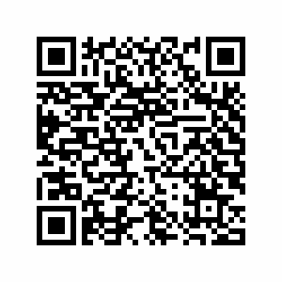 | Complete this lesson with an online summary of  - 3 concepts you feel you have understood,  - 2 questions you still have, and  - 1 feedback on the practical.  https://tinyurl.com/y9d7np8e

URLs for students who prefer to use laptops:
Simulation 1 – Geostationary Satellites
https://tinyurl.com/y7udothb

Simulation 2 – If Superman Throws a Ball Fast Enough…?!
https://tinyurl.com/y735eygl

Simulation 3 – Newton’s Law of Gravitation
https://tinyurl.com/y9k69twq

Simulation 4.1 – Gravitational Field Strength near and far
https://tinyurl.com/ybfa4aju

Simulation 4.2 – Gravitational Field Strength relationship and graph
https://tinyurl.com/ycdljka4

Simulation 5 – Binary Stars?
https://tinyurl.com/yd4ehhp9

Conclusion
https://tinyurl.com/y9d7np8e

