Monitoring of EjsS Simulations in SLS
Current Situation
Moodle 4.0 and SLS integrated via LTI Apps
General design
Integration Moodle – SLS

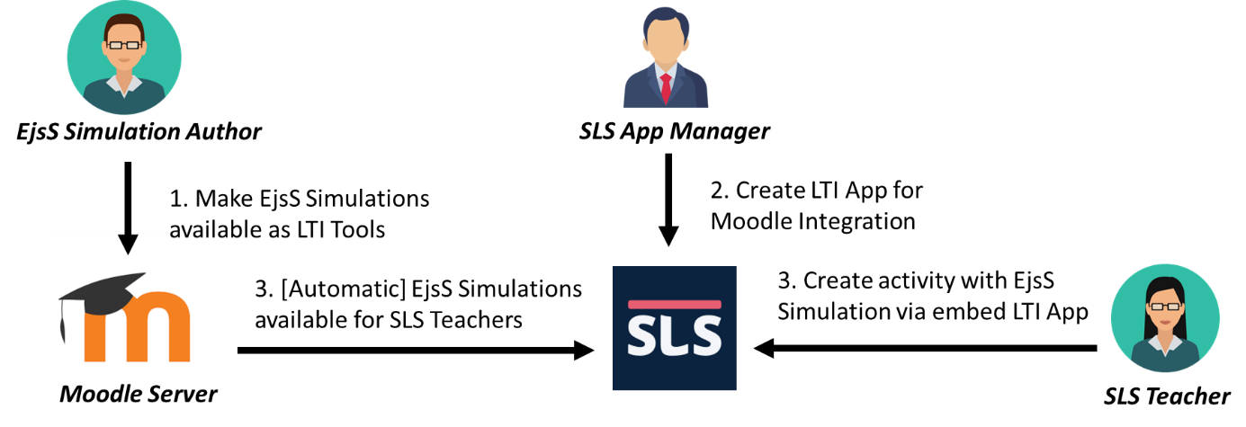

Student assignment and monitoring

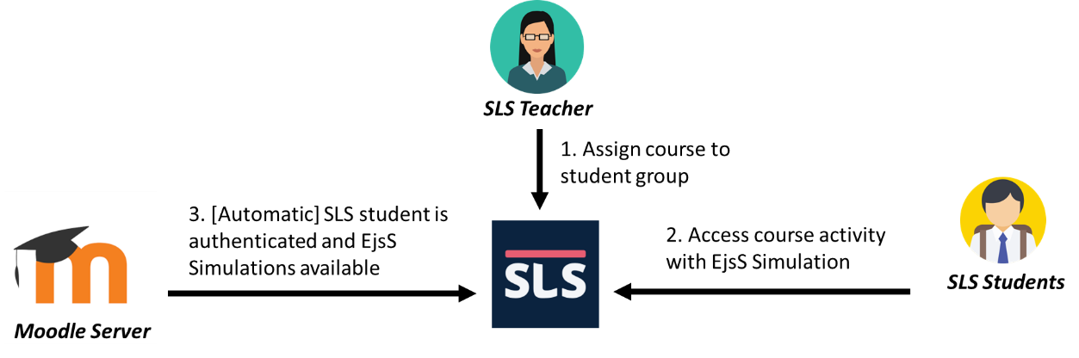

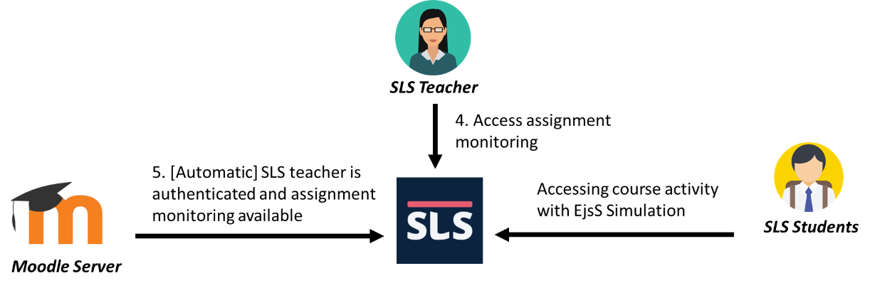

Data exchange
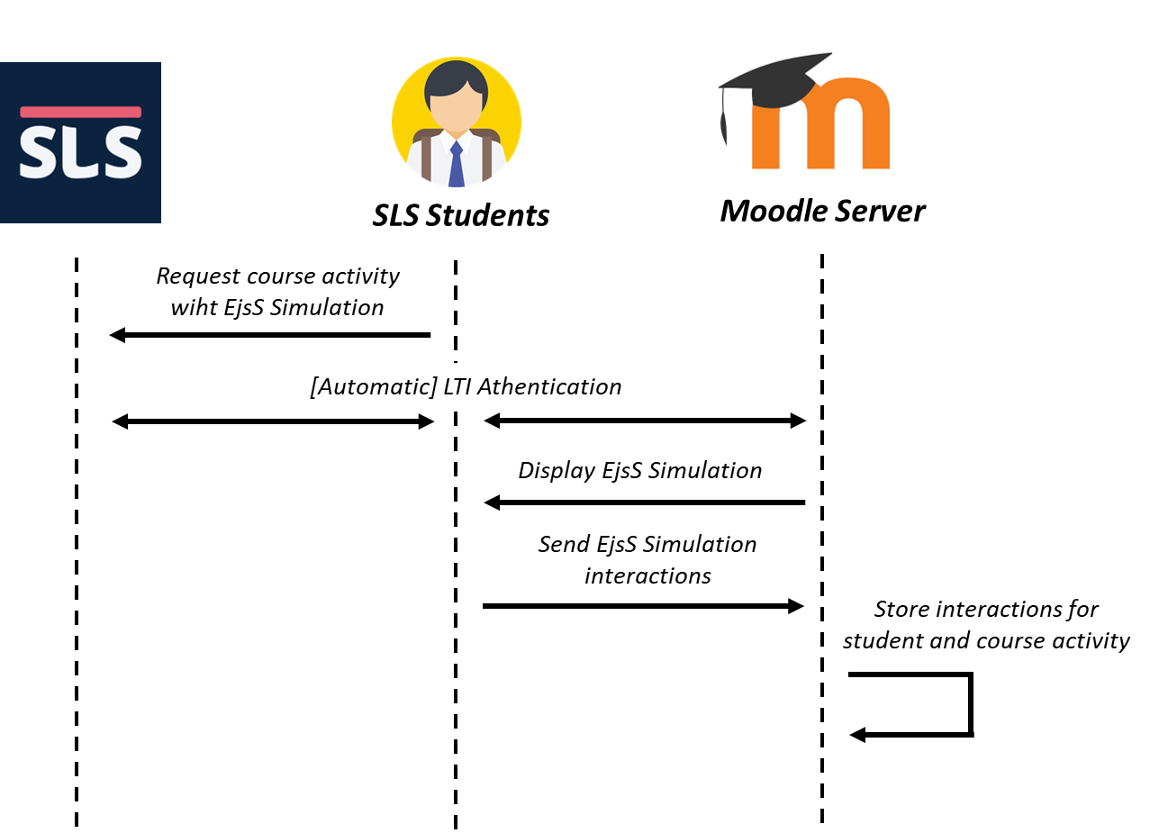

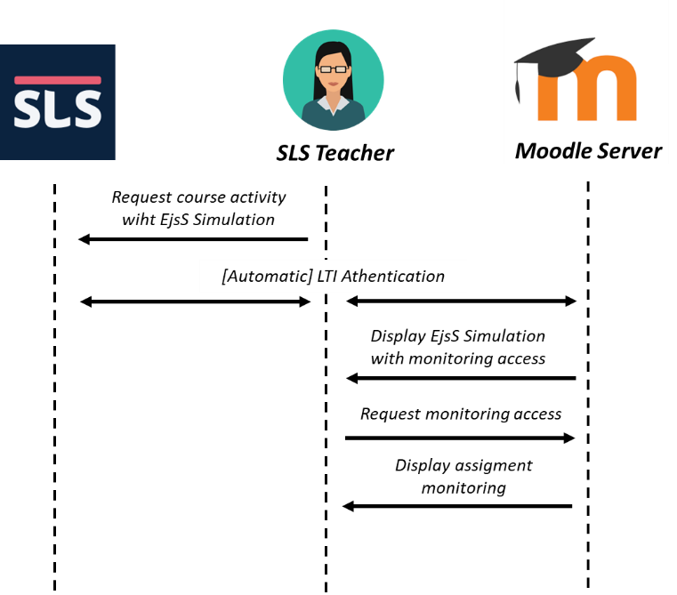

Step 1. Define an assessment file
As a course creator in Moodle, define the file assessment.json with the activity steps required. This file is used by Moodle to check the student interactions and automatic assess the student experience.
The general format of this file is:
[
{ "name": "short name of the first step",
"description": "description of the first step",
"interactions": [
{ "element": "simulation element name",
"property": "property name",
"action": "action name",
"data": "property value"},
...]
},
...]

An example is the following one:
[
{ "name": "Test 1",
"description": "Checked",
"interactions" : [
{"element": "checkBox", "property": "Checked", "data": false }
]
},
{ "name": "Test 2",
"description": "Reset",
"interactions" : [
{"element": "resetbutton", "action": "OnClick"}
]
}
]

And upload this file with the EjsS simulation in Moodle.
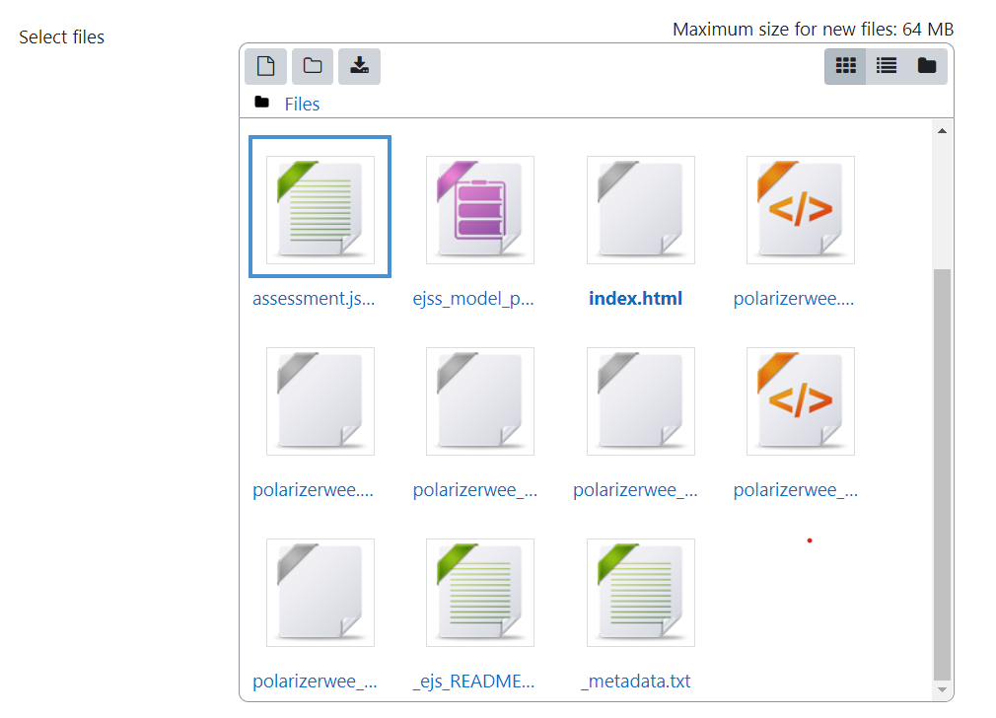
Step 2. Access monitoring from SLS
As a SLS teacher access the activity with the EjsS Simulation and then click the button "See Analytics".
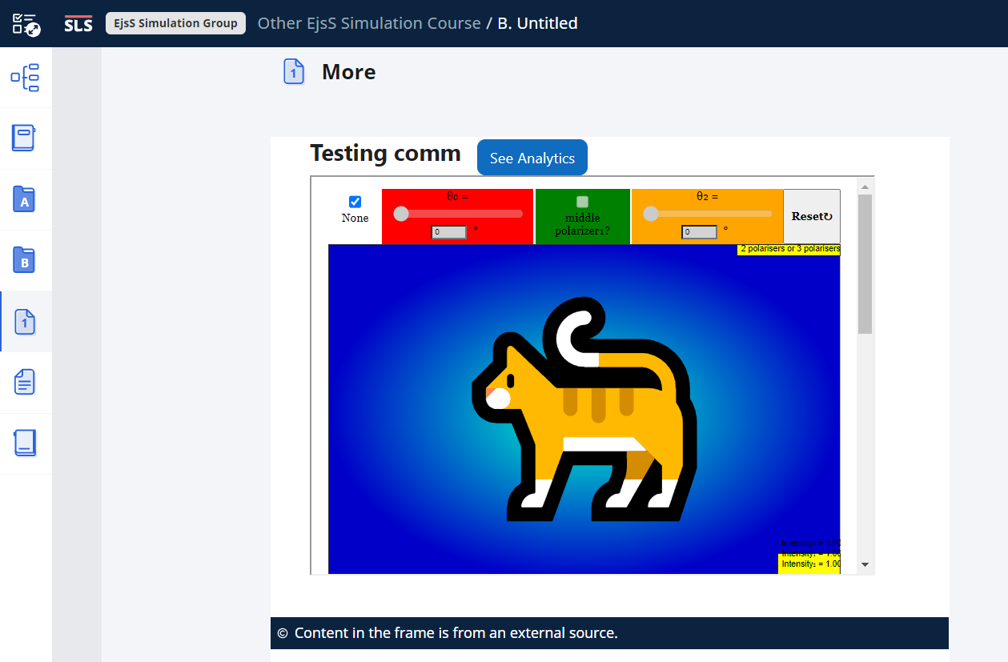
The assignment monitoring will report students status considering the file assessment.json.
