Name : __________________________( ) Class : _________ Date : ___________

1. | Basic of graphs of rate of change:
 | a. | Horizontal axis represents ____________.
 | b. | Vertical axis represents other physical quantity. For example: _______________
 | c. | Label the time axis and the displacement axis on the figure below.
2. | How do you represent change in a physical quantity with respected to time?  By plotting corresponding values of ______________ and the value of a physical quantity (e.g. distance) on the x-y axes graph.
3. | How do you know if there is a change in a physical quantity with respect to time on x and y axes?
 | When the __________________________ changes with __________ on the graph.
 | Representing change on graphs
4. | Is there a change of distance with respect to time?  displacement changes / does not change with time.  displacement changes / does not change with time.  displacement  displacement  time  time
 | Rate of change
5. | How does the displacement change with respect to time?  displacement  time
  The distance increases at ………………………rate.
 | a | Define velocity.  __________________________________________________________________.
 | b | What is the rate of change of displacement in the above graph?  __________________________________________________________________.
 | d | What velocity is represented on the graph above?  Since velocity is defined as the rate of change of displacement, a graph representing ____________ of change of displacement shows a _________________________ motion.
 | c | What is the gradient of the displacement-time graph above?  __________________________________________________________________.
 | e | Conclusion:  ______________ gradient of displacement-time graph means the speed is ____________.
6. | Non-constant rate of Change – Part I.  displacement  time
  A
  B
 | a | Which plot A or B represent constant rate of change of displacement?
 | b | Does the rate of change for plot B remain constant? _________
 | c | What type of rate of change is plot B?
 | d | Use another phrase to describe “decreasing rate of change of displacement”.
 | e | Describe the gradient of the displacement-time plot B.
 | f | From the phrase “decreasing velocity”, is the velocity constant?
 | g | State another description of ‘decreasing velocity’.  _____________________
7. | Non-constant rate of Change – Part II.  displacement  time
  A
  B
 | a | On the graph space above, predict the plot for increasing rate of change of displacement. Label the plot C
 | b | Give another name to increasing velocity.  ______________________.

Practice to test your understanding.

- The motion of four cars is described below. Sketch the shape of distance-time graph. [8]

Motion | Shape of distance-time graph | Gradient of distance-time graph
at rest | distance  time | …………………………………..
constant speed | distance  time | …………………………………..
increasing speed | distance  time | …………………………………..
decreasing speed | distance  time | …………………………………..
Extension of Learning

- Two cyclists compete with one another.

The distance-time graph of the cyclists is shown in the screen-grab from a computer Video Analysis.

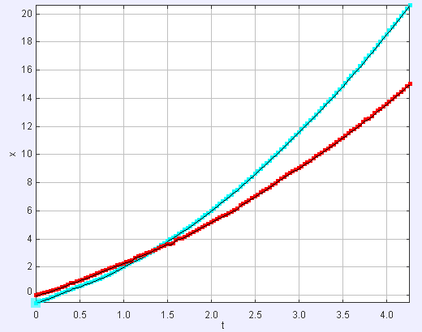
cyclist A
cyclist B

 | a | Which cyclist has a greater acceleration?  ……………………………………………………………………………………………….. | [1]
 | b | Explain your answer above.  ………………………………………………………………………………………………..  ……………………………………………………………………………………………….. | [2]
 | c | Sketch the speed-time graph of cyclist A and B on the graph space below. | [2]

speed
time

…... end ……

