

Worksheet (Measuring Devices -Measurement of Density) Using Open Source Physics/ Singapore/ iwant2study.org. Interactive Simulation

**Dep. Of Applied Physics and Astronomy University of Sharjah**

**Name: ID#:**

This activity consists of three parts.

Part one: Dimensions Measurement using Vernier Caliper.

Part two: Dimensions Measurement using Micrometer.

Part three: Measurement of Density

To be familiar with reading the dimensions of a given object using both Vernier caliper and Micrometer like length, width, diameter, inner, outer, and depth dimension of a hollow object using an interactive simulation. Kindly, open the following links and play with them.

For Vernier Caliper, open the following link.

[**https://iwant2study.org/lookangejss/01_measurement/ejss_model_AAPTVernierCaliper/AAPTVernierCaliper_Simulation.xhtml**](https://iwant2study.org/lookangejss/01_measurement/ejss_model_AAPTVernierCaliper/AAPTVernierCaliper_Simulation.xhtml)

For Micrometer open the following link.

[**https://iwant2study.org/lookangejss/01_measurement/ejss_model_Micrometer02/Micrometer02_Simulation.xhtml**](https://iwant2study.org/lookangejss/01_measurement/ejss_model_Micrometer02/Micrometer02_Simulation.xhtml)

**Objectives:**

In this experiment you will make some elementary measurements of length and mass. From these measurements you will derive other quantities such as volume and density of an object. You will learn how to use delicate instruments such as Vernier caliper and micrometer when you need more accurate and precise measurements.

Since the precision of any measurement is limited, it is necessary to estimate the standard error in each measurement.

**Theory:**

The goal of this laboratory is to measure the density of two different materials using two different objects (cylinder and Sphere). The density of a substance tells us how much matter is contained in a certain volume. The density of a substance is defined as the ratio of mass (m) to the volume (V) of an object. In equation form

density = mass/volume $ρ=\frac{ρ}{m} …………..(1)$,

The unit of density in (SI system of units) is **kg/m3** or **g/cm3**

All that is needed to find the density of a particular substance is the measurement of the mass and the volume of an object made from that substance. The mass m can be determined by a laboratory balance, while the volume of the cylinder can be determined from the following relation:

$v= \frac{πd^{2}}{4} l …………….(2)$

where π = 3.14, d is diameter of the cylinder and *l* is length of the cylinder

Now using equation (1) and (2), the density is given by

$$ρ=\frac{4m}{πd^{2}l} ……………(3)$$

The volume of the sphere can be determine using the formula below:

$V=\frac{4}{3}πr^{3} …………(4)$

Now using equation (1) and (4), the density is given by

$$ρ=\frac{6m}{πd^{3}} …………………(5)$$

we are going to use the Vernier Caliper to measure the length of the cylinder and to use the Micrometer to measure the diameter. The question arises now, *how to use these instruments?*

**Part I**

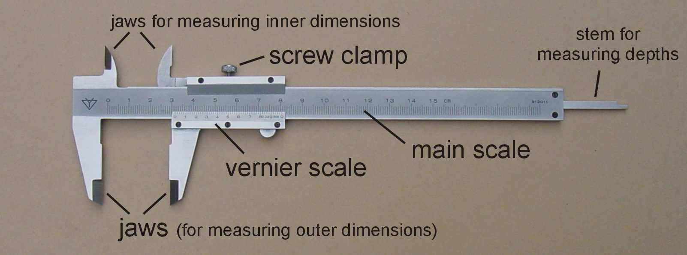**Using Verner Caliper**

The Vernier Caliper enables us to measure the length, the depth, inner and outer diameters of an object. The name Vernier refers to the special scale on the sliding jaw which gives reading to tenths of millimeter. The Vernier scale has different number of divisions which are slightly smaller than 1millimeter (actually 0 – 0.99 mm). This scale gives reading to 0.1 mm or 0.01mm.

Now, how can you read the scale?

1. Find an object to measure and close the jaws of the caliper until they just grip it. The main scale is usually numbered in centimeters but has millimeters divisions.
2. Read the main scale opposite the zero mark on the sliding jaw, obtaining a reading to 0.1 cm or 1mm accuracy.
3. To read the Vernier scale, look for the mark on the Vernier scale which exactly lines up with a mark on the main scale. The number of this mark on the Vernier scale is the reading for tenths of millimeters.
4. Read the following dimension of the shown Vernier caliper and write your reading in the space of each one:

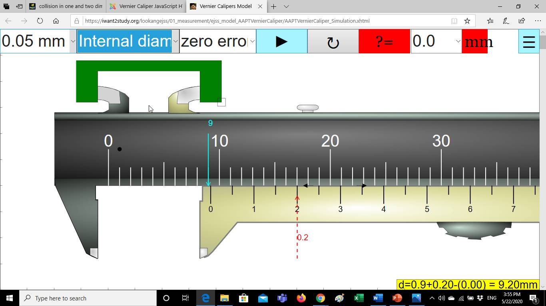

*The accuracy of the shown caliper is:……………*

*The instrumental error of the shown caliper is:……………….*

*The main scale reading =………….….*

*The Vernier scale reading =…..……..*

*The inner dimension of the shown object =……………….*

Measurement (1)

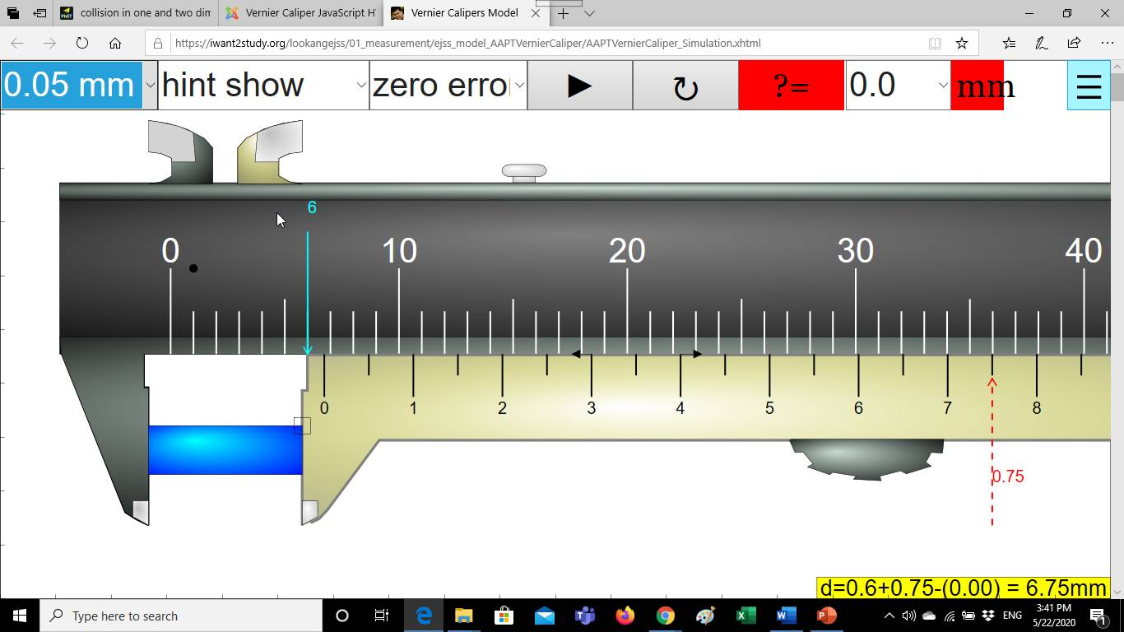

Measurement (2)

*The accuracy of the shown caliper is:……………*

*The instrumental error of the shown caliper is:……………….*

*The main scale reading =………….….*

*The Vernier scale reading =…..……..*

*The length of the shown cylinder =……………….*

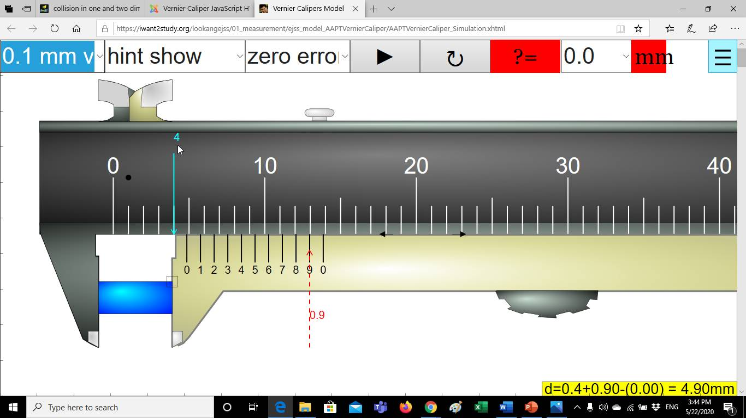

Measurement (3)

*The accuracy of the shown caliper is:……………*

*The instrumental error of the shown caliper is:……………….*

*The main scale reading =………….….*

*The Vernier scale reading =…..……..*

*The length of the shown cylinder =……………….*

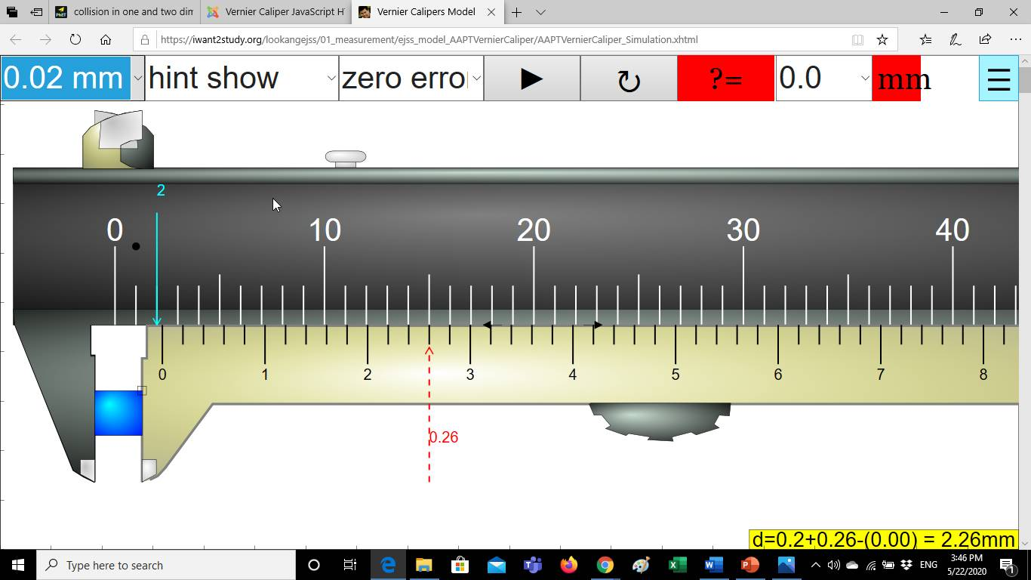

Measurement (4)

*The accuracy of the shown caliper is:……………*

*The instrumental error of the shown caliper is:……………….*

*The main scale reading =………….….*

*The Vernier scale reading =…..……..*

*The length of the shown cylinder =……………….*

**Part II**

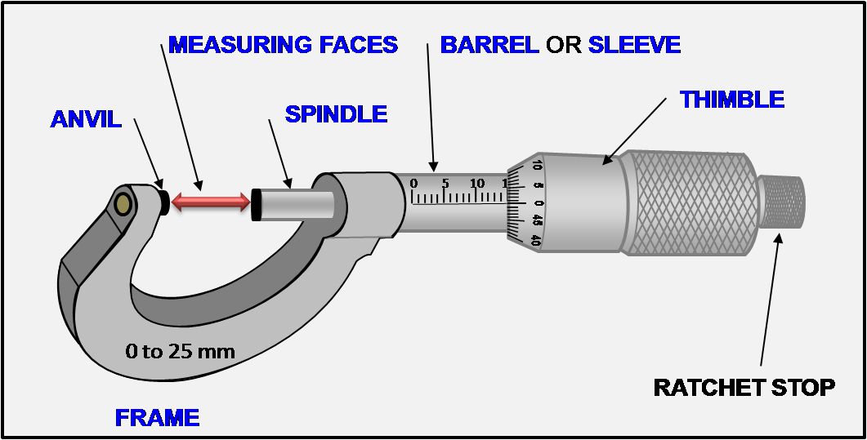**Using Micrometer**

How can you read the scale?

1. Hold the object between the open jaws and screw them closed using the ratchet.

The ratchet will slip when the grip of the jaws is just tight enough to give an accurate reading. The main scale, marked along the sleeve, is numbered in mm and has mm and 0.5 marks.

1. Read this scale at the edge of the thimble. The ratchet turns the rotating thimble, one revolution of which opens or closes the gap between the jaws by 0.5 mm. A scale which has 50 divisions, is marked around the edge of the thimble. In each complete revolution of the thimble it’s movement of 0.5 mm along the sleeve is divided into 50 parts. So, each division on the thimble scale is 0.01 mm (hundredths of millimeters).
2. Read the number of hundredths of millimeters on the thimble scale opposite the center line of the sleeve scale.

In the figure shown up, the sleeve scale reads 14 mm and the thimble scale reads 0.00 mm, so the diameter of the sphere is 14.0 + 0.00 = 14.00 mm.

1. Read the following dimension of the shown Micrometer and write your reading in the space of each one:

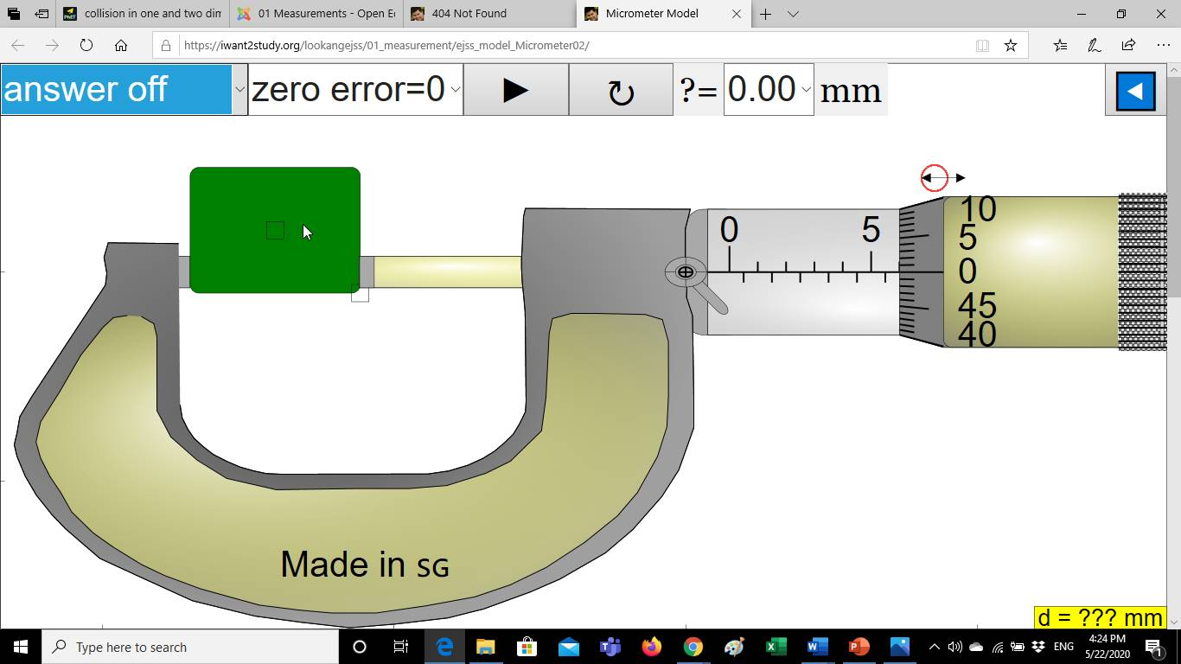

Measurement (1)

*The accuracy of the shown micrometer is:……………*

*The instrumental error of the shown mivrometer is:……………….*

*The main scale (sleeve) reading =………….….*

*The Vernier scale (thimble) reading =…..……..*

*The length of the shown object =……………….*

Measurement (2)

*The accuracy of the shown micrometer is:……………*

*The instrumental error of the shown mivrometer is:……………….*

*The main scale (sleeve) reading =………….….*

*The Vernier scale (thimble) reading =…..……..*

*The length of the shown object =……………….*

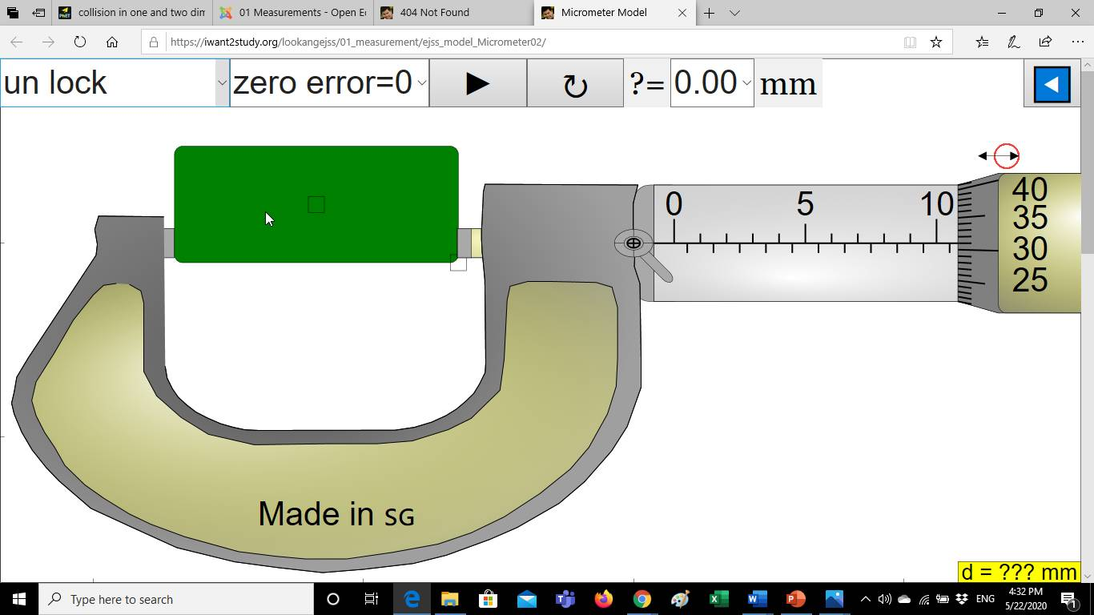

**Part III**

**Measurement of density**

Now we know well how to use the Vernier Caliper and the Micrometer to measure the length and the diameter of the cylinder and sphere. Return

back to equations (3) and (5), the quantities m, d, *l*, will be determined by measuring each of them four times independently and calculating the mean and the standard error for each quantity. Using the mean of each measured quantity in equation (3) leads to the best value for the measured density ρ.

In addition, the standard error in the density of the cylinder will be determined by the following equation:

$$Δρ = ±\overline{ρ}\sqrt{(\frac{∆m}{m})^{2}+(\frac{∆l}{l})^{2}+(\frac{2∆d}{d})^{2}} ………….(6)$$

And the standard error in the density of the Sphere will be determined by the following equation:

$$∆ρ=±ρ\sqrt{(\frac{∆m}{m})^{2}+(\frac{3∆d}{d})^{2} }…………….(7)$$

Use the data shown in table 1 to calculate the cylinder’s density and the data in table 2to calculate the sphere’s density.

1. The measurements of the masses of the two objects were taken using a laboratory balance and shown in table 1 (cylinder) and table 2 (Sphere).
2. Four separate trials of the length of the cylinder were measured using the Vernier caliper and shown in table 1.
3. The diameter at four different positions along the length of the cylinder were measured using the Micrometer and shown in table 1.
4. The diameter at four different positions along the surface of the sphere were measured using the Micrometer and shown in table 2.

***Cylinder Sphere***

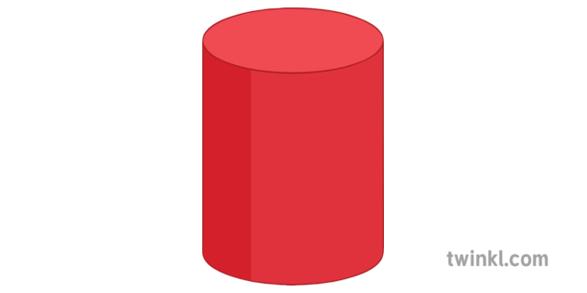

***Diameter***

***Length***

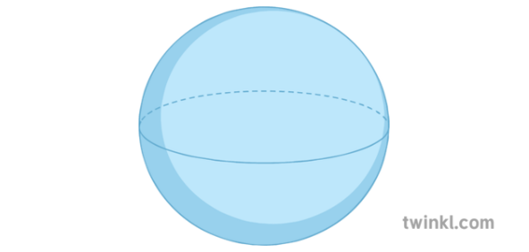

***Diameter***

|  |  |  |  |  |  |
| --- | --- | --- | --- | --- | --- |
| Table 1 | | Trial 1 | Trial 2 | Trial 3 | Trial 4 |
| **Cylinder**  **Material**  **( )** | *Mass (g)* | 84.4 | 84.5 | 84.4 | 84.3 |
| *Diameter (cm)* | 2.15 | 2.14 | 2.22 | 2.27 |
| *Length (cm)* | 3.15 | 3.10 | 3.00 | 3.15 |

|  |  |  |  |  |  |
| --- | --- | --- | --- | --- | --- |
| Table 2 | | Trial 1 | Trial 2 | Trial 3 | Trial 4 |
| **Sphere**  **Material**  **( )** | *Mass (g)* | 21.4 | 21.5 | 21.5 | 21.4 |
| *Diameter (cm)* | 3.07 | 3.09 | 3.12 | 3.12 |

**Calculations & Data analysis:**



1. Calculate the mean of length and diameter and the standard errors for both objects,

$\overline{l}\text{ ,}\overline{d}\text{ , }Δ\text{l , }Δd$.

1. Use equation (3) to calculate the density of the cylinder and equation (5) for the sphers’s density (*ρ)*.
2. Calculate the standard error of the density Δ*ρ*
3. Record your results in table 3.

**Table 3**



|  |  |  |  |  |  |  |  |  |  |
| --- | --- | --- | --- | --- | --- | --- | --- | --- | --- |
| ***Object*** | **( g )** | **( g )** | **(cm)** | **(cm)** | **(cm)** | **(cm)** |  |  |  |
| ***Cylinder*** |  |  |  |  |  |  |  |  |  |
| ***Sphere*** |  |  |  |  | **---------** | **---------** |  |  |  |

**Questions:**

1. A glass stopper has a volume of 16 cm3 and a mass of 40g. Calculate the density of glass in g/cm3 and in kg/m3.

………………………………………………………………………………………………….

………………………………………………………………………………………………….

………………………………………………………………………………………………….

.…………………………………………………………………………………………………

1. Calculate the percentage error in your experimental density of the cylinder, given that the real density of the cylinder is (8.96 g/cm3).

………………………………………………………………………………………………….

………………………………………………………………………………………………….

………………………………………………………………………………………………….

.…………………………………………………………………………………………………

1. Derive equation (3) in page (2)?

………………………………………………………………………………………………….

………………………………………………………………………………………………….

………………………………………………………………………………………………….

.…………………………………………………………………………………………………

1. How can you measure the density of non-uniform object?

………………………………………………………………………………………………….

………………………………………………………………………………………………….

………………………………………………………………………………………………….

1. The width of the object shown in the figure below is 7.86mm, is this reading correct or incorrect? Explain your answer.

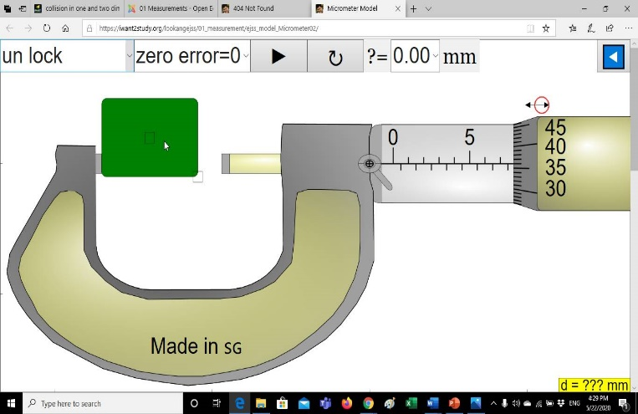

………………………………………………

………………………………………………

….…………………………………………...

…………………………….…………………

***True or False***

1. To measure the depth of a hollow object we use the rod at the end of the Vernier caliper. (the pink rod shown in the figure below). ……..

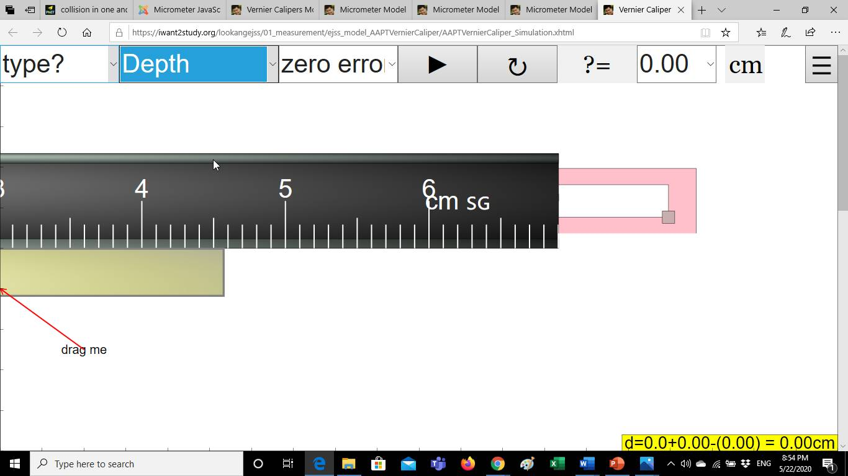

1. The reading shown below is zero. ……..

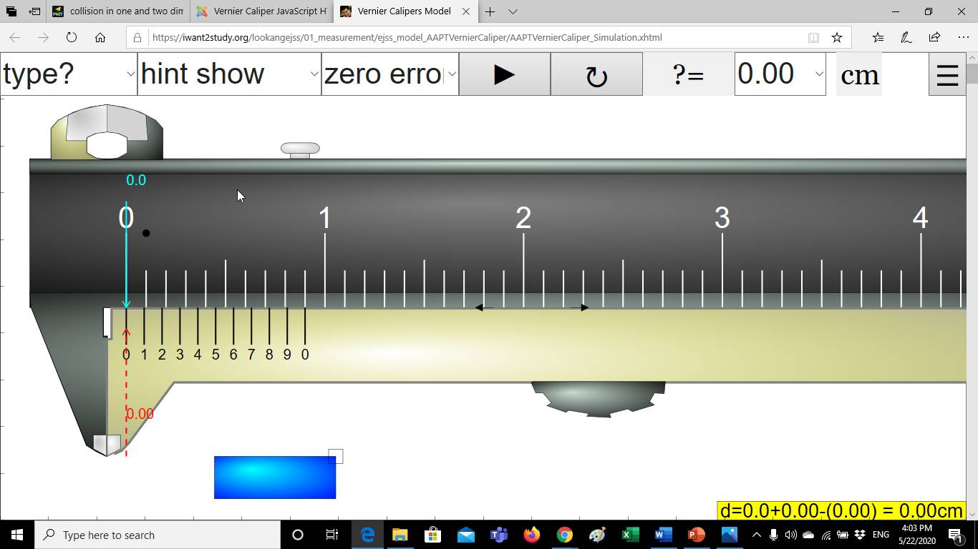

1. The reading 4.50mm shown on the micrometer is the thimble reading and the reading 0.22mm is the sleeve reading.……….

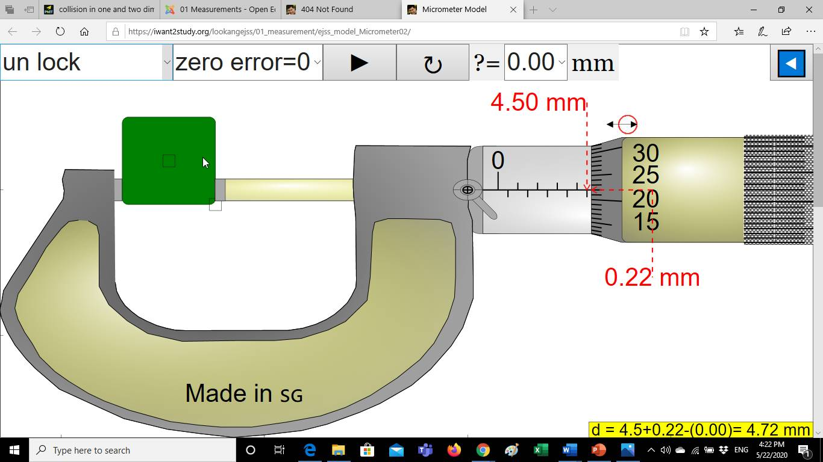

1. The reading of the shown Vernier caliper is 9.20mm.……..

