Topic
Projectile Motion

Learning objectives
- To explain the effect of gravity on projectile motion using concepts of forces and motion.
- To describe the horizontal and vertical components of the velocity of a projectile.
- To analyze horizontally-launched projectile cases using modelling technique [diagrammatic models, mathematical models (kinematic equations), or any set of explanatory rules/principles].
- To analyze angle-launched projectile cases using modelling technique [diagrammatic models, mathematical models (kinematic equations), or any set of predictive and explanatory rules/principles].

Important concepts
- Projectile motion is one type of two-dimensional motion under constant acceleration, where
a_{x} = 0
a_{y} = -g
- It is useful to think of projectile motion as the superposition of two motions:
- Constant-velocity motion in the x direction.
- Free-fall motion in the vertical direction subject to a constant downward acceleration of magnitude g = 9.80 m/s².

Note:
- Ignore air resistance in all cases.
- Take g = 9.80 m/s² at the Earth’s surface.
- Explain your answer to each of the questions using diagrams, equations, or any explanatory rules/principles.

Activity 1 (for Introduction)

- Two balls (balls A and B) are released simultaneously from the same height. Ball A is released from rest, while ball B is given an initial velocity component in the horizontal direction. Which hits the floor first?

Play with the simulation below:
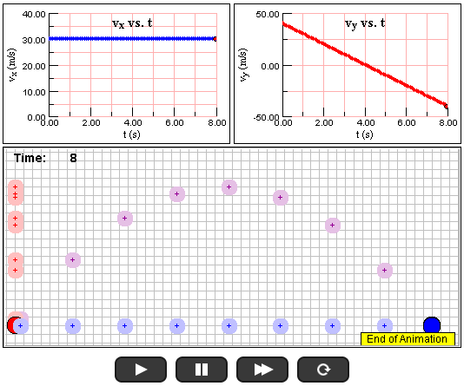
http://www.compadre.org/Physlets/mechanics/illustration3_4.cfm

Write down your scientific observation on the simulation above.

Check your answer to question 1 here:
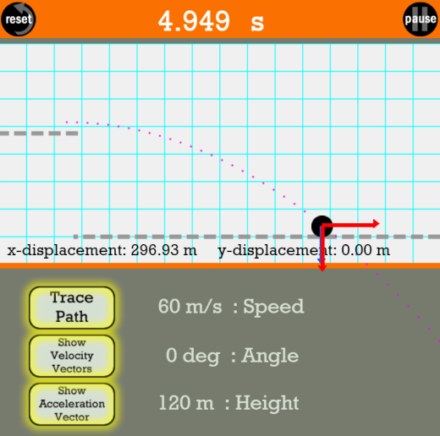
http://www.physicsclassroom.com/Physics-Interactives/Vectors-and-Projectiles/Projectile-Simulator/Projectile-Simulator-Interactive

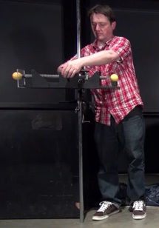
https://www.youtube.com/watch?v=zMF4CD7i3hg

Activity 2

- An archer shoots an arrow horizontally at 80 m/s. The bull’s eye on the target and the arrow are at the same height. If the target is 20 m from the archer, will the arrow hit the bull’s eye?
Note: Teacher may ask further questions
- How far below the bull's eye will the arrow hit the target?
- What are the variables that the archer needs to adjust so that the arrow will hit the bull’s eye?

- A man shoots an arrow with a speed of 11 m/s to hit an apple hanging from a tree a horizontal distance of 8 m away from him and a vertical distance of 2 m above the ground. If the arrow is released 1.7 m above the ground, what are the possible angles between the arrow and the horizontal such that the arrow will hit the apple?

Play with the simulations below:
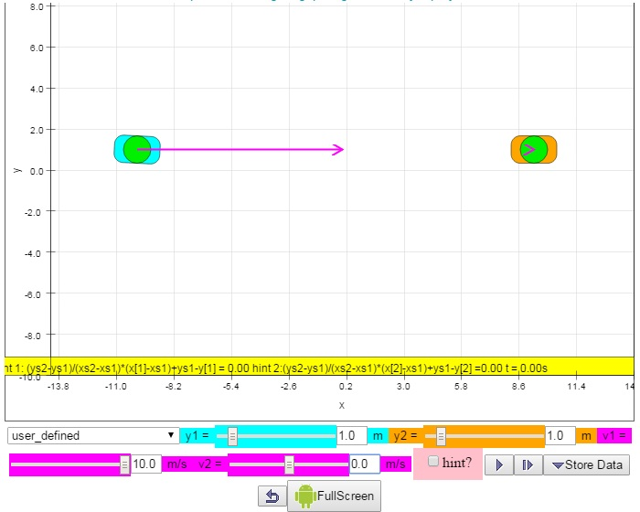 http://weelookang.blogspot.sg/2015/02/ejss-2-cannon-aim-at-each-other.html

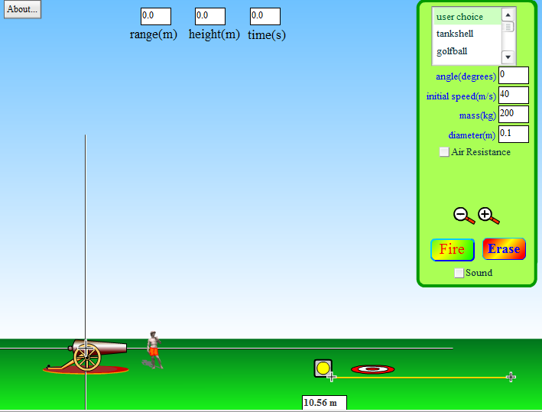
http://phet.colorado.edu/en/simulation/projectile-motion

Write down your scientific observation on the two simulations above.

Activity 3

- A man fires a projectile at a small stuffed monkey hanging from a tree. At the moment the projectile leaves the projectile launcher, the stuffed monkey drops straight down (hoping to avoid being hit). To hit the monkey, should the man aim high (over the monkey’s head), aim directly at the monkey, or aim low (below the monkey)?
Note: Teacher may ask further question
If the man aims directly at the stuffed monkey, will the projectile always hit the monkey, regardless of the initial speed of the projectile?

- A monkey jumps from the ground with an initial speed of 10 m/s. It jumps directly towards a peanut held by a tourist a horizontal distance of 3 m away and a vertical distance of 1.7 m above the ground. The tourist releases the peanut the instant the monkey jumps.
- Will the monkey catch the peanut?

- If the initial speed of the monkey is 5 m/s, will it catch the peanut?

- What is the minimal initial speed of the monkey in order to catch the peanut? [BONUS]

Play with the simulation below:
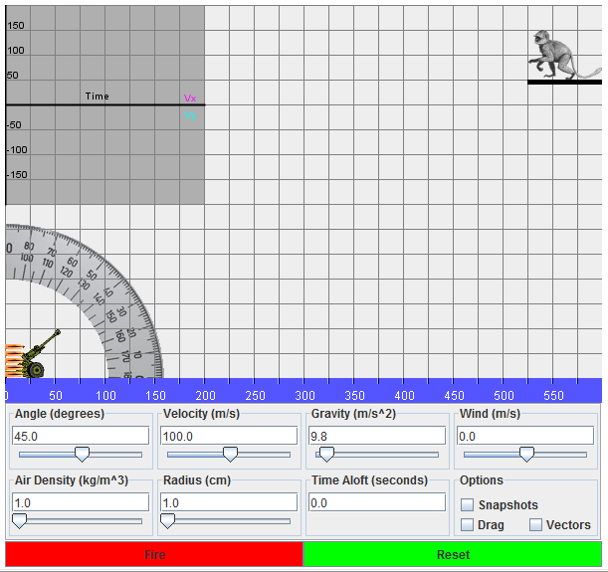
http://jersey.uoregon.edu/vlab/newCannon/NewCannon_plugin.html

Write down your scientific observation on the simulation above.

Check your answer to question 4 here:
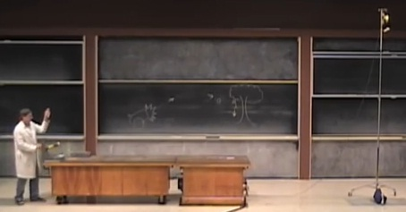
https://www.youtube.com/watch?v=cxvsHNRXLjw

