|  |  |  |
| --- | --- | --- |
| **Subject:** | **Physics - Secondary** | Time: 90 mins |
| **Worksheet Title:** | Kinematics of a Falling Ball – Tracker Video Analysis | |

**Aim**: To investigate the kinematics of a falling ball

**Apparatus**: Computer Lab with

Tracker by Prof. Douglas Brown, Workshop by Wee_Loo_Kang@moe.gov.sg

**Windows Installer Tool:** <http://www.cabrillo.edu/~dbrown/tracker/installers/Tracker-4.61-windows-installer.exe>

Webstart Tool : <http://www.cabrillo.edu/~dbrown/tracker/webstart/tracker.jnlp>

Tracker is free software; you can redistribute it and/or modify it under the terms of the [GNU General Public License](http://www.opensource.org/licenses/gpl-license.php)

**Internet Help**[*http://www.cabrillo.edu/~dbrown/tracker/tracker_help.pdf*](http://www.cabrillo.edu/~dbrown/tracker/tracker_help.pdf) *or* [*http://www.cabrillo.edu/~dbrown/tracker/help/frameset.html*](http://www.cabrillo.edu/~dbrown/tracker/help/frameset.html)

**Forum:**  [Kinematics of a Falling Ball using Tracker Video Analysis Physics Secondary](http://ictconnection.edumall.sg/cos/o.x?ptid=709&c=/ictconnection/forum&func=showthread&t=64)

**Video**  <http://www.youtube.com/watch?v=HfnXBDOhGE0&NR=1>

<http://jabryan.iweb.bsu.edu/videoanalysis/balldropbounce4x.avi>

<http://jabryan.iweb.bsu.edu/videoanalysis/ElasticI.avi>

<http://www.cabrillo.edu/~dbrown/tracker/mechanics_videos.zip>

**PD video** <http://www.youtube.com/watch?v=cuYJsnhWXOw>

<http://www.youtube.com/watch?v=WSG1x3klkH0>

## Background:

Concepts in mechanics which include speed, velocity, acceleration, force, gravitational field and energy conversion and conservation are explored in this lesson. Analysis of the motion of an object is performed using free-body and vector diagrams, graphical analysis as well as Mathematical formulas.

**Procedure**:

Setup

1. Launch the software tracker by double clicking on the [*tracker.jar*](http://www.cabrillo.edu/%7Edbrown/tracker/webstart/tracker.jar) file. The screen should look like this.

**File Open**

**Play**

**Clip Settings**

**Frame number**

**Axes**

**Tape Measure**

**Step back**

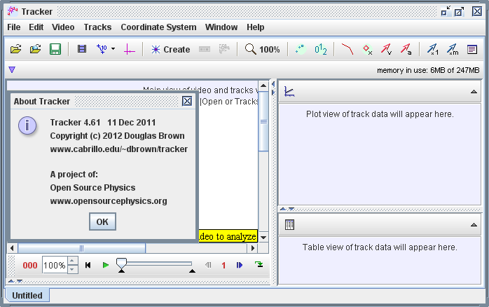

1. Click the Open button or File|Open menu item and select a QuickTime video (.mov) or tracker file (.trk) to open it. Import the video ballbouncelookang01_x264.mp4 and save the project as a filename of your choice for example balldropbounce4x_mpeg4_002.mp4.trk.



Select the display of the clip settings by clicking the **clip settings** button at the right end of the player as shown.

In the clip settings dialog, set the **Start** and **End** frames to define the range you wish to analyze. In this video, set start frame to be 2 while the end as default. Click on OK to proceed.

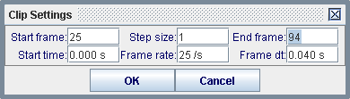

1. **Set the reference frame origin and angle.** Click the **Axes** button to show the coordinate axes. Drag the origin and/or x-axis to set the reference frame origin and angle. A common choice for the origin is the initial position of an object of interest.



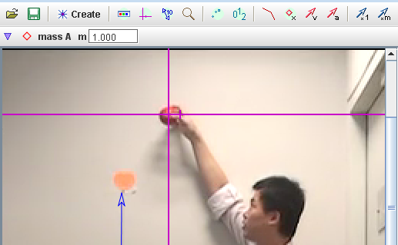

1. To **calibrate the scale on the video,** click the **Tape Measure** button to show the tape measure. For this video, the 1.000 m metre rule is on the video, move it to capture the length as in the video.



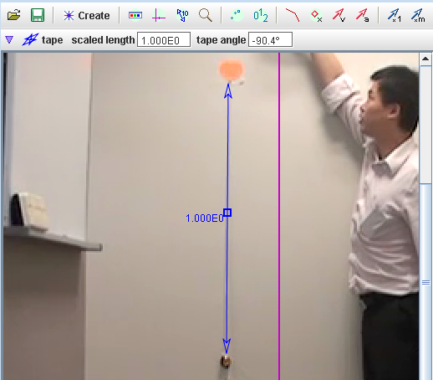

1. **Track objects of interest with the mouse or model them with particle models.** Click the **Create** button and choose a track type from the menu of choices. Most moving objects are tracked using a [**Point Mass**](http://www.cabrillo.edu/%7Edbrown/tracker/help/pointmass.html)**.**

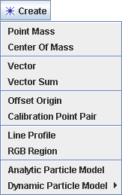

1. (optional) The ball maybe difficult to detect due to the quality of the frames, thus in this case, select the Video–Filters-Deinterlace-Even and close it after selection. This step may increase the visibility of the ball.
2. If tracking an object, mark its position on every frame by holding down the **shift key** and clicking the mouse (crosshair cursor) as the video automatically steps through the video clip. **Note**: don't skip frames--if you do, velocities and accelerations cannot be determined. Track the ball until end of frame. **Plot and analyze the tracks** The **Plot View** displays graphs of track data. To plot multiple graphs, click the **Plots** button and select the desired (3) plots number. Click the x- or y-axis label to change the variable plotted on that axis. In this video, choose y versus t, vy versus t & ay versus t.

+ mouse click

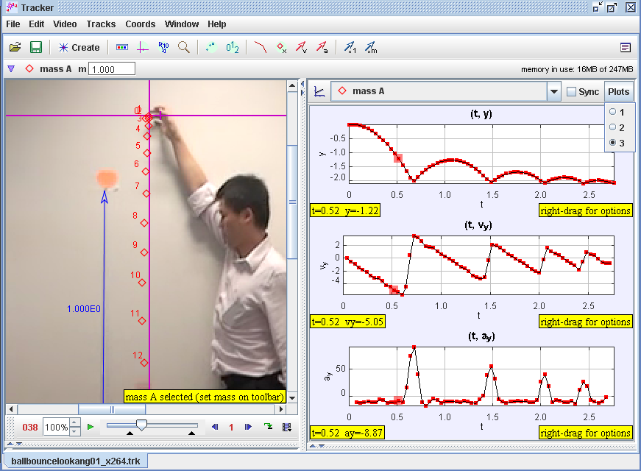

1. In your groups, discuss and make sense of the shape y versus t, vy versus t & ay versus t. Highlight one initial idea or learning point for each plot.

Y vs t , graph of displacement versus time of the bouncing ball, up as positive

vy vs t , graph of velocity in y direction versus time, as it hit the ground, velocity quickly become +

ay vs t graph of acceleration in y direction versus time, always -9.8 m/s^2 unless when hit ground then ay is a very large number.

1. 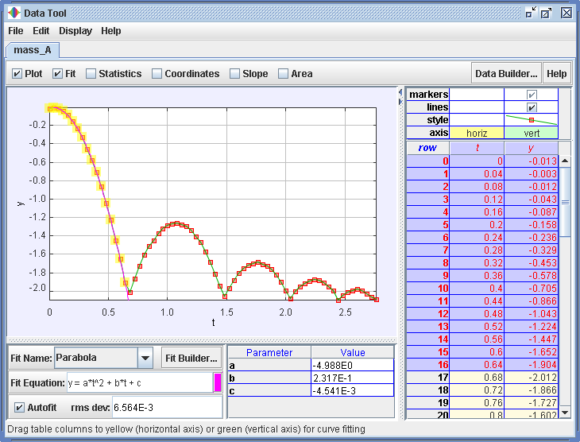Right-click on a plot (y versus t) to access display and analysis options in a popup menu. Select the various options as shown in the figure.
2. For time t =0 to 0.5 s, write down your values for the “Parabola” Fit Equation of the form y = a*t^2 + b*t + c, your data analysis values.

Coefficient parabola fit, a = ___-4.988______________ and units ___m/s^2_______

Coefficient parabola fit, b = ___0.2317______________ ____m/s_______

Coefficient parabola fit, c = ___0______________ ______m______

1. Hence by comparing to EOM s = u*t + 0.5*a*t2 or otherwise, suggest an equation for the graph of

y(t)= __0+ 0.2317*t + 0.5*(-9.976)*t^2______________________ and units _________m____ .

1. * Repeat Steps 9 to 11 for plot (vy versus t) and fill in the “Linear” Fit Equation of the form y = a*t + b. hint: EOM v = u + a*t

Coefficient of linear fit, a = __ -1.003E1 _______________ and units __m/s^2________

Coefficient of linear fit b = ____ 2.585E-1 ____________ ___ m/s________

1. * Hence or otherwise, suggest an equation for the graph of

vy(t)= ____ 2.585E-1 + -1.003E1*t______________________ and units ______m/s_______ .

1. 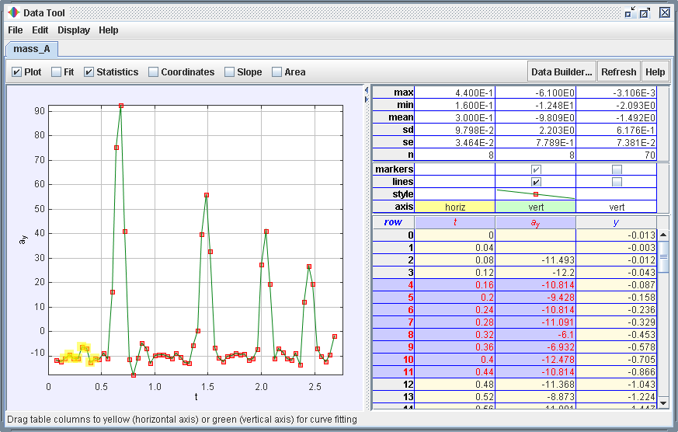Right-click on a plot (ay versus t) to access display and analysis options in a popup menu. Select the various options as shown in the figure.

What is the average values of ay=__-9.809E0___________ units _m/s^2__in your statistics mean?

Suggest with reason(s) what this value should be __gravitational field acceleration of Earth ~ -9.8 m/s^2 with positive y direction as upwards___________________?

Hint: acceleration of free fall for a body near to the Earth is constant and is  
approximately 10 m/s^2

((-9.976)+( -1.003E1)+( -9.809E0) )/3 = -9.94 m/s^2

* Name one assumption in this example’s determination of ay

The ruler in the video is correctly calibrated and measured in the tracker

* Calculate the percentage error in this value hint: use the average g.

(9.94 – 9.81)/9.81 = 1.3%

* Suggest with reason, what is random error here how to reduce the random error?

The human measurement of each position of the ball, consistently take the middle of the blur ball as reference.

* Suggest with reason, what could be a source of systemic error here and how to reduce the systemic error?

The ruler axes could be not vertically downwards in the direction of the gravitational field due to off axis video taken

The ruler could be off the calibrated length, need to recalibrate against longer length

1. What is the difference between velocity and speed, for example velocity in the y direction vy and speed in the y direction? Select one of the plot and define a new data function called “speed = sign(vy)*vy” or “speed = sqrt(vy*vy)” Compare the plot of speed |vy| and velocity vy and suggest the relationship between them.

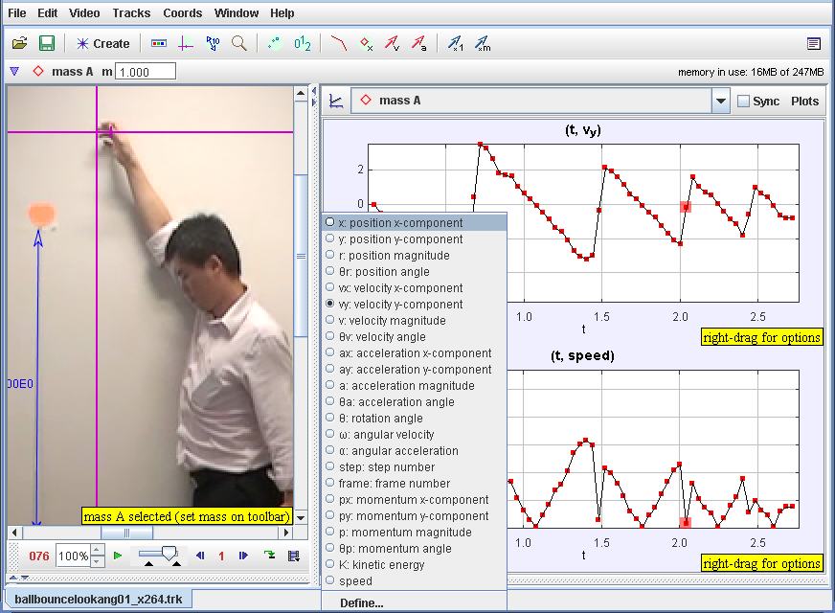

Velocity has direction and magnitude, example vy

Speed is only the magnitude of velocity, example |vy|

|vy| is the magnitude of vy only.

1. Calculate the average velocity for time t = 0 to 2.04 s (3 bounces) using displacement / time taken

From y vs t graph: -2.07/2.04= -1.0 m/s

From vy vs t graph by measuring area: -2.02/2.04= -1.0 m/s

1. Calculate the average speed for time t = 0 to 2.04 s (3 bounces) using distance travelled / time taken.

Hint: move the axes to the bottom of the floor may help in the reading of the different heights.

|((-2.07-0)|+ |(-1.24-(-2.07))*2| + |(-1.68-(-2.07))*2| / 2.04 = |-(2.07+0.83*2+0.39*2)|/3= |4.51|/3=

1.5 m/s

|((-1.98)|+ |0.731| +|(-0.753)| + |0.316|+ |-0.335| / 2.04 = 4.115/3= 1.4 m/s

1. State what is meant by uniform acceleration and indicate the range(s) of time when it can be approximately observed?

Uniform acceleration is constant magnitude and direction of rate of change of velocity

~0 to 0.56 s

1. From the video or otherwise, suggest an approximate time taken by the ball as the velocity change direction during the 1st rebound.

About 0.64 to 0.72 s

1. Hence, calculate the value of the acceleration during the 1st rebound using  
   change in velocity / time. Verify the greatest value of ay by reading off the ay versus t plot.

4.13-(-5.32)/ (0.72-0.64) = 118 m/s^2

Graph of ay versus t is 103 m/s^2

1. By taking a free body diagram of the ball during 1st rebound on the ground and using, Newton’s 2nd Law, F = m*a, calculate the greatest instantaneous contact force on the ball during impact. Hint: m = 0.026 kg

m*g

R

a

F = ma  R – (0.026)*(9.81) = 0.026*(103)  R = 34 N

1. * By taking a free body diagram of the ball during 1st rebound on the ground and using, Newton’s 2nd Law and assuming that the shape of ay versus t graph is approximately a triangle, hence or otherwise, calculate the average contact force on the ball during impact. Hint: m = 0.026 kg

ave R = R/2 = 17 N

1. Indicate part of the motion of the bouncing ball where acceleration in non-uniform.

About 0.64 to 0.72 s

1. * Give 2 examples of non-uniform acceleration that you can illustrate (can be real world example that you have encounter).

Circular motion

At the moment of the bounce of a ball

1. Right click on the plot of vy versus t and select Analyze-Area and select by click and drag the 2 grey vertical boundaries to select the area to measure for the duration of start of motion to the start of 1st bound of the ball. Calculate the area under a velocity-time graph.

Drag the grey lines

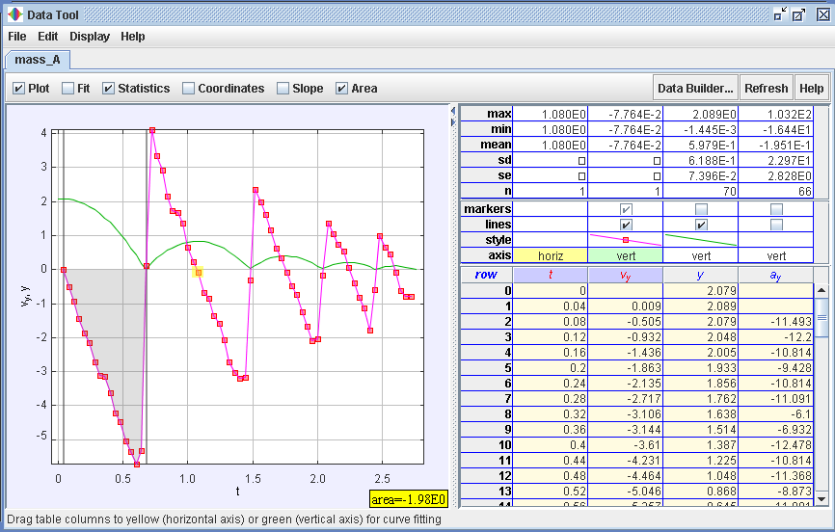

the area under a velocity-time graph from t = 0 to 2.04 s is -1.98 m

1. *How is the area under a velocity-time graph related to change in displacement?

Area under a velocity-time graph = change in displacement

1. 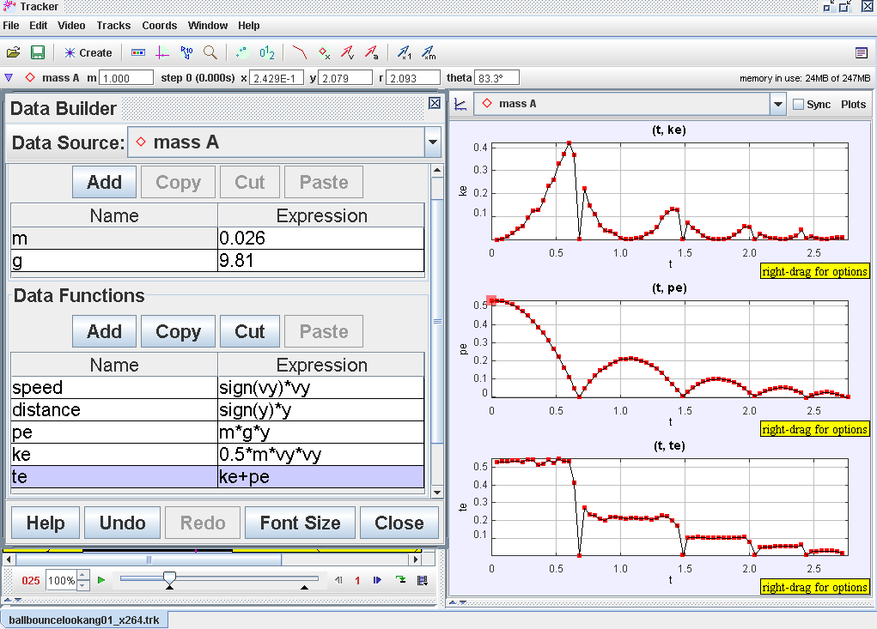By defining potential energy, kinetic energy and total energy, hence show the analysis as shown.
2. Suggest what evidence(s) indicate that the total energy is conserved and for which part of the motion?

The total energy is conserved when the ball is moving in the air without bouncing on the ground

1. Calculate the percentage total energy loss for the 1st rebound and suggest what happened to the total energy loss? hint: think about energy conversion

TE loss = ((-0.219) – (0.54))/ 0.54 = 0.59

Converted to other energy like heat and sound

1. Now click and drag the axes of the World View at any y position. What did you observe? What conclusion(s) can you draw about the determination of potential energy with respect to a reference level?

The PE is arbitrary set depending on the reference level (axes of y )

Please email [WEE_Loo_Kang@moe.gov.sg](mailto:WEE_Loo_Kang@moe.gov.sg) to improve the lesson

Post your *.trk file (may need to zip it first) on the ICT connection discussion forum [http://ictconnection.edumall.sg/cos/o.x?ptid=709&c=/ictconnection/forum&func=forumdisplay&id=47](http://ictconnection.edumall.sg/cos/o.x?ptid=709&c=/ictconnection/forum&func=forumdisplay&id=47%20) if you need help with this tracker tool.