Name: \_\_\_\_\_\_\_\_\_\_\_\_\_\_\_\_\_\_\_\_\_\_\_\_\_\_\_\_\_\_\_ ( ) Class: \_\_\_\_\_\_\_\_\_\_\_\_\_\_ Date: \_\_\_\_\_\_\_\_\_\_

|  |  |  |
| --- | --- | --- |
| **Kinematics of a Falling Ball**  *Student’s Handout* | | |
| **Topic:** Kinematics |  | **Estimated Duration:** 2 hours |

* **Aim**To describe the motion of an object falling under gravity in terms of the graphs of its displacement and velocity with respect to time.
* **Description**

A ball is launched vertically upwards by a person’s hand (Figure 1). It eventually reaches a maximum height before falling back to the ground. *Note: upwards motion is taken as positive and downwards motion is taken as negative in this exercise.*

Positive direction



Figure 1

* **Key Questions**
* How do the graphs of motion of the ball tell us when it changes direction?
* How do the graphs of motion of the ball tell us when it is speeding up or slowing down?
* How is the displacement-time graph of the ball related to its velocity-time graph?
* **Materials**
* Worksheets
* Tracker software from <http://www.cabrillo.edu/~dbrown/tracker/>   
  Materials such as sample videos and Beginners’ Guide can also be found on the website.
* Video clip of ball thrown upwards

(From the above website, download “mechanics\_video.zip” from “Sample Videos”. Locate and save the video “BallTossUp” onto your computer desktop.)

|  |
| --- |
| **(A) Displacement-time graph** |

Displacement is the distance moved in a particular direction. The displacement of the ball changes continuously with time.

* **Instructions/Procedure**

**Setup**

1. Launch the software tracker by double clicking on the [*tracker.jar*](http://www.cabrillo.edu/%7Edbrown/tracker/webstart/tracker.jar) file. The screen should look like this.  
     
   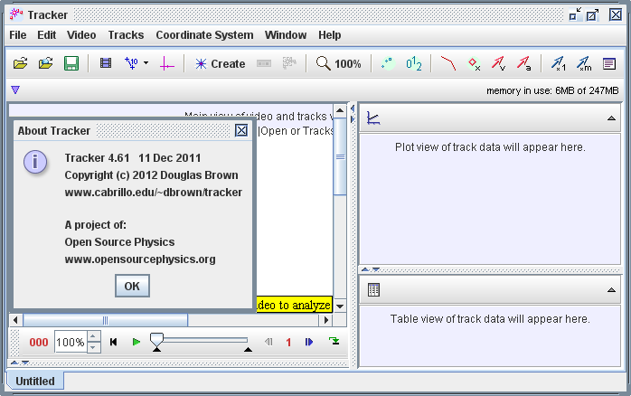

**Play**

**Frame number**

**Axes**

**Step back**

**Tape Measure**

**File Open**

**Clip Settings**

1. Click the **Open** button Open buttonor File|Open menu item and select the video “BallTossUp” from the desktop.
2. **Select the display of the clip settings** by clicking the **clip settings** button . In the clip settings dialog, set the **Start** and **End** frames to define the range you wish to analyze. In this video, set the start frame to be “14” and end frame as “39” as shown below. Click on “OK” to proceed.

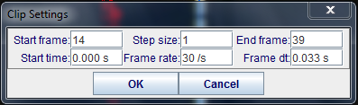

1. **Set the reference frame origin and angle.** Click the **Axes** button Tape measure buttonOpen buttonto show the coordinate axes. Drag the origin and/or x-axis to set the reference frame origin and angle. A common choice for the origin is the initial position of an object of interest.

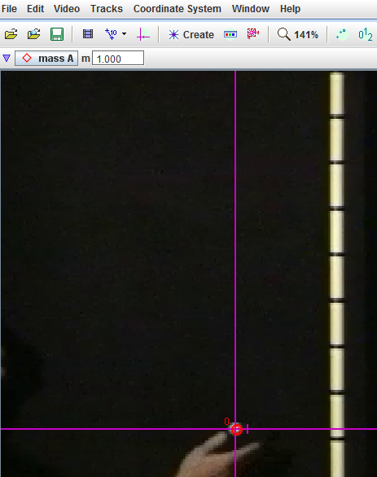



initial position

1. To **calibrate the scale on the video,** click the **Tape Measure** button  Open buttonto show the tape measure. For this video, the 1.000 m metre rule is on the video, move it to capture the length as in the video.



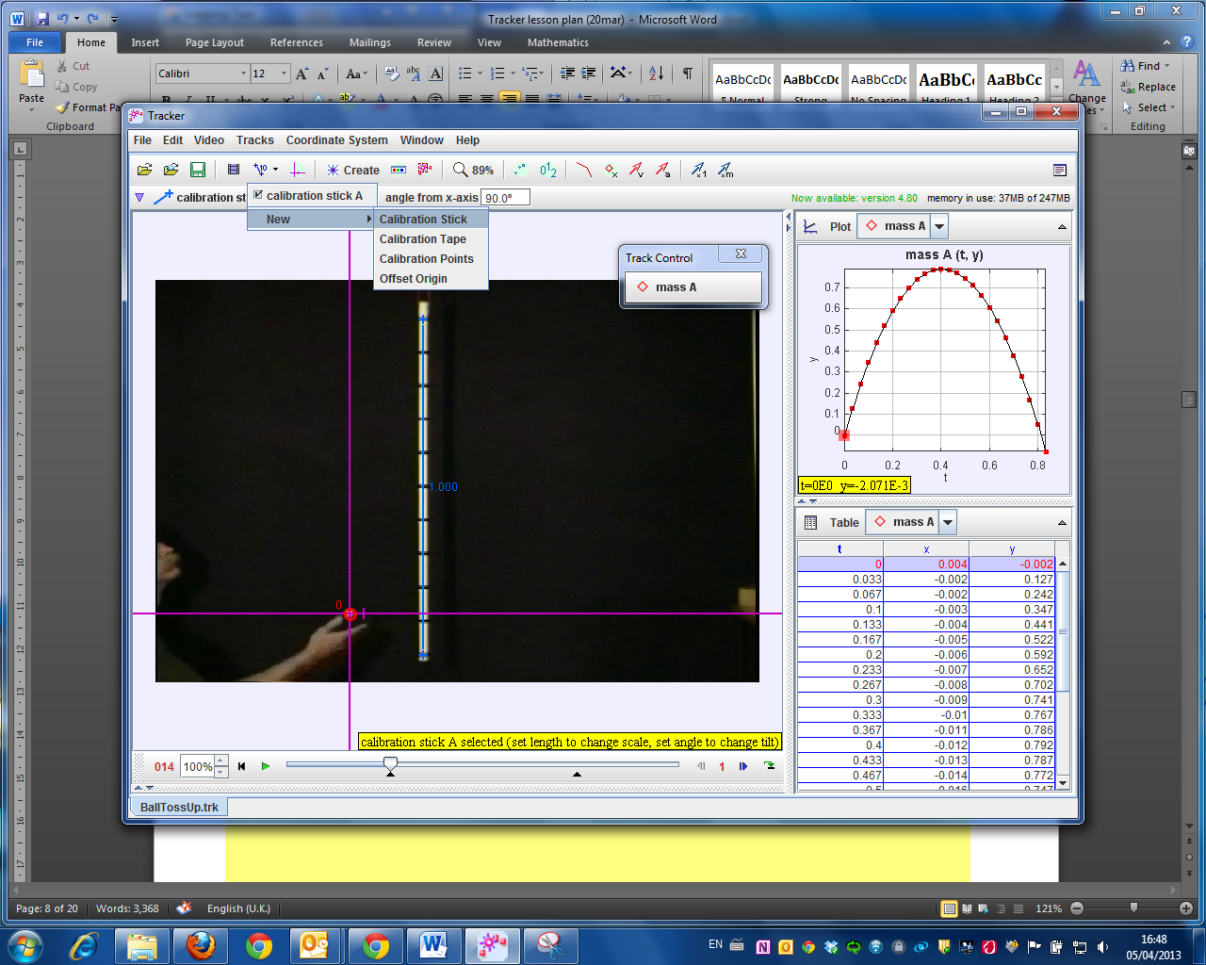

1. **Track objects of interest with the mouse or model them with particle models.** Click the **Create** button create_buttonOpen buttonand choose a track type from the menu of choices. Most moving objects are tracked using a [**Point Mass**](http://www.cabrillo.edu/%7Edbrown/tracker/help/pointmass.html)**.**

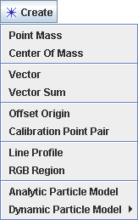

1. (optional) The ball maybe difficult to detect due to the quality of the frames, thus in this case, select the “Video|Filters|New|Deinterlace|Even” and close it after selection. This step may increase the visibility of the ball.

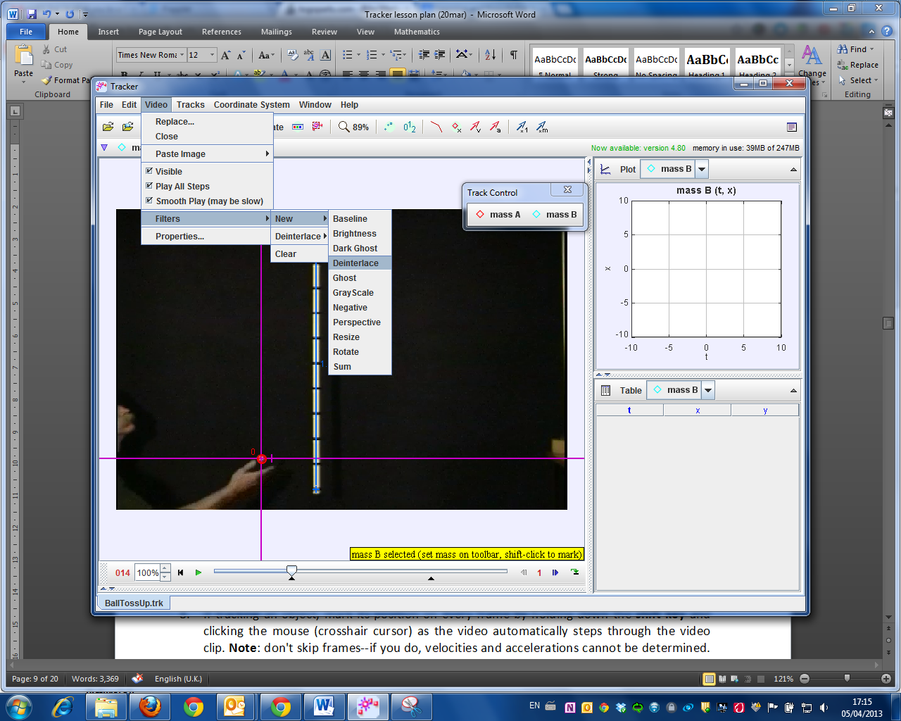

1. When tracking an object, mark its position on every frame by holding down the **shift key** and clicking the mouse (crosshair cursor) as the software automatically steps through the video clip. **Note**: don't skip frames--if you do, velocities and accelerations cannot be determined. Track the ball until end of frame.

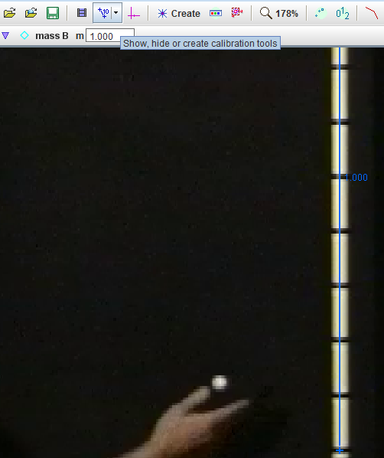



+ Mouse click

Mouse over and click on object to be tracked

1. **Plot and analyze the tracks.** The **Plot View** displays graphs of track data. To plot multiple graphs, click the **Plots** button  and select the desired (2) plots number.

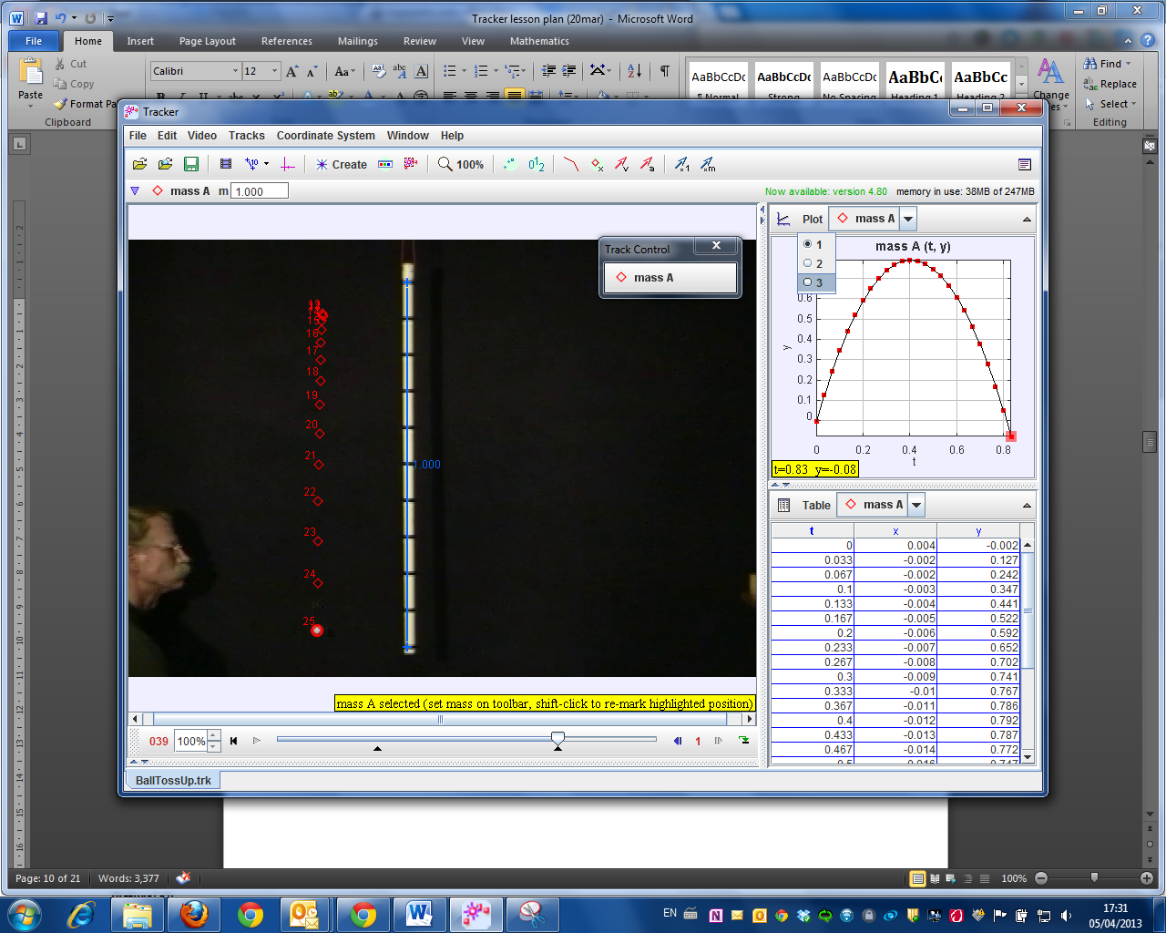

Select 3 Plots

1. Click the x- or y-axis label to change the variable plotted on that axis. In this video, choose *y* versus *t* and *vy* versus *t*.

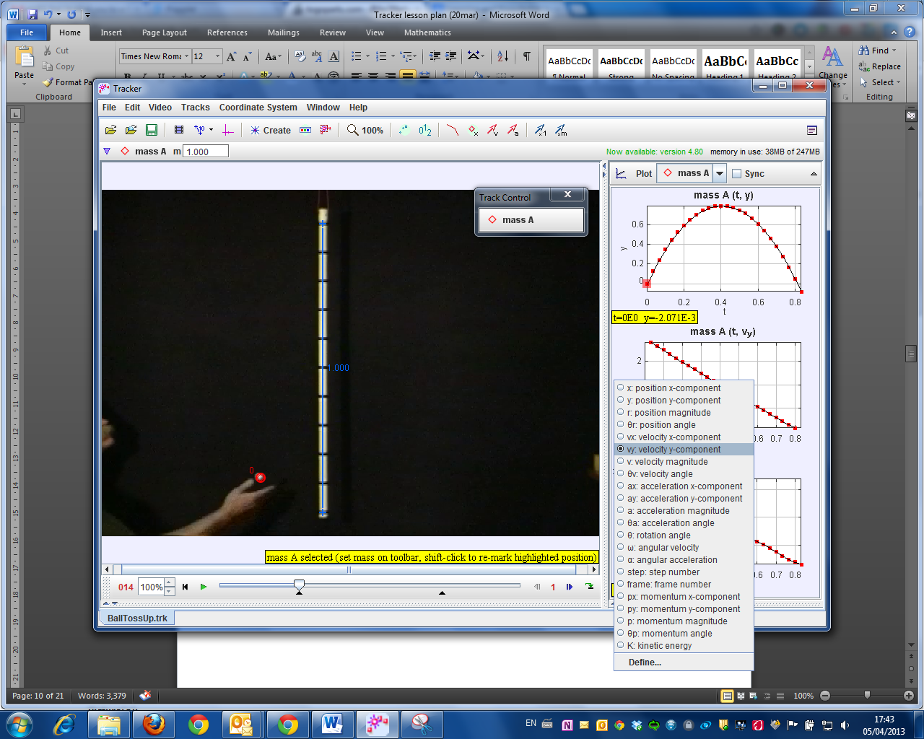

|  |
| --- |
| **Results (Displacement-time graph)** |

Sketch the displacement-time (**y-t**) graph obtained in the space provided.

Displacement

Time

Figure 2

|  |
| --- |
| **Analysis (Displacement-time graph)** |

Review and analyse the video clip to answer the following questions.

1. **Direction of motion and gradient of a displacement-time graph**
   1. Mark the *region* of the displacement-time graph (Figure 2) which shows
      1. The ball moving upwards (label this region **A**)
      2. The ball moving downwards (label this region **C**)

*Hint: Analyse the frames of the video clip to determine the ball’s direction of motion and use the time codes to help you determine which time intervals correspond to* **A** *and* **C***.*

* 1. Complete the table below, indicating whether the gradient of **A** and **C** is “positive” or “negative”.

|  |  |  |
| --- | --- | --- |
| **Region** | **Direction of motion** | **Gradient of displacement-time graph** |
| **A** | The ball is moving upwards (in the positive direction as shown in figure 1) |  |
| **C** | The ball is moving downwards (in the negative direction) |  |

* 1. What can you say about the direction of an object’s motion and the gradient of its displacement-time graph?

\_\_\_\_\_\_\_\_\_\_\_\_\_\_\_\_\_\_\_\_\_\_\_\_\_\_\_\_\_\_\_\_\_\_\_\_\_\_\_\_\_\_\_\_\_\_\_\_\_\_\_\_\_\_\_\_\_\_\_\_\_\_\_\_\_\_\_\_\_\_\_\_\_\_\_\_\_\_\_\_\_\_\_\_\_\_\_\_\_\_\_\_\_\_\_\_\_\_\_\_\_\_\_\_\_\_\_\_\_\_\_\_\_\_\_\_\_\_\_\_\_\_\_\_\_\_\_\_\_\_\_\_\_\_\_\_\_\_\_\_\_\_\_\_\_\_\_\_\_\_\_\_\_\_\_\_\_\_\_\_\_\_\_\_\_\_\_\_\_\_\_\_\_\_\_\_\_\_\_\_\_\_\_\_\_\_\_\_\_\_\_\_\_\_\_\_\_\_\_\_\_\_\_\_\_\_\_\_\_\_\_\_\_\_\_\_\_\_\_\_\_\_\_\_\_

* 1. Mark a point on the displacement-time graph (Figure 2) which shows the ball changing direction (label this point **B**).

1. **Velocity of a moving object and gradient of a displacement-time graph**
   1. Is the gradient of the displacement-time graph (Figure 2) increasing or decreasing in region **A**? From the video, does the ball speed up or slow down during this time?

\_\_\_\_\_\_\_\_\_\_\_\_\_\_\_\_\_\_\_\_\_\_\_\_\_\_\_\_\_\_\_\_\_\_\_\_\_\_\_\_\_\_\_\_\_\_\_\_\_\_\_\_\_\_\_\_\_\_\_\_\_\_\_\_\_\_\_\_\_\_\_\_\_\_\_

* 1. Is the gradient of the displacement-time graph (Figure 2) increasing or decreasing in region **C**? From the video, does the ball speed up or slow down during this time?

\_\_\_\_\_\_\_\_\_\_\_\_\_\_\_\_\_\_\_\_\_\_\_\_\_\_\_\_\_\_\_\_\_\_\_\_\_\_\_\_\_\_\_\_\_\_\_\_\_\_\_\_\_\_\_\_\_\_\_\_\_\_\_\_\_\_\_\_\_\_\_\_\_\_

* 1. What can you say about an object’s velocity and the gradient of its displacement-time graph?

\_\_\_\_\_\_\_\_\_\_\_\_\_\_\_\_\_\_\_\_\_\_\_\_\_\_\_\_\_\_\_\_\_\_\_\_\_\_\_\_\_\_\_\_\_\_\_\_\_\_\_\_\_\_\_\_\_\_\_\_\_\_\_\_\_\_\_\_\_\_\_\_\_\_\_

* 1. Describe the gradient at point **B** and hence state the instantaneous velocity of the object at **B**.

\_\_\_\_\_\_\_\_\_\_\_\_\_\_\_\_\_\_\_\_\_\_\_\_\_\_\_\_\_\_\_\_\_\_\_\_\_\_\_\_\_\_\_\_\_\_\_\_\_\_\_\_\_\_\_\_\_\_\_\_\_\_\_\_\_\_\_\_\_\_\_\_\_\_\_

1. **Summary for displacement-time graph**

Using the blocks below, construct a flow chart to show how the 4 displacement-time graphs of moving objects below could be obtained. You can use each grey block more than once.

Increasing gradient

In which direction is the body moving?

Positive gradient

Negative gradient

Does it speed up or slow down?

Decreasing gradient

Start

End

**Flow chart for sketching displacement-time graph of a moving object:**

|  |
| --- |
| **(B) Velocity- time graph** |

The velocity of the ball changes with time because it experiences acceleration due to the Earth’s gravitational pull. In this section, we will illustrate the ball’s velocity with respect to time in a graphical manner.

|  |
| --- |
| **Results (Velocity-time graph)** |

Sketch the velocity-time (**v-t**) graph obtained in the space provided.

Velocity

Time

Figure 3

|  |
| --- |
| **Analysis (Velocity-time graph)** |

Review and analyse the video clip to answer the following questions.

1. **Direction of motion and the velocity-time graph of an object**
   1. Mark the *region* of the velocity-time graph (Figure 3) which shows
      1. the velocity values are all positive. Label this region **A**.
      2. the velocity values are all negative. Label this region **C**.
   2. In which direction is the ball moving during the time intervals represented by regions **A** and **C**? *(Hint: you can review the video clip frame by frame to determine its direction of motion during the time intervals corresponding to* **A** *and* **C***.)*

\_\_\_\_\_\_\_\_\_\_\_\_\_\_\_\_\_\_\_\_\_\_\_\_\_\_\_\_\_\_\_\_\_\_\_\_\_\_\_\_\_\_\_\_\_\_\_\_\_\_\_\_\_\_\_\_\_\_\_\_\_\_\_\_\_\_\_\_\_\_\_\_\_\_\_\_\_\_\_\_\_\_\_\_\_\_\_\_\_\_\_\_\_\_\_\_\_\_\_\_\_\_\_\_\_\_\_\_\_\_\_\_\_\_\_\_\_\_\_\_\_\_\_\_\_\_\_\_\_\_\_\_\_\_\_\_\_\_\_\_\_\_\_\_\_\_\_\_\_\_

* 1. Mark on the velocity-time graph (Figure 3), a point where the graph intersects the horizontal (time) axis. Label this point **B**.
  2. What is the velocity of the ball at point **B**?

\_\_\_\_\_\_\_\_\_\_\_\_\_\_\_\_\_\_\_\_\_\_\_\_\_\_\_\_\_\_\_\_\_\_\_\_\_\_\_\_\_\_\_\_\_\_\_\_\_\_\_\_\_\_\_\_\_\_\_\_\_\_\_\_\_\_\_\_\_\_\_\_\_\_\_

* 1. Observe the video and describe what happens to the ball at this point.

\_\_\_\_\_\_\_\_\_\_\_\_\_\_\_\_\_\_\_\_\_\_\_\_\_\_\_\_\_\_\_\_\_\_\_\_\_\_\_\_\_\_\_\_\_\_\_\_\_\_\_\_\_\_\_\_\_\_\_\_\_\_\_\_\_\_\_\_\_\_\_\_\_\_\_

1. **Velocity of a moving object and the velocity-time graph**
   1. In region **A**, does the velocity-time graph (Figure 3) move towards or away from the horizontal axis (representing zero velocity) as time passes? Does the object speed up or slow down during this time interval?

\_\_\_\_\_\_\_\_\_\_\_\_\_\_\_\_\_\_\_\_\_\_\_\_\_\_\_\_\_\_\_\_\_\_\_\_\_\_\_\_\_\_\_\_\_\_\_\_\_\_\_\_\_\_\_\_\_\_\_\_\_\_\_\_\_\_\_\_\_\_\_\_\_\_\_\_\_\_\_\_\_\_\_\_\_\_\_\_\_\_\_\_\_\_\_\_\_\_\_\_\_\_\_\_\_\_\_\_\_\_\_\_\_\_\_\_\_\_\_\_\_\_\_\_\_\_\_\_\_\_\_\_\_\_\_\_\_\_\_\_\_\_\_\_\_\_\_\_\_\_

* 1. In region **C**, does the velocity-time graph (Figure 3) move towards or away from the horizontal axis (representing zero velocity) as time passes? Does the object speed up or slow down during this time interval?

\_\_\_\_\_\_\_\_\_\_\_\_\_\_\_\_\_\_\_\_\_\_\_\_\_\_\_\_\_\_\_\_\_\_\_\_\_\_\_\_\_\_\_\_\_\_\_\_\_\_\_\_\_\_\_\_\_\_\_\_\_\_\_\_\_\_\_\_\_\_\_\_\_\_\_\_\_\_\_\_\_\_\_\_\_\_\_\_\_\_\_\_\_\_\_\_\_\_\_\_\_\_\_\_\_\_\_\_\_\_\_\_\_\_\_\_\_\_\_\_\_\_\_\_\_\_\_\_\_\_\_\_\_\_\_\_\_\_\_\_\_\_\_\_\_\_\_\_\_\_

* 1. What does the shape of the velocity-time graph (Figure 3) tell you about the change in velocity of the ball as time passes?

\_\_\_\_\_\_\_\_\_\_\_\_\_\_\_\_\_\_\_\_\_\_\_\_\_\_\_\_\_\_\_\_\_\_\_\_\_\_\_\_\_\_\_\_\_\_\_\_\_\_\_\_\_\_\_\_\_\_\_\_\_\_\_\_\_\_\_\_\_\_\_\_\_\_\_\_\_\_\_\_\_\_\_\_\_\_\_\_\_\_\_\_\_\_\_\_\_\_\_\_\_\_\_\_\_\_\_\_\_\_\_\_\_\_\_\_\_\_\_\_\_\_\_\_\_\_\_\_\_\_\_\_\_\_\_\_\_\_\_\_\_\_\_\_\_\_\_\_\_\_

1. **Summary for displacement-time and velocity-time graphs**

Given that the regions **A, B** and **C** from the velocity-time graph (Figure 3) correspond with the regions **A, B** and **C** from the displacement-time graph (Figure 2), complete the table below.

|  |  |  |  |  |
| --- | --- | --- | --- | --- |
| **Region** | **Direction of motion** | **Velocity (Positive, Negative or Zero)** | **Gradient of displacement-**  **time graph (Positive, Negative or Zero)** | **Position of velocity-**  **time graph (Above, Below or Intersecting the horizontal axis)** |
| A | Upwards |  |  |  |
| B | Change direction |  |  |  |
| C | Downwards |  |  |  |

1. **Extension questions**

Figure 4 below shows the velocity-time graphs of a ball in 3 different scenarios. Graph **Z** shows the ball thrown upwards on the surface of the Earth. Which graph is a result of

* 1. throwing the same ball upwards with larger force? Explain your answer.

\_\_\_\_\_\_\_\_\_\_\_\_\_\_\_\_\_\_\_\_\_\_\_\_\_\_\_\_\_\_\_\_\_\_\_\_\_\_\_\_\_\_\_\_\_\_\_\_\_\_\_\_\_\_\_\_\_\_\_\_\_\_\_\_\_\_\_\_\_\_\_

* 1. throwing the same ball upwards on the surface of the moon? Explain your answer.

\_\_\_\_\_\_\_\_\_\_\_\_\_\_\_\_\_\_\_\_\_\_\_\_\_\_\_\_\_\_\_\_\_\_\_\_\_\_\_\_\_\_\_\_\_\_\_\_\_\_\_\_\_\_\_\_\_\_\_\_\_\_\_\_\_\_\_\_\_\_\_

\_\_\_\_\_\_\_\_\_\_\_\_\_\_\_\_\_\_\_\_\_\_\_\_\_\_\_\_\_\_\_\_\_\_\_\_\_\_\_\_\_\_\_\_\_\_\_\_\_\_\_\_\_\_\_\_\_\_\_\_\_\_\_\_\_\_\_\_\_\_\_

Velocity

0

time

**Y**

**Z**

**X**

Figure 4

|  |  |  |  |  |
| --- | --- | --- | --- | --- |
| **Kinematics – Analysis of free-fall motion**  *Teacher’s notes* | | | | |
| **Stream:** Exp/NA |  | **Topic:** Kinematics |  | **Estimated Duration:** 2 hours |

* **Description of activity**

Students will use the Tracker software to analyse a video clip of a ball thrown upwards. They will make connections between changes in speed and direction of the ball with computer-generated graphs of its displacement and velocity with respect to time.

* **Key Ideas**
* The change in displacement and velocity of a moving object with respect to time can be described graphically.
* Displacement and velocity are vector quantities which have magnitude and direction.
* **Key Questions**
* How do the graphs of motion of the ball tell us when it changes direction?
* How do the graphs of motion of the ball tell us when it is speeding up or slowing down?
* How is the displacement-time graph of the ball related to its velocity-time graph?
* **Aim**

Students will understand changes in position, speed and direction of a moving object in terms of its displacement and velocity-time graphs. The tracker software is used as it allows real-time analysis of the motion of a moving object.

* **Objectives**
  + **Related Syllabus Learning Outcomes**
* Plot and interpret a displacement-time graph and a velocity-time graph
* Deduce from the shape of a displacement-time graph when a body is:
* at rest
* moving with uniform velocity
* moving with non-uniform velocity
* Deduce from the shape of a velocity-time graph when a body is:
* at rest
* moving with uniform velocity
* moving with uniform acceleration
  + **Skills and Processes**

Students will *analyze* the displacement and velocity-time graphs of the ball and make *deductions* about its speed and direction.

* + **21CC**

**ICS – Management of Information, CIT – Decision-making**

Students are to:

* Utilize technology appropriately to extract relevant information about the motion of ball.
* Develop well-constructed explanations by analyzing the video clip of the ball’s motion and making comparison to its graphs of motion.
* Extend or modify their thinking so as to their adapt explanations and make predictions about unfamiliar contexts.
* Collaborate with others using ICT tools to communicate their ideas about motion.
* **Prior knowledge required**

Students should be able to:

State what is meant by displacement, velocity and acceleration.

* **Materials**
  + Worksheets
  + Tracker software from <http://www.cabrillo.edu/~dbrown/tracker/>
  + Video clip of ball thrown upwards

(From the above website, download “mechanics\_video.zip” from “Sample Videos”. Locate and save the video “BallTossUp” onto the students’ desktops)

* **Suggested lesson guide**

| Assessment indicators | **LESSON ACTIVITY** | Pedagogical Considerations |
| --- | --- | --- |
|  | **Introduction**  **Introduction**   * Ask a student to demonstrate the simple action of throwing a ball vertically up into the air (figure 1 in worksheet). * Teacher facilitates a class discussion asking students to describe the motion of the ball. Encourage students to unpack the term ‘motion’, e.g. in terms of position, speed, rate of change of speed, direction etc. * Inform students that there are many models to represent or communicate the motion of a moving object (qualitatively, mathematically or graphically). The aim of the lesson is to introduce graphical representation of motion using ICT tools. | Introduce to students the purpose of learning kinematics – models and language for describing motion of objects (qualitatively, mathematically and graphically). The use of tracker allows real time analysis of movement of the object. |
| *Evidence of learning is shown when students are able to…*  Deduce from a displacement-time graph the change in direction and velocity of an object.  Deduce from a velocity-time graph the change in direction and velocity of an object.  Draw connections between a displacement-time and velocity-time graph. | **Lesson Development**  **(A) Displacement-time graphs**   * Teacher will guide students in using the Tracker software to analyze the video clip and obtain the displacement–time (**y-t**) and velocity-time (**v-t**) graphs of the ball. * Students sketch the **y-t** graph on their worksheet and work in their groups / facilitated by teacher to discuss Questions 1 – 3: * Q1: students explore how the displacement-time graph can be used to indicate the direction of motion of an object and if the object has changed direction. * Q2: students explore how the displacement-time graph represents the speeding up and slowing down of an object. * Qn 3 summarises the concepts in the form of a graphic organizer (Note: Teachers can choose to add the “start” bubble and the first “decision rhombus” to provide some guidance for students). | Graphic organisers are a pictorial way of constructing knowledge and organizing information. They convey complex information in a simple-to-understand manner.   1. Students **give priority to** **evidence** when they are given data and guided to analyse it. 2. Students **construct explanations** when they are guided in the process of formulating explanations from evidence. 3. Students evaluate their explanations when they are provided with **connections**. 4. Students **communicate** and justify their explanations when they are provided guidelines for communication. |
| **(B) Velocity-time graphs**   * Students sketch the **v-t** graph on their worksheet and work in their groups / facilitated by teacher to discuss questions 4 – 7: * Q4: students explore how the **v-t** graph indicates the change in direction of an object. * Q5: students investigate how the **v-t** graph represents the speeding up and slowing down of an object. * Qn 6 summarises the relationship between the direction of motion and its representation on a **y-t** graph and **v-t** graph * In Q7, the activity is extended to include discussion the implications of the action of a force on the v-t graph. |
|  | **Lesson Closure**   * The teacher engages class in a discussion on the possible sources of errors in this investigation. Possible prompts to students:   + Accuracy: Will distance be correctly represented in the video if the camera angle is slanted? Is the number of frames (samples) per second enough to accurately represent the motion of the ball?   + Validity: Can we assume that the ball is falling only under the influence of gravity? (negligible air resistance) * Teacher uses the flowchart in Section (A) and table in section (B) to summarise how the displacement and velocity-time graphs can be used to represent motion. | This investigation offers opportunities for students to explore sources of errors and ascertain the meaning of “sources of errors” from the process. |

* **Suggested Solutions**

|  |
| --- |
| **Analysis (Displacement-time graph)** |

Review and analyse the video clip to answer the following questions.

1. **Direction of motion and gradient of a displacement-time graph**
   1. Complete the table below, indicating whether the gradient of **A** and **C** is “positive” or “negative”.

|  |  |  |
| --- | --- | --- |
| **Region** | **Direction of motion** | **Gradient of displacement-time graph** |
| A | The ball is moving upwards (in the positive direction as shown in figure 1) | Positive |
| C | The ball is moving downwards (in the negative direction) | Negative |

* 1. What can you say about the direction of an object’s motion and the gradient of its displacement-time graph?

When an object moves in the positive direction, the gradient of its displacement-time graph is positive.

When an object moves in the negative direction, the gradient of its displacement-time graph is negative.

1. **Velocity of a moving object and gradient of a displacement-time graph**
   1. Is the gradient of the displacement-time graph (Figure 2) increasing or decreasing in region **A**? From the video, does the ball speed up or slow down during this time?

The gradient decreases. Ball slows down.

* 1. Is the slope of the displacement-time graph (Figure 2) becoming steeper or gentler in region **C**? From the video, does the ball speed up or slow down during this time?

The gradient increases. Ball speeds up.

* 1. What can you say about an object’s velocity and the gradient of its displacement-time graph?

An object with a greater velocity will have a larger gradient on its displacement-time graph.

* 1. Describe the gradient at point **B** and hence state the instantaneous velocity of the object at **B**?

It does not have a gradient. Hence the instantaneous velocity of the ball at **B** is zero.

1. **Summary for displacement-time graph**

Using the blocks below, construct a flow chart to show how the 4 displacement-time graphs of moving objects below could be obtained. You can use each grey block more than once.

Increasing gradient

In which direction is the body moving?

Positive gradient

Negative gradient

Does it speed up or slow down?

Decreasing gradient

Start

End

**Flow chart for sketching displacement-time graph of a moving object**

Start

In which direction is the body moving?

Negative

Positive

Negative gradient

Positive gradient

Does it speed up or slow down?

Does it speed up or slow down?

Speeds up

Slows down

Speeds up

Slows down

Decreasing gradient

Increasing gradient

Increasing gradient

Decreasing gradient

End

End

End

End

|  |
| --- |
| **Analysis (Velocity-time graph)** |

Review and analyse the video clip to answer the following questions.

1. **Direction of motion and the velocity of an object**
   1. In which direction is the ball moving during the time intervals represented by regions **A** and **C**? *(Hint: you can review the video clip frame by frame to determine its direction of motion during the time intervals corresponding to* **A** *and* **C***.)*

Region A: Upwards (positive)

Region C: Downwards (negative)

* 1. What is the velocity of the ball at point **B**?

Zero

* 1. Observe the video and describe what happens to the ball at this point.

Changes direction

1. **Velocity of a moving object and the velocity-time graph**
   1. In region **A**, does the velocity-time graph (Figure 3) move towards or away from the horizontal axis (representing zero velocity) as time passes? Does the object speed up or slow down during this time interval?

It approaches the horizontal axis. It slows down.

* 1. In region **C**, does the velocity-time graph (Figure 3) move towards or away from the horizontal axis (representing zero velocity) as time passes? Does the object speed up or slow down during this time interval?

It moves away from the horizontal axis. It speeds up.

* 1. What does the shape of the velocity-time graph (Figure 3) tell you about the change in velocity of the ball as time passes?

The straight line graph indicates that the ball’s change in velocity per unit time is uniform. It undergoes uniform acceleration.

1. **Summary for displacement-time and velocity-time graphs**

Given that the regions **A, B** and **C** from the velocity-time graph (Figure 3) correspond with the regions **A, B** and **C** from the displacement-time graph (Figure 2), complete the table below.

|  |  |  |  |  |
| --- | --- | --- | --- | --- |
| **Region** | **Direction of motion** | **Velocity (Positive, Negative or Zero)** | **Gradient of displacement-**  **time graph (Positive, Negative or Zero)** | **Position of velocity-**  **time graph (Above, Below or Intersecting the horizontal axis)** |
| A | Upwards | Positive | Positive | Above the horizontal axis |
| B | Change direction | Zero | Zero | Intersecting the horizontal axis |
| C | Downwards | Negative | Negative | Below the horizontal axis |

1. **Extension questions**

Figure 4 below shows the velocity-time graphs of a ball in 3 different scenarios. Graph **Z** shows the ball thrown upwards from the surface of the Earth. Which graph is a result of

* + 1. throwing the same ball upwards with a larger force? Explain your answer.

**X**. The ball will have larger initial velocity.

* + 1. throwing the same ball upwards from the surface of the moon? Explain your answer.

**Y.** The gravitational pull on the moon is weaker than on the Earth. Hence the rate of change of the ball’s velocity decreases.

Velocity

0

time

**Y**

**Z**

**X**

Figure 4

* **References**

The Tracker software, sample videos and Beginners’ Guide for Tracker <http://www.cabrillo.edu/~dbrown/tracker/>

* **Acknowledgement**

This lesson package is crafted in collaboration with Educational Technology Division (Learning Partnership in Educational Technology Branch)