|  |  |  |  |  |
| --- | --- | --- | --- | --- |
| **Newton’s Third Law**  *Trigger Activity* | | | | |
| **Stream:** Express |  | **Topic:** Dynamics |  | **Estimated Duration:** 20 min |

This trigger uses the pedagogy of concept cartoons, which is a useful tool for teachers to uncover common preconceptions in students. Teachers could use this to spark off rich discussion about Newton’s Third Law, starting with the identification of action-reaction pairs of forces acting on two interacting bodies.

**Material:**

Concept Cartoons (Appendix I – pages 2 and 3)

|  |  |
| --- | --- |
| **Description of activity** | **Pedagogical and Assessment Considerations** |
| 1. Students form groups and discuss the cartoons in their groups. They have to identify the character/s with the best answer and explain why they feel the other character/s is/are wrong. 2. The teacher move around during the group discussion to pick out underlying preconceptions and identify groups to present ideas.  (An example of a common preconception:   - Unaware of the fact that action-reaction pairs of forces act on mutually opposite bodies.)   1. The groups identified share their ideas with the rest of the class. The class’ preconceptions can be summarised using a table drawn on the whiteboard to facilitate further discussion. 2. Teacher can choose to address the preconceptions immediately or to address them at strategic points as the topic progresses. | Concept cartoons provide opportunities for students voice their ideas and preconceptions, while lessening their fear of voicing their own opinions, as the ideas are from the cartoon characters.  Principle of Learning #1: Engaging Prior Understanding. Concept cartoons provide teachers with opportunities to identify students’ pres as they explain their agreement or disagreement with the cartoon characters’ viewpoints.  Summarising the preconceptions collectively first instead of addressing them one by one reduces the pressure on the presenting groups.  See “Recommendations for subsequent part of lesson” (pages 4 and 5) on ideas to address preconceptions. |

**Plucking your eye lashes**

**Appendix I**

Meiling, Peter and Aisha are discussing about the forces in interaction when a pair of tweezers pulls on an eyelash. Who do you agree with?

Eye lash

Tweezers

Eye lid

**Forces involved**

1. Tweezers pull on eyelash (trying to pluck it out)
2. Eyelids pulls on eyelash (trying to prevent it from being plucked out)
3. Eyelash pulls on the tweezers (holding back the tweezers)
4. Eyelash pulls on the eyelids (producing the sensation of pain)

**The action force is (A):**

Tweezers pull on eyelash

**Produces a reaction (B):**

Eyelids pull on the eyelash

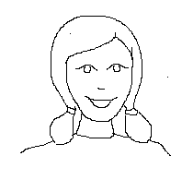

Aishah

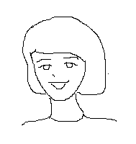

Meiling

**The action force is (B):**

Eyelids pull the eyelash

**Produces a reaction (D):**

Eyelash pulls on the eyelids

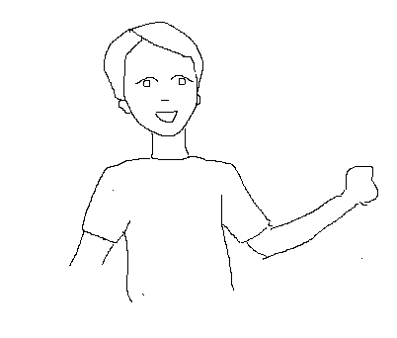

Peter

**The action force is (A):**

Tweezers pull on eyelash

**Produces a reaction (C):**

Eyelash pulls on the tweezers

**Nail in the wall**

**Appendix I (cont’d)**

Weiming uses a claw-hammer to remove a nail from the wall. He discusses the forces interacting between the hammer and the nail with Mary and Devi. Who would you agree with?

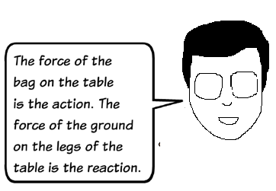

**C:\Users\S7835031H\AppData\Local\Microsoft\Windows\Temporary Internet Files\Content.IE5\OGAALTAL\MC900290591[1].wmf**

**Weiming**

**The action due to the:**

Pulling force of hammer on the nail

**Produces a reaction, which is the:**

Force of nail pulling back on the hammer

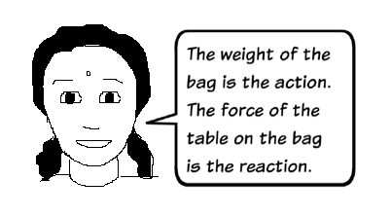

**Devi**

**The action due to the:**

Pulling force of hammer on the nail

**Produces a reaction, which is the:**

Force of wall holding back on the nail

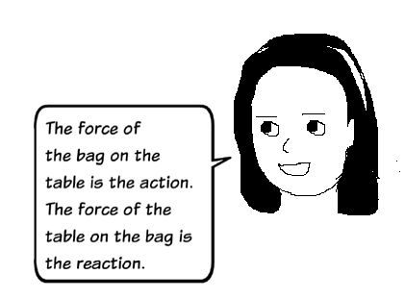

**The action due to the:**

Force of nail pulling on the wall

**Produces a reaction, which is the:**

Force of wall pulling back on the nail

**Mary**

* **Recommendation for subsequent part of the lesson**

**Part A – Further questions to deepen concept using the concept cartoons**

For each figure, identify

1. How many pairs of objects are there?
2. Which of these pairs of objects exert a force on each other?
3. What is the action-reaction force for each pair of objects?

Magnet

C:\Users\S7835031H\AppData\Local\Microsoft\Windows\Temporary Internet Files\Content.IE5\OGAALTAL\MC900389488[1].wmf

Iron nail

C:\Users\S7835031H\AppData\Local\Microsoft\Windows\Temporary Internet Files\Content.IE5\OGAALTAL\MC900391152[1].wmf

Wall

Figure 1

Suggested response

1. Iron nail and Magnet

Wall and Iron nail

Wall and Magnet

1. Iron nail and Magnet

Wall and Iron nail

1. For Iron Nail and Magnet pair

*Action: Force of Magnet on Nail*

*Reaction: Force of Iron Nail on Magnet*

For Wall and Iron nail pair

*Action: Force of Iron Nail on Wall*

*Reaction: Force of Wall on Iron Nail*

Wall

Iron Nail

C:\Users\S7835031H\AppData\Local\Microsoft\Windows\Temporary Internet Files\Content.IE5\OGAALTAL\MC900389488[1].wmf

The Earth

Figure 2

Suggested response

1. Iron nail and Earth

Iron nail and Wall

Wall and Earth

1. Iron nail and Earth

Iron nail and Wall

Wall and Earth

1. For Iron Nail and Earth

Action: Force of Earth on Iron Nail (Weight of Nail)

Reaction: Force of Iron Nail on Earth

For Wall and Iron nail pair

Action: Force of Iron Nail on Wall

Reaction: Force of Wall on Iron Nail

For Wall and Earth

Action: Force of Earth on Wall (Weight of Wall)

Reaction: Force of Wall on Earth

**Part B – Other concepts to consider**

After students are comfortable in identifying the action-reaction pairs acting on two interacting bodies, other aspects of Newton’s Third Law can be discussed e.g.

* When one object exerts a force on a second object, the second object exerts an equal and opposite force on the first.
* Identification of action-reaction forces in cases involving non-contact forces.
* **Notes for teachers**

Possible preconceptions in subsequent lessons:

* It is not possible for objects of different size and strength to exert equal forces on each other.
* Non-contact forces such as gravitational force cannot be action-reaction forces. Action-reaction forces require the objects to be in contact.
* **References**Naylor S., Keogh B, (2000). Concept Cartoons in Science Education. Miligate House Publishers.