Identify gas by analysing the emission line spectrum with tracker
Objective: This activity allow the entire class to identify several gas emission spectrum
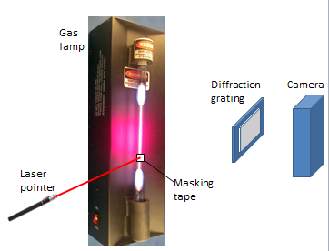
Apparatus: Various gas lamp (with their labelled covered so that students cannot just lead off the label to identify the lamp), diffraction grating (600 lines/mm; more lines is better though lesser lines will also work), laser pointer of known wavelength (Typically red, green, blue laser has wavelength of 633, 532 and 473 nm respectively, camera (can be phone camera), retort stand, masking tape
- Tape a piece on masking tape on tube of the gas lamp.
- Clamp a laser pointer such that the beam shines continuously on the masking tape.
- Place a diffraction grating between the camera and the lamp.
- Take photo of spectrum through the diffraction grating (ensure that the camera is horizontal and perpendicular to the light)
- Repeat step 1 to 4 using several gas lamps.

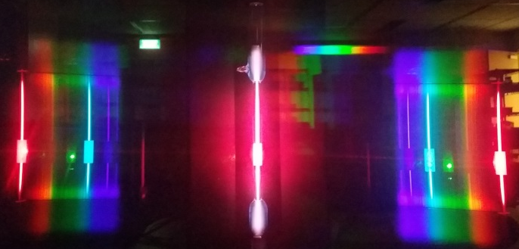
- Copy the photo to a computer with tracker software.
- Drag the photo into tracker software.
- Collect data of the intensity and wavelength of the light.
- Click on to show the axes.
- Drag the axes to the central bright fringe.
- Click on to create the calibration stick
- Drag the 2 ends of the calibration stick to the 2 laser dots.
- Double click the number and key in the twice the wavelength of the laser (eg. 633 nm will be keyed in as 1.266e-6).
- Click on to create line profile.
- Hold on the shift-key and drag from the left end of the spectrum to the right end of the spectrum (If you click the points inaccurately, you can drag the ends to the correct position).
- Key in the spread as 30 to take the average intensity of the photo over a wider region
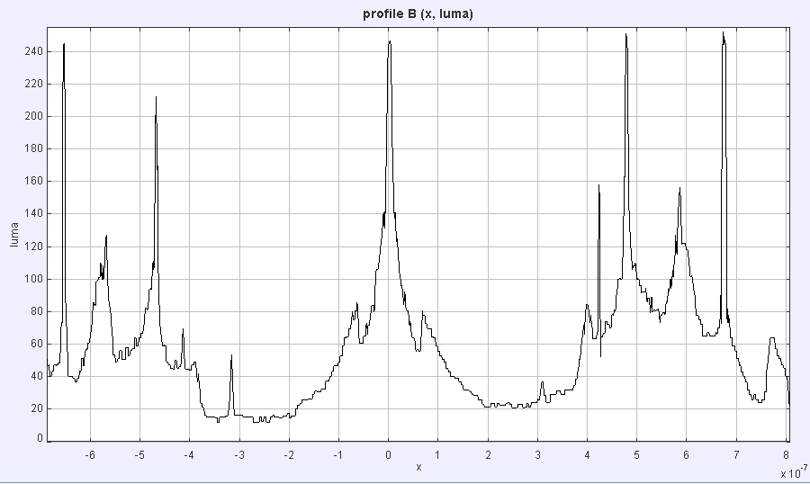
- The graph of the intensity against wavelength will be plotted.
- Click and hold on any peaks to collect the wavelength of the peaks.

- Compare it with the table below to identify the gas. (The 6 highest peaks are arranged in descending intensity are shown here. For complete data, please refer to: http://astro.u-strasbg.fr/~koppen/discharge/)

Gas | λ/nm |  | Gas | λ/nm |  | Gas | λ/nm |  | Gas | λ/nm |  | Gas | λ/nm
Hydrogen | 656 |  | Argon | 697 |  | Mercury | 436 |  | Neon | 585 |  | Helium | 588
 | 486 |  |  | 707 |  |  | 405 |  |  | 618 |  |  | 447
 | 434 |  |  | 715 |  |  | 577 |  |  | 439 |  |  | 707
 | 410 |  |  | 435 |  |  | 546 |  |  | 640 |  |  | 502
 |  |  |  | 476 |  |  | 579 |  |  | 422 |  |  | 588
 |  |  |  | 488 |  |  | 615 |  |  | 438 |  |  | 668
You may also find the visual comparison useful.

Hydrogen

Argon

Mercury

Helium

Neon
- Repeat for all the photos and identify all the gas lamps.

………………………………………………………………………………………………………………………………………………

- Suggest the sources of errors

………………………………………………………………………………………………………………………………………………

………………………………………………………………………………………………………………………………………………
Teacher notes (not to be printed)
Errors discussion:
Some of the lines wavelengths are very close to each other and their combined intensity may end up being higher than a higher intensity peak.
It’s assume that the angle is small enough for sin θ to be θ.
Perspective errors due to tilting the camera may lead to error.
Most cameras are most sensitive to green than other colours leading to a higher intensity near to green.
The masking tape and the gas lamp are not in the same plane and hence the angle may vary slightly.

