Name: ___________________________ ( ) Class: ___________ Date: _____________

|  |  |  |  |  |
| --- | --- | --- | --- | --- |
| **Sources of Electrical Energy**  *Trigger Activity (Student Handout)* | | | | |
| **Stream:** Express |  | **Topic:** Practical Electricity |  | **Estimated Duration:** 15 min |

This activity helps students to make connections between various energy sources and the process of generation of electricity. Using a concept map, students will compare the differences and similarities in the electricity generation process when different energy sources (nuclear source and fossil fuels) are used at the start of the energy conversion chains.

* **Instructions**

Using the labels in the parking lot below, construct a concept map on the following page to show:

**The production of electricity from nuclear sources and fossil fuels**

Parking Lot

Coal

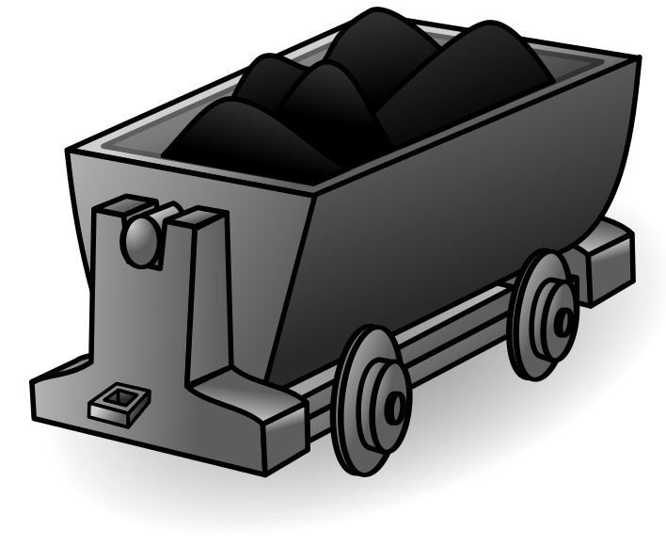

Thermal Energy



Oil

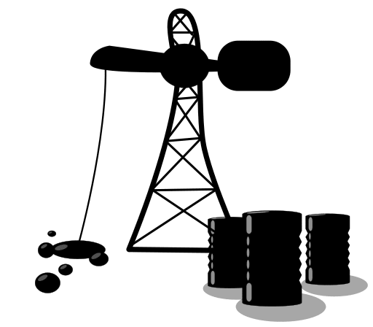

Steam

Hot gas

C:\Users\S7835031H\AppData\Local\Microsoft\Windows\Temporary Internet Files\Content.IE5\P8LS2F6X\MC900281798[1].wmf

Generators

Nuclear Sources

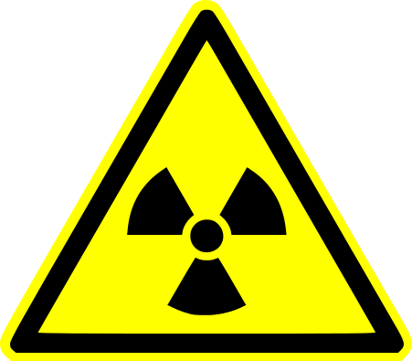

Nuclear Fission

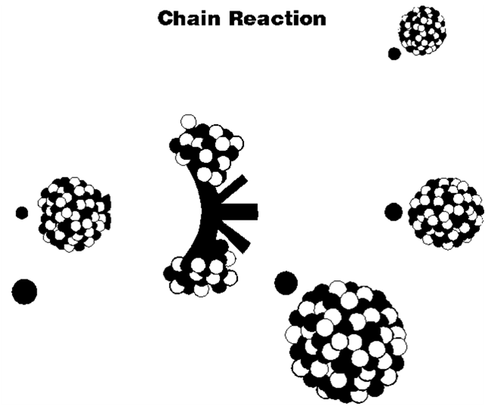

Fossil Fuels

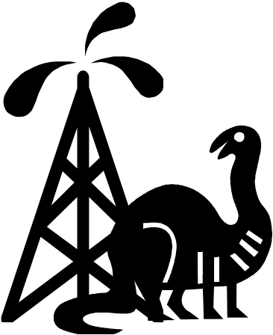

Gas

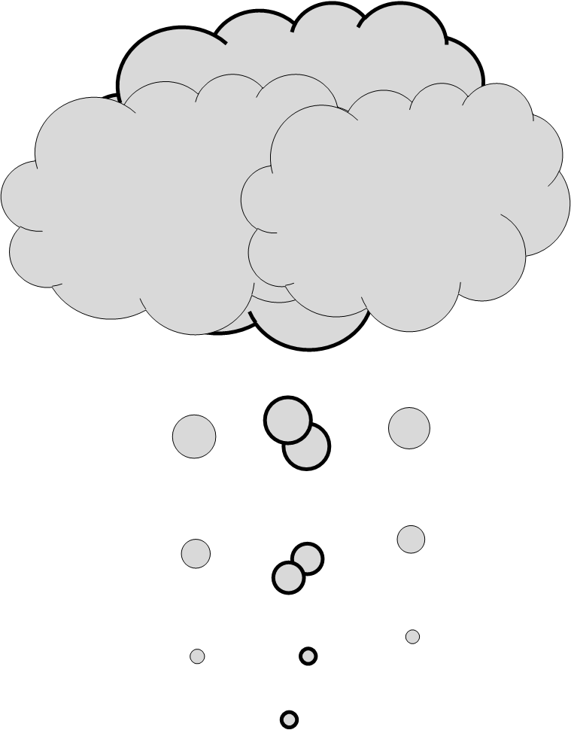

Turbines

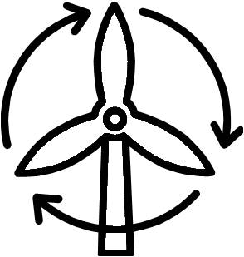

Electricity

C:\Users\S7835031H\AppData\Local\Microsoft\Windows\Temporary Internet Files\Content.IE5\P8LS2F6X\MC900384314[1].wmf

Uranium

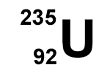

**Concept Map**   
Use the labels above to construct a concept map to show the production of electricity from nuclear sources and fossil fuels. Three of the labels have been inserted at the start and end of the organiser for you.

**The production of electricity from nuclear sources and fossil fuels**

Nuclear Sources



Fossil Fuels



Electricity

C:\Users\S7835031H\AppData\Local\Microsoft\Windows\Temporary Internet Files\Content.IE5\P8LS2F6X\MC900384314[1].wmf

|  |  |  |  |  |
| --- | --- | --- | --- | --- |
| **Sources of Electrical Energy**  *Trigger Activity (Teacher’s notes)* | | | | |
| **Stream:** Exp |  | **Topic:** Practical Electricity |  | **Estimated Duration:** 30 min |

This activity makes use of a concept map to help students make important connections between various energy sources and the process of electricity generation. This trigger can be used just before the study of renewable and non-renewable energy sources.

Given various energy-related labels provided in a “parking lot” (see page 1 of student handout), students create links between these labels to show how electricity is produced from energy sources such as fossil fuels and nuclear energy. This concept map allows students to compare the differences and similarities in the electricity generation process when different energy sources are used at the start of the energy conversion chains.

**Material:**

Student handout (Suggest not to print double-sided for easy reference of parking lots)

|  |  |
| --- | --- |
| **Description of activity** | **Pedagogical and Assessment Considerations** |
| The ‘Think-Pair-Share’ pedagogy can be employed to carry out the activity.  Think:  Students study the words given in the parking lot on page 1 of the worksheet. They will then arrange and write the given words on page 2 and fill in the links between the words to construct the concept map.  Pair:  Students then work with their shoulder partners to discuss each others’ concept maps and merge their concept maps into a final one.  Share:  The teacher can move around the class during the Pair-work to select a few pairs to share their concept maps with the rest of the class. | Principle of Learning #1 (Engaging Prior Understandings): Students will need to apply their existing understanding to construct their individual concept maps. Teacher can gain a better understanding of students’ preconceptions throughout the activity, e.g.   * Some students may not know that the conversion from nuclear energy to electrical energy is similar to the electrical generation processes using coal and oil, where steam has first to be produced before being used to turn turbines. * Some students may not know that “hot gas” is not used to produce steam, but rather hot gas is used directly to turn the turbines.   Students construct knowledge from working with each other.  Teacher plays the role of a resource person to provide information to questions that students might ask, e.g. what is uranium? What is nuclear fission? Teacher can also address students’ preconceptions here (or in subsequent lessons).  21CC, CGC (Global Awareness):  Students will have deeper understanding about the electricity generation process and be aware of the different sources of energy available. |

* **Recommendation for subsequent part of the lesson**

1. The teacher could include other sources of energy, e.g. solar, wind and hydroelectric, in the concept map (see boxes with broken lines in “Suggested Answer” on the following page). This allows the teacher to further facilitate the comparison of the process of electricity generation from these sources.
2. The teacher could compare the use of non-renewable and renewable energy sources in terms of energy conversion efficiency, cost per kWh produced and environmental impact. Examples of questions:
3. Which of these sources are renewable and which of them are non-renewable?
4. From the concept map, identify and discuss some of the processes which have a negative impact on the environmental.
5. From the concept map, identify some of the processes which results in reduced energy efficiency (Students can circle these processes directly on the concept map; One of the processes has been circled in the suggested answer).

* **Suggested Answer**



Not all the thermal energy is transferred to the water. Some is lost to the surroundings.

Moving water

Wind

Sunlight

Solar panels

shines on

turns

to produce