Name: _______________________________ ( ) Class: ______________ Date: __________

|  |  |  |
| --- | --- | --- |
| **Resistance of a current-carrying conductor**  *Student’s Handout* | | |
| **Topic: Current of Electricity** |  | **Estimated Duration: 1 h** |

* **Aim(s)**To investigate how the length and cross-sectional area of a conductor affects its resistance.
* **Materials**
  + Electricity package consisting of:
* 9 V battery
* Light-emitting diode (LED)
* Crocodile clips and wires
* 2B pencil
  + Inquiry worksheet

|  |
| --- |
|  |

* **Instructions/Procedure**

**Activity 1: To investigate how the resistance of a conductor is affected by its length**

1. Using the materials provided, construct the circuit shown in Figure 1.

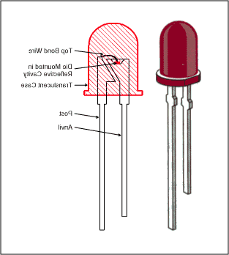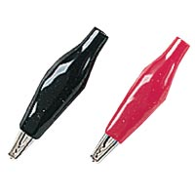

**A**

**B**

**9 V**

Figure 1

1. The 3 rectangles below have the same width but different lengths. They will be used as resistors in this activity. Before the rectangles can be used as resistors, they need to be coated with a layer of conducting material. Using a pencil, shade the rectangles thickly and completely.

**Resistor K**

**Resistor L**

**Resistor M**

1. Press the crocodile clips A and B on the dots on both ends of Resistor K.

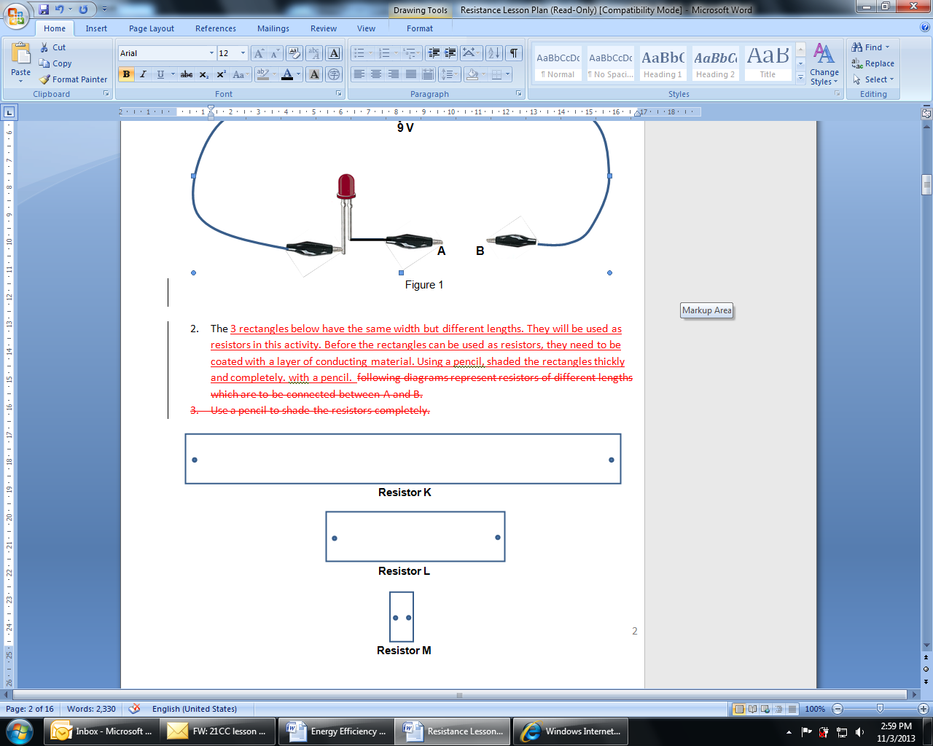



**B**

**A**

1. Observe the brightness of the LED.
2. Repeat Steps 3 and 4 for Resistors L and M and complete the table below (fill in with K, L or M).

|  |  |  |  |
| --- | --- | --- | --- |
| **Length** | **Shortest to longest** | | |
| Resistor |  |  |  |
| **Brightness of LED** | **Dimmest to brightest** | | |
| Resistor |  |  |  |

1. Based on the results in the table, describe the relationship between the length of a resistor and its resistance. Justify your answer.

___________________________________________________________________  
  
___________________________________________________________________

___________________________________________________________________  
  
___________________________________________________________________

___________________________________________________________________  
  
___________________________________________________________________  
  
___________________________________________________________________

**Activity 2: To investigate how the resistance of a conductor is affected by its cross-sectional   
area**

1. State the independent variable and dependent variable for this investigation:

Independent variable: __________________________________

Dependent variable: __________________________________

1. You are required to use the same setup in Figure 1 for this investigation. However, three new resistors will be needed. The first one, Resistor **P** has been provided below. Draw another two rectangles, Q and R, which will enable you to complete the investigation.

**Resistor P**

1. What is one key variable you kept constant for resistors **P**, **Q** and **R**?

The variable kept constant is ______________________________________.

1. Shade all the 3 rectangles thickly with pencil.
2. Connect resistors **P, Q** and **R** (one at a time) to the circuit in Figure 1. Record your observations in the form of a table in the space provided.
3. Based on the results in the table, write down the relationship between the cross-sectional area of a resistor and its resistance. Justify your answer.

___________________________________________________________________  
  
___________________________________________________________________  
  
___________________________________________________________________

___________________________________________________________________  
  
___________________________________________________________________  
  
___________________________________________________________________

___________________________________________________________________

**Application Questions**

For industrial use, resistance wires are usually bought and sold in large rolls or bundles. The labels on each roll typically look like this.

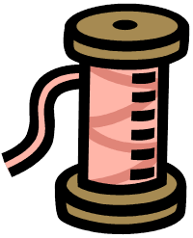

Aluminium

10 mm2

0.00265 Ω/m



Tungsten

15 mm2

0.0036 Ω/m

**Wire A**

**Wire B**

1. For **Wire A** (Aluminum),
   1. which physical quantity of the wire has the value of 10 mm2?

_________________________________________________________________  
  
_________________________________________________________________

* 1. what is the meaning of the value ‘0.00265 Ω/m’?

_________________________________________________________________  
  
_________________________________________________________________

1. A length of **Wire A** does not have the same electrical resistance as an equal length of wire B. What are two possible reasons for this difference?

_______________________________________________________________________  
  
_______________________________________________________________________

1. A technician’s measurement shows that the resistance of 50 cm of **Wire B** is 18 mΩ. What is the resistance of
2. 3.5 m of **Wire B**?

1. 15 cm of **Wire B**?
2. **A certain length** of **Wire B** is connected in a series circuit. The current flowing in the circuit is 0.80 A. State the value of the current if the length of the resistor is
3. doubled

1. halved

1. A new material is used to make resistance wires. When the cross sectional area of the wire is 10 mm2 and its length 4.0 m, it has a resistance of 0.60 Ω. Complete the table for varying cross-sectional areas, lengths and resistances of wires from this new material.

|  |  |  |
| --- | --- | --- |
| **Cross-sectional area / mm2** | **Length / m** | **Resistance / Ω** |
| 10.0 | 4.0 | 0.60 |
| 20.0 | 4.0 |  |
| 2.5 |  | 1.20 |
| 20.0 | 8.0 |  |
|  | 1.0 | 1.50 |

**Additional questions**

1. When a technician cut out 50.0 cm of **wire B**, he obtained an average reading less than the expected value of 18 mΩ. Suggest why the measured value differs from the expected value.

_______________________________________________________________________

_______________________________________________________________________

|  |  |  |  |  |
| --- | --- | --- | --- | --- |
| **Resistance of a current-carrying conductor**  *Teacher’s notes* | | | | |
| **Stream:** Exp/NA |  | **Topic:** Current of electricity |  | **Estimated Duration:** 1 hour |

* **Description of activity**

There are three activities in this lesson. In the first activity, students are guided through an investigation to study how the length of a conductor affects its resistance.

In the second activity, students will get to design their own experiment guided by their experience from the first activity. They have to consider the constant variable, dependent variable, independent variable as well as the design of the conductors to investigate the effect of the cross-sectional area of a conductor on its resistance.

In both activities, students will shade with a pencil on different shapes and sizes of rectangles to produce electrical conductors of varying lengths and cross-sectional areas; this allows them to focus on the effect of the dimensions of the conductor on its resistance.

The third activity provides an opportunity for students to apply the concepts from the first two activities to answer questions set within an authentic context.

* **Key Ideas**

The resistance of a conductor is:

* + directly proportional to its length.
  + inversely proportional to its cross-sectional area
* **Aim**To investigate how the length and cross-sectional area of a conductor affects its resistance.
* **Objectives**
  + **Related Syllabus Learning Outcomes**

At the end of this lesson, students should be able to:

Recall and apply the relationship of the proportionality between resistance and the length and cross-sectional area of a wire to new situations or to solve related problems

* + **21CC**

**CIT – Sound Reasoning, ICS – Management of Information**

In the first two activities, students have to make connections between the various physical aspects of the problem; from what they are able to observe between the dimensions of the resistor and the brightness of the Light Emitting Diodes (LED), to the inferences that they can make with regards to the current and hence resistance of the current-carrying conductor. In the third activity, students identify the necessary information from the given context and apply their conclusions from the prior activities to answer the questions on industrial-use resistance wires.

* + **Skills and Processes**

In Activity 2, students have to plan an investigation to study the relationship between the cross-sectional area of a resistor and its resistance. They have to decide on the independent, dependent and constant variables in their investigation. They also have to design the dimensions of the resistors, and decide what and how observations are to be made.

* **Prior knowledge**

Students should be able to state the definition that *resistance = p.d. / current.*

* **Materials**
  + Electricity package consisting of:
* 9 V battery
* Light-emitting diode (LED)
* Crocodile clips and wires
* 2B pencil
  + Inquiry worksheet
* **Suggested lesson guide**

| Assessment indicators | **LESSON ACTIVITY** | Pedagogical Considerations |
| --- | --- | --- |
| *Evidence of learning is shown when students are able to…*  Infer that the longer the resistor, the larger its resistance.  *Evidence of learning is shown when students are able to…*  Students are able to decide on the dependent, independent and constant variables to carry out the intent of the investigation.  Infer that the larger the cross-sectional area of the resistor, the smaller its resistance.  *Evidence of learning is shown when students are able to…*  Apply the concepts above to solve the application questions. | **Introduction**   * Introduce the lesson objectives: Students will learn about the effect of the length and cross-sectional area of a current-carrying conductor on its resistance. * Recap the concept of resistance: Resistance = p.d. / current   **Lesson Development**  Activity 1 - Resistance and Length   * Students will investigate the relationship between resistance and length. * Through the worksheet, students will ‘create’ their own resistors by using a pencil to shade shapes of different lengths. * Using the electric circuit, students will explore how the brightness of the light-emitting diode (LED) is varied with the length of the resistors; they will observe that if they connect the circuit to the longer resistor, the brightness of the LED will be dimmer as compared to using a shorter resistor (student handout question 5). * From the observation of the brightness, students will infer the relationship between the length of the resistor, its current and hence resistance (student handout question 6).   Activity 2 - Resistance and cross-sectional area   * Students will investigate the relationship between resistance and cross-sectional area of the resistor through an investigative activity where students are required to design the following:   - dependent, independent and constant variables  - shape and size of the resistors to be used in the investigation  - table for recording observations   * From the investigation, students will infer the relationship between the cross-sectional area of the resistor and its resistance (student handout question 12).   Application Questions  With the industrial use of resistance wires as a context, students apply the concepts from Activity 1 and 2 to answer questions on the relationship between the dimensions of wires and their resistance (student handout question 13-18).  **Lesson Closure**  The resistance of a conductor is:   * + directly proportional to its length.   + inversely proportional to its cross-sectional area | 21 CC (Critical and Inventive thinking)  Students have to construct relationships between the essential elements of the problem i.e. length of resistor → relationship with brightness →inference about current →inference about resistance  Process skill (Planning an investigation)  The teacher can point out the constant, independent and dependent variables in this investigation to highlight the importance of choosing the correct variables in experimental design. This is also to prepare students for activity 2.  Process skill (Planning an investigation)  Think-Pair-Share can be conducted here where students think through and jot down their answers before discussing with their shoulder partners. The teacher will then pick a few students to share and discuss their experimental design with the rest of the class.  Some leading questions that the teacher could ask:  - What is the variable that is being manipulated here?  - What is the variable that is changed as a result?  - At any one time, only one variable can be manipulated. What are the variables that must be kept constant?  Authentic Context  Students apply the concepts learnt previously to answer questions about real-life examples of industrial-use resistance wires.  21 CC (Information and communication skills)  Students have to manage information when they identify the necessary information from the given context and apply their conclusions from activities 1 and 2 to answer the questions on industrial-use resistance wires. |

* **Suggested answers**

**Activity 1**

* + 1. Repeat Steps 3 and 4 for Resistors L and M and complete the table below (fill in with K, L or M).

|  |  |  |  |
| --- | --- | --- | --- |
| Lengths | Shortest to longest | | |
| Resistor | **M** | **L** | **K** |
| Brightness of LED | Dimmest to brightest | | |
| Resistor | **K** | **L** | **M** |

* + 1. Based on the results in the table, describe the relationship between the length of a resistor and its resistance. Justify your answer.   
       **- The longer the resistor, the larger its resistance.  
       - From the table, the brightness of the LED decreases with length of the resistor. This   
        means that the current flowing through a long resistor is smaller than a current flowing   
        through a short resistor. Hence a long resistor has larger resistance.**

**Activity 2**

* + 1. State the independent variable and dependent variable for this investigation:

Independent variable: **_Cross-sectional area of the resistors_**

Dependent variable: **___Resistance of the resistors___**

* + 1. You are required to use the same setup in Figure 1 for this investigation. However, three new resistors will be needed. The first one, Resistor **P** has been provided. Draw another two rectangles, Q and R, which will enable you to complete the investigation.



**Resistor Q**

* + 1. What is one key variable you kept constant for resistors **P**, **Q** and **R**?

The variable kept constant is __ **the length of the resistors**______.

1. Connect resistors P, Q and R (one at a time) to the circuit in Figure 1. Record your observations in the form of a table in the space provided.

(**Table is not provided)**

|  |  |  |  |
| --- | --- | --- | --- |
| **Cross-sectional area** | **Thinnest to thickest** | | |
| **Resistor** | **P** | **Q** | **R** |
| **Brightness of LED** | **Dimmest to brightest** | | |
| **Resistor** | **P** | **Q** | **R** |

1. Based on the results in the table, write down the relationship between the cross-sectional area of a resistor and its resistance. Justify your answer.
   * + - **The larger the cross-sectional area of the resistor, the smaller its resistance.**
       - **From the table, the brightness of the LED increases with the cross-section of the resistor. This means that the current flowing through a thicker resistor is higher than a current flowing through a thin resistor. Hence a thicker resistor (larger cross-sectional area) has lower resistance.**

**Application Questions**

1. For **Wire A** (Aluminium),
2. which physical quantity of the wire has the value of 10 mm2?

**Its cross-sectional area (do not accept thickness, which should have units mm instead of mm2)**

1. what is the meaning of the value ‘0.00265 Ω/m’?

**Every 1 m of length of wire A has an electrical resistance of 0.00265 Ω.**

1. A length of **Wire A** does not have the same electrical resistance as an equal length of wire B. What are 2 possible reasons for this difference?

**Different cross sectional area; made of different materials**

1. A technician’s measurement shows that the resistance of 50 cm of wire B is 18 mΩ. What is the resistance of
2. 3.5 m of wire B?

**126 mΩ**

1. 15 cm of wire B?

**5.4 mΩ**

1. **A certain length** of wire B is connected in a series circuit. The current flowing in the circuit is 0.80 A. State the value of the current if the length of the resistor is
2. doubled

**0.40 A**

1. halved

**1.6 A**

1. A new material is used to make resistance wires. When the cross sectional area of the wire is 10 mm2 and its length 4.0 m, it has a resistance of 0.60 Ω. Complete the table for varying cross-sectional areas, lengths and resistances of wires from this new material.

|  |  |  |
| --- | --- | --- |
| Cross-sectional area / mm2 | Length / m | Resistance / Ω |
| 10.0 | 4.0 | 0.60 |
| 20.0 | 4.0 | **0.30** |
| 2.5 | **2.0** | 1.20 |
| 20.0 | 8.0 | **0.60** |
| **1.0** | 1.0 | 1.50 |

**Additional questions**

1. When a technician cut out 50.0 cm of wire B, he obtained an average reading less than the expected value of 18 mΩ. Suggest why the measured value differs from the expected value.

**Temperature, kinks in wire, corrosion/oxidation of metal**

******************************************************************************

* **Acknowledgement**

This lesson was developed with contributions from Mr Muhd Dzulqarni Mohd Safii (St Patrick’s School).