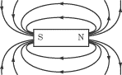C:\Users\user\AppData\Local\Microsoft\Windows\Temporary Internet Files\Content.IE5\LUPVIOEG\MC900238189[1].wmf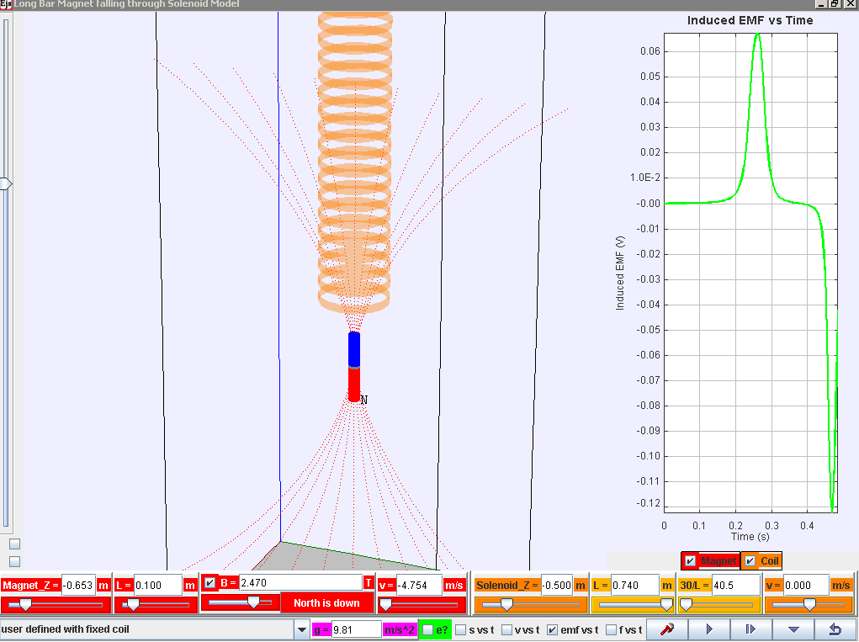

**Play/pause, step, initialize (compare different runs) and reset**

**Control buttons**

**Bonus! For exploring other scenarios!**

**Data analysis!! Really cool tool to help analyse voltage**

**show graphs for magnet and/or coil (solenoid)**

**various graphs!**

**show motion of electrons in solenoid**

**Zoom!**

N

N

**reverse magnetic polarity**

**show magnetic field lines from magnet**

**view from bottom**

**vertical/horizontal**

Download the simulation **ejs_FallingMagnet10memory4.3.0.jar** from the following link:

**Latest version**

[**https://dl.dropbox.com/u/44365627/lookangEJSworkspace/export/ejs_FallingMagnet10memory4.3.0.jar**](https://dl.dropbox.com/u/44365627/lookangEJSworkspace/export/ejs_FallingMagnet10memory4.3.0.jar)

**Parameters (refer to bottom of the simulation) for exploration**

|  |  |
| --- | --- |
| **Parameter / unit** | **Definition/Meaning** |
| Magnet_Z / m | Initial vertical position (z-axis) of the magnet |
| L / m (in **red** for magnet) | Length of magnet |
| B / T | Maximum Magnetic Field Strength (in the core of the magnet) |
| v / m/s (in **red** for magnet) | Initial speed of magnet |
| Solenoid_Z / m | Initial vertical position (z-axis) of the solenoid |
| L / m (in **orange** for solenoid) | Length of the solenoid |
| 30/L | This is meant to be number of turns per unit length.  Due to programming constraints, it is 30 turns/Length set in the computer model. |
| v / m/s (in **orange** for solenoid) | Velocity of solenoid (for exploration of relative velocity. ☺) |