Designing Open Source Computer Models for Physics by Inquiry using Easy Java Simulation
Loo Kang WEE¹, Sze Yee LYE¹
¹Ministry of Education, Education Technology Division, Singapore

wee_loo_kang@moe.gov.sg, lye_sze_yee@moe.gov.sg
http://weelookang.blogspot.sg, http://iwant2study.org/easyjava

Abstract: The Open Source Physics community (http://www.compadre.org/osp/) has created hundreds of physics computer models (Wolfgang Christian, Esquembre, & Barbato, 2011; F. K. Hwang & Esquembre, 2003) which are mathematical computation representations of real-life Physics phenomenon. Since the source codes are available and can be modified for redistribution licensed Creative Commons Attribution or other compatible copyrights like GNU General Public License (GPL), educators can customize (Wee & Mak, 2009) these models for more targeted productive (Wee, 2012) activities for their classroom teaching and redistribute them to benefit all humankind.
In this interactive event, we will share the basics of using the free authoring toolkit called Easy Java Simulation (W. Christian, Esquembre, & Mason, 2010; Esquembre, 2010) (http://www.um.es/fem/EjsWiki/pmwiki.php) so that participants can modify the open source computer models for their own learning and teaching needs. These computer models has the potential to provide the experience and context, essential for deepening students conceptual understanding of Physics through student centred guided inquiry approach (Eick, Meadows, & Balkcom, 2005; Jackson, Dukerich, & Hestenes, 2008; McDermott, Shaffer, & Rosenquist, 1995; Wee, Lee, & Goh, 2011).
.
Keyword: easy java simulation, active learning, education, teacher professional development, e-learning, applet, design, open source, physics
PACS: 01.50.H-, 07.05.Tp, 01.50.Lc, 83.10.Rs

Introduction
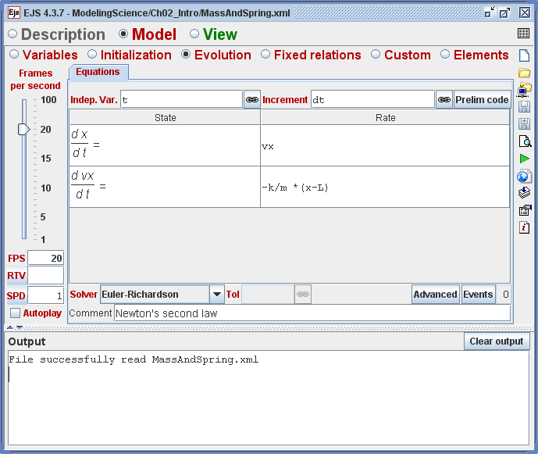
- EJS authoring toolkit version 4.3.7 showing the Evolution Page with the Ordinary Differential Equations to model a simple spring mass system.
The goal of the Open Source Physics (OSP) project is to make a large number of simulations together with source code available for education using the GNU General Public License (GPL) open-source model. OSP provides both high-level modeling tools and a lower-level computational physics library to create computer simulations through the use of a consistent object-oriented framework (Wolfgang Christian & Esquembre, 2012). The Java-based OSP library defines objects to build interactive user interfaces, draw 2D and 3D objects, numerically solve ordinary differential equations using different algorithms, and represent data using tables and graphs.
This workshop provides a hands-on beginners’ introduction to Open Source Physics (OSP) and Easy Java Simulations (EJS) to model physical systems such as those provided by the interactive event leaders.
Participants will study and explore, step by step, important computational example of the spring mass system model (Wolfgang Christian & Esquembre, 2008a, 2008b), to learn how they have been implemented, and then modify these example to add new capabilities. Assistance will be provided during the sessions. There after, the organisers hope to get participants to identify and self direct (Tan, Shanti, Tan, & Cheah, 2011) their own personally motivating computer model from the OSP and NTNU digital libraries and work collaboratively (Chai, Lim, So, & Cheah, 2011) with the OSP community to create customized or new models.
During the workshop we will discuss the general pedagogical (Wee, Chew, Goh, Tan, & Lee, 2012) and technical issues in the design of interactive computer-based tutorials as well as how existing models can be adapted to Singapore school context. All workshop material will be made available through our blogs http://weelookang.blogspot.sg and http://iwant2study.org/easyjava .

Description of format of interactive event
The interactive event consists of the following segments:
- Introduction to Open Source Physics
- Sharing of computer models customized by the interactive event leaders
- Introduction of Easy Java Simulation
- Hands-on-with Easy Java Simulation with spring mass system model (Wolfgang Christian & Esquembre, 2008a, 2008b)
- Sharing of tips to easily adapt codes from other simulations into a new model
- Participants download a simulation that is personally motivating to them from OSP Digital Libraries, that they want to edit and improve on even after the workshop, in collaborative group of 2-3.
- Upload to NTNU Java Virtual Lab (F.-K. Hwang, 2010) (http://www.phy.ntnu.edu.tw/ntnujava/index.php?board=28.0)
- Closing discussions

Materials, hardware, software, and other technologies
- Easy Java Simulation (Esquembre, 2010) (EJS) tool kit
- Java Runtime
- Java 3D (for Java 3D models)

Scheduling need
- One shot (3 hour or half day)

Summary of equipment
- BYOL (Bring Your Own Laptop)
- Wireless access

Conclusion
This is a series of professional workshops that is conducted by the interactive event leaders in a funded project by NRF2011-EDU001-EL001 Java Simulation Design for Teaching and Learning, (MOE, 2012b) awarded by the National Research Foundation in collaboration with National Institute of Education, Singapore and the Ministry of Education (MOE), Singapore.
Our computer models are downloadable on NTNU Java Virtual Lab (F.-K. Hwang, 2010) creative commons attribution licensed and lesson packages on the ICT Connection edumall 2.0 portal under ICT-in-ACTION http://ictconnection.edumall.sg/cos/o.x?c=/ictconnection/ictlib&uid=200&ptid=711 (edumall 2.0 login required).
We hope other educators will share their own creative works with the world as demonstrated by the OSP community leaders like Francisco Esquembre, Fu-Kwun Hwang and Wolfgang Christian and the passionate (interactive event leaders included) community of the Open Source Physics Project.

Acknowledgement
We wish to acknowledge the passionate contributions of Francisco Esquembre, Fu-Kwun Hwang and Wolfgang Christian for their ideas and insights in the co-creation of interactive simulation and curriculum materials.
This workshop research is made possible thanks to the eduLab project NRF2011-EDU001-EL001 Java Simulation Design for Teaching and Learning, (MOE, 2012b) awarded by the National Research Foundation in collaboration with National Institute of Education, Singapore and the Ministry of Education (MOE), Singapore.
Lastly, we also thank MOE for the recognition of our research on the computer model lessons as a significant innovation in 2012 MOE Innergy (HQ) GOLD Awards (MOE, 2012a) by Educational Technology Division and Academy of Singapore Teachers.

Reference
Chai, C. S., Lim, W.-Y., So, H.-J., & Cheah, H. M. (2011). Advancing collaborative learning with ICT: Conception, Cases and Design. MOE (Ed.) Retrieved from http://ictconnection.edumall.sg/ictconnection/slot/u200/mp3/monographs/advancing%20collaborative%20learning%20with%20ict.pdf
Christian, W., & Esquembre, F. (2008a). Modeling Science Textbook Chapter 2: Introduction to Easy Java Simulations.
Christian, W., & Esquembre, F. (2008b). Modeling Science Textbook Chapter 3: EJS and Java Concepts Modeling Science: From Free Fall to Chaos.
Christian, W., & Esquembre, F. (2012, Jul 04, 2011 - Jul 06, 2011). Computational Modeling with Open Source Physics and Easy Java Simulations. Paper presented at the South African National Institute for Theoretical Physics Event, University of Pretoria, South Africa.
Christian, W., Esquembre, F., & Barbato, L. (2011). Open Source Physics. Science, 334(6059), 1077-1078. doi: 10.1126/science.1196984
Christian, W., Esquembre, F., & Mason, B. (2010). Easy Java Simulations and the ComPADRE OSP collection. NUOVO CIMENTO- SOCIETA ITALIANA DI FISICA SEZIONE C, 33(3), 33-42.
Eick, C., Meadows, L., & Balkcom, R. (2005). Breaking into Inquiry: Scaffolding Supports Beginning Efforts to Implement Inquiry in the Classroom. Science Teacher, 72(7), 5.
Esquembre, F. (2010). Easy Java Simulations Retrieved 20 October, 2010, from http://www.um.es/fem/Ejs/Ejs_en/index.html
Hwang, F.-K. (2010). NTNU Virtual Physics Laboratory Retrieved 20 October, 2010, from http://www.phy.ntnu.edu.tw/ntnujava/index.php
Hwang, F. K., & Esquembre, F. (2003). Easy java simulations: An interactive science learning tool. Interactive Multimedia Electronic Journal of Computer - Enhanced Learning, 5.
Jackson, J., Dukerich, L., & Hestenes, D. (2008). Modeling Instruction: An Effective Model for Science Education. Science Educator, 17(1), 10-17.
McDermott, L., Shaffer, P., & Rosenquist, M. (1995). Physics by inquiry: John Wiley & Sons New York.
MOE. (2012a). MOE Innergy Awards: MOE Innergy (HQ) Awards Winners : Gold Award :Educational Technology Division and Academy of Singapore Teachers: Gravity-Physics by Inquiry Retrieved 25 May, 2012, from http://www.excelfest.com/award
MOE. (2012b). Press Releases: eduLab at the Academy of Singapore Teachers (eduLab@AST) to Bring Ideas into Practice Retrieved 25 May, 2012, from http://www.moe.gov.sg/media/press/2012/03/edulab-at-the-academy-of-singa.php
Tan, S. C., Shanti, D., Tan, L., & Cheah, H. M. (2011). Self-directed learning with ICT: Theory, Practice and Assessment. MOE (Ed.) Retrieved from http://ictconnection.edumall.sg/ictconnection/slot/u200/mp3/monographs/self-directed%20learning%20with%20ict.pdf
Wee, L. K. (2012). One-dimensional collision carts computer model and its design ideas for productive experiential learning. Physics Education, 47(3), 301.
Wee, L. K., Chew, C., Goh, G. H., Tan, S., & Lee, T. L. (2012). Using Tracker as a pedagogical tool for understanding projectile motion. Physics Education, 47(4), 448.
Wee, L. K., Lee, T. L., & Goh, J. (2011, 10 November). Physics by Inquiry with Simulations Design for Learning Paper presented at the The Academy Symposium, Singapore.
Wee, L. K., & Mak, W. K. (2009, 02 June). Leveraging on Easy Java Simulation tool and open source computer simulation library to create interactive digital media for mass customization of high school physics curriculum. Paper presented at the 3rd Redesigning Pedagogy International Conference, Singapore.

INTERACTIVE EVENT LEADERS (AUTHORS)
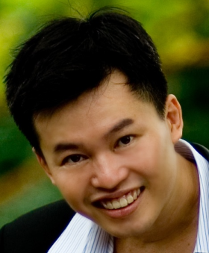 | Loo Kang WEE is currently an educational technology specialist at the Ministry of Education, Singapore and a PhD candidate at the National Institute of Education, Singapore. He was a junior college physics lecturer and his research interest is in Open Source Physics tools like Easy Java Simulation for designing computer models and use of Tracker.
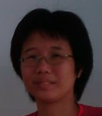 | Sze Yee LYE is currently educational technology officer at the Ministry of Education, Singapore. She was a primary and secondary physics teacher and her research interest is in free tools for technology use in education.

