Ministry of Education, Singapore  Educational Technology Division  Singapore | lawrence_wee@moe.gov.sg  Phone: +6568976526  Mobile: +6592475573  Website: http://weelookang.blogspot.sg/  https://iwant2study.org/ospsg/
Loo Kang Lawrence Wee
https://www.researchgate.net/profile/Loo_Kang_Wee
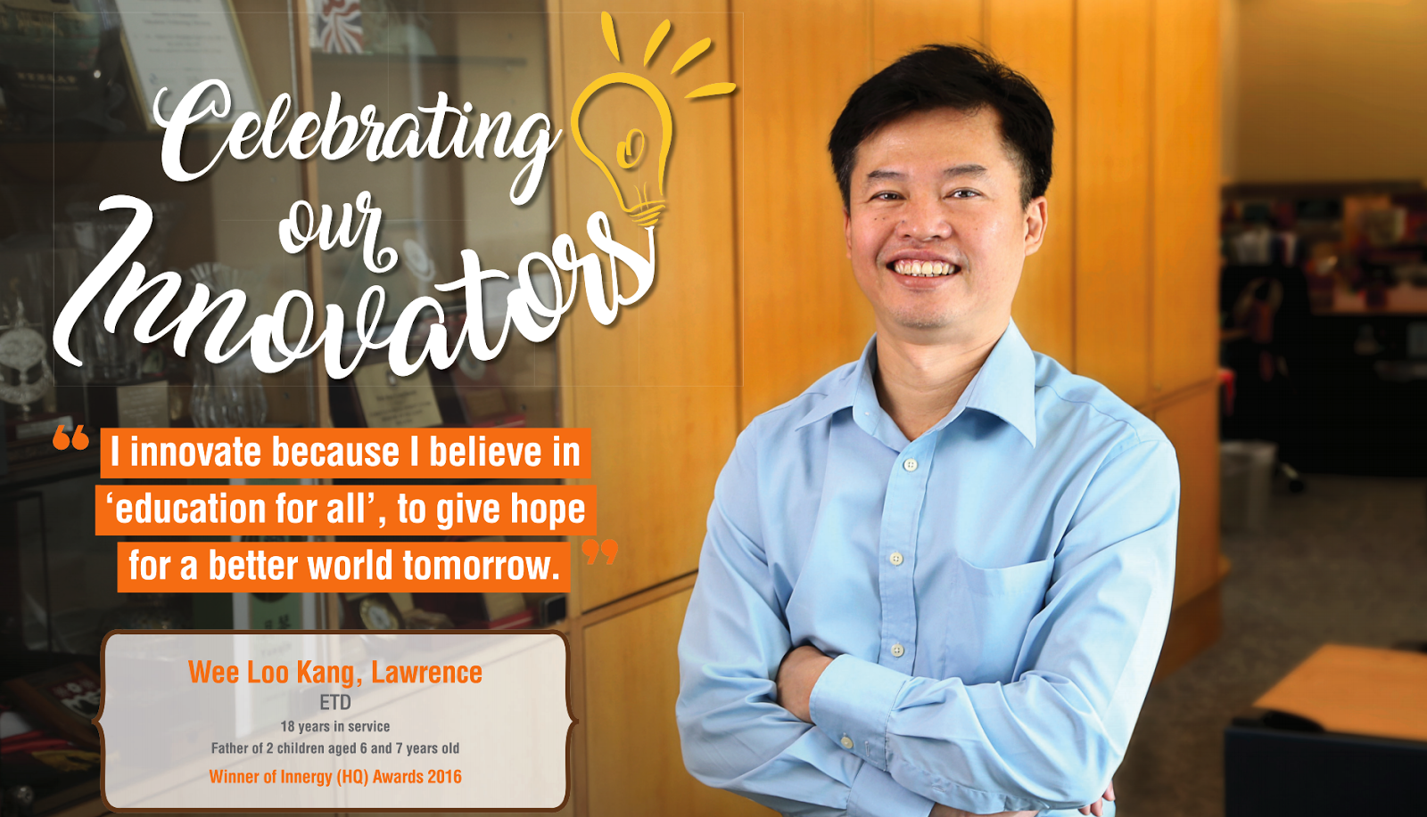
Lawrence graduated with a Bachelor of Engineering (Hons) from the University of Singapore and obtained his Masters in Instructional Design and Technology from the National Institute of Education (NIE), Nanyang Technological University (NTU). He believes in developing Open Educational Resources (OER) where anyone around the world with the ability and the motivation could get the skills that they need to make a better life for themselves, their families and their communities.
Lawrence’s interest lies in OER because the public, any teachers and students will be able to access and adapt these resources freely with little restrictions, such as licensing OER's materials under Creative Commons Attribution-NonCommercial-ShareAlike 2.0 Generic (CC BY-NC-SA 2.0). Working with communities of local teachers and professors from Spain, USA and Taiwan, he co-develop Open Source Physics simulations and Tracker video analysis and modelling resources and instructional strategies to motivate and engage students.

Lawrence has been awarded Ministry of Education 'MOE Outstanding Innovator Award' in 2013, the ‘Singapore Public Service PS21 Distinguished Star Service Award PSSSA’ in 2014, the ‘UNESCO King Hamad Bin Isa Al-Khalifa Prize for the Use of ICTs in Education, Pedagogical Innovation in the Use of ICT in Teaching and Learning’ in 2015 and 'National Day Awards Commendation Medal' in 2018, Excellence in Physics Education Award from American Physical Society 2020 and Global Online Laboratory Consortium (GOLC) International Online Laboratory Award (Visualized Laboratory category) 2021.
He also led and supported Professional Learning Community of teachers and Ministry Of Education Head Quarters officers to develop innovative technology solutions and curriculum that led them to clinch the MOE Innergy (Gold) Awards in 2012( ETD Gravity-Physics by Inquiry) , 2016 (Open Source Physics at Singapore), 2017 (Innovative DC Motor Demonstration Kit Set), 2019 (Promoting Joy of Learning by Turning phone into scientific equipment) and (Bronze) 2019 (Do-It-Yourself (DIY) Android and iOS Apps).

Education
Jan 2005 – Jun 2007 | National Institute of Education (NIE), Singapore  Master of Arts, Instructional Design and Educational Technology  Singapore, Singapore
Jun 1999 – Jun 2000 | National Institute of Education (NIE), Singapore  Post Grad Diploma (Teaching) Merit, Mathematics, Physics  Singapore, Singapore
Apr 1990 – Apr 1994 | National University of Singapore  Bachelor of Engineering, Mechanical Engineering  Singapore, Singapore
Experience
Jan 2014 – present | Lead Specialist  Ministry of Education, Educational Technology, Singapore
Jan 2011 – present | Senior Specialist  Ministry of Education, Educational Technology Singapore, Singapore
Jul 2007 – Dec 2010 | Education Technology Officer  Ministry of Education, Educational technology Singapore, Singapore
Jul 2000 – Jun 2007 | Education Officer  Ministry of Education, Yishun Junior College Singapore, Singapore
Statistics
ResearchGate Score | 6.13
Publications | 53
Reads | 31, 651
Citations | 220
Awards & Grants
Jan 2021 | Award: Global Online Laboratory Consortium (GOLC) International Online Laboratory Award (Visualized Laboratory category)
Nov 2020 | Award: MOE Innergy Commendation Wave Simulator Demonstration Kit Set: A Pedagogical Action and Reasoning Framework Approach
Jun 2020 | Award: Excellence in Physics Education Award from American Physical Society goes to Open Source Physics Team
Jan 2020 | Grant: SSTRF_2020_ETD_03 Designing Interactive e-Assessment Test Items using Open Source Tools Senior Specialist Track Research Fund 2020
Jan 2019 | Award: MOE Innergy Promoting Joy of Learning by Turning phone into scientific equipment
Jan 2019 | Award: MOE Innergy Bronze Do-It-Yourself (DIY) Android and iOS Apps
Nov 2018 | Award: National Day Award: Commendation Medal
Jan 2018 | Grant: AEP 10/17 LW Virtual Lab Learning Analytics-Moodle extension
Jan 2018 | Grant: AEP 14/17 LTK Promoting joy of learning by turning phone into 3 scientific equipment
Jan 2017 | Award: MOE Innergy Gold Open Source Physics at Singapore
Jan 2017 | Grant: SSTRF_2017_ETD_3 Explore-Useful Learning Math Apps
Oct 2016 | Award: Best paper 6th International Conference on Learning, Education and Pedagogy (LEAP) Hong Kong
Jan 2016 | Award: UNESCO King Hamad Bin Isa Al-Khalifa Prize for the Use of ICTs in Education
Jan 2016 | Grant: AEP 03/16 LW Apps as Virtual Lab
Nov 2015 | Award: Academy Awards for Professional Development 2015 Associate Award
Jul 2015 | Grant: OER 10/15 GWF Understanding Teacher Learning Community as Support for Implementation of Open Source Physics for Conceptual Instruction
Jan 2015 | Grant: NRF2015-EDU001-EL021 Modelling-Inquiry Enabled Interactive Textbook
May 2014 | Award: Distinguished Star Service Excellence Public Service 21 2014
Apr 2014 | Award: MOE Innergy Commendation Primary school Interactive Resources
Mar 2013 | Award: MOE Outstanding Innovator Award 2013
Jan 2013 | Grant: NRF2013-EDU001-EL017 Becoming Scientists through Video Analysis
Jun 2012 | Award: Academy Awards for Professional Development 2012 Associate Award
Jun 2012 | Award: Public Service PS21 Excel Awards Best Ideator 2012
Mar 2012 | Award: Innergy Award Winner 2012 (Gravity-Physics by Inquiry)
Mar 2012 | Award: Innergy Award Winner 2012 (Bringing Innovative Ideas to Practice Through Propel-T Projects) Gold Award
Jan 2012 | Grant: SSTRF-ETD_2012_01 Gravity Physics by Inquiry
Jan 2012 | Award: MOE excellence service award 2012
Sep 2011 | Award: Public Service Excellence in Service Award (EXSA) Star 2011
Jun 2011 | Award: Appreciation Award by Academy of Singapore Teachers 2011
Mar 2011 | Award: Innergy Award Winner School Commendation 2011 (Learning Physics through video analysis RVHS)
Jan 2011 | Grant: NRF2011-EDU001-EL001 Java Simulation Design for Teaching and Learning
Sep 2010 | Award: Public Service Excellence in Service Award (EXSA) Gold 2010
Sep 2009 | Award: Public Service Excellence in Service Award (EXSA) Silver 2009
Skills & Activities
Skills | Educational Technology, Tracker, Open Source Physics, Easy Java Simulation, Online Learning, Technology Enhanced Learning, Virtual Environments, Curriculum Development, Physics Education, Pedagogics, Teaching, Curriculum, Instructional Design, Science Education, Learning, Teaching and Learning, Pedagogy and Education
Languages | Chinese, English
Scientific Memberships | American Association Physics Teacher
Interests | Open Educational Resources
Publication Highlights
Loo Kang Wee: One-dimensional collision carts computer model and its design ideas for
productive experiential learning. Physics Education 04/2012; 47(3)., DOI:10.1088/0031-9120/47/3/301
Loo Kang Wee, Charles Chew, Giam Hwee Goh, Samuel Tan, Tat Leong Lee:Using Tracker as a Pedagogical Tool for Understanding Projectile Motion. Physics Education 06/2012; 47(4)., DOI:10.1088/0031-9120/47/4/448
Loo Kang Wee, Hwee Tiang Ning:Vernier caliper and micrometer computer models using Easy Java Simulation and its pedagogical design feature-ideas to augment learning with real instruments. Physics Education 08/2014; 49(5)., DOI:10.1088/0031-9120/49/5/493
Loo Kang Wee, Tat Leong Lee, Charles Chew, Darren Wong, Samuel Tan:Understanding resonance graphs using Easy Java Simulations (EJS) and why we use EJS. Physics Education 01/2015; 50(2)., DOI:10.1088/0031-9120/50/2/189
Loo Kang Wee, Kim Kia Tan, Tze Kwang Leong, Ching Tan:Using Tracker as a Pedagogical Tool for Understanding Toss Up-Free Fall Motion. Physics Education 01/2015;
Journal Publications
Loo Kang Lawrence Wee, Victor Lim, Jessica Teo, Shannalyn, Shannalyn Ng:Massive Open and Online Courses and Open Education Resources in Singapore.
Mustafa Şahin Bülbül, Loo Kang Wee:Using the knowledge of penumbra with a trick simulation.
Lyna Kwan, Loo Kang Wee:A Case Study of Open Source Physics (OSP) Learning Community (LC).
Loo Kang Wee:What National Examinations Reforms should be made and how may technology be leveraged?.
Loo Kang Wee, Kim Kia Tan, Tze Kwang Leong, Ching Tan:Using Tracker to understand 'toss up' and free fall motion: A case study. Physics Education 07/2015; 50(4)., DOI:10.1088/0031-9120/50/4/436
Loo Kang Wee, Tze Kwang Leong:Video Analysis and Modeling Performance Task to Promote Becoming Like Scientists in Classrooms. American Journal of Educational Research 02/2015; 3(2)., DOI:10.12691/education-3-2-14
Kah Hean Chua, Ming Yeo Oh, Loo Kang Wee, Ching Tan:Multimedia-Video for Learning.
Dennis Toh, Ravintharan, Matthew Lim, Loo Kang Wee, Matthew Ong:Robotics for Learning.
Loo Kang Wee, Kim Kia Tan, Tze Kwang Leong, Ching Tan:Using Tracker as a Pedagogical Tool for Understanding Toss Up-Free Fall Motion. Physics Education 01/2015;
Loo Kang Wee, Tat Leong Lee, Charles Chew, Darren Wong, Samuel Tan:Understanding resonance graphs using Easy Java Simulations (EJS) and why we use EJS. Physics Education 01/2015; 50(2)., DOI:10.1088/0031-9120/50/2/189
Charles Chew, Loo Kang Wee:Use of Blended Approach in the Learning of Electromagnetic Induction.
Loo Kang Wee, Ai Phing Lim, Sze Yee Lye:NRF2011-EDU001-EL001 EduLab Project Scaling-up Reflections on Using Open Source Physics.
Sze Yee Lye, Loo Kang Wee, Yao Chie Kwek, Suriati Abas, Lee Yong Tay:Design, Customization and Implementation of Energy Simulation with 5E Model in Elementary Classroom. Educational Technology & Society 08/2014; 17(3).
Loo Kang Wee:Open Educational Resources from Performance Task using Video Analysis and Modeling - Tracker and K12 science education framework.
Loo Kang Wee, Hwee Tiang Ning:Vernier caliper and micrometer computer models using Easy Java Simulation and its pedagogical design feature-ideas to augment learning with real instruments. Physics Education 08/2014; 49(5)., DOI:10.1088/0031-9120/49/5/493
Loo Kang Wee, Giam Hwee Goh, Ee-Peow Lim:Easy Java Simulation, an innovative tool for teacher as designers of gravity-physics computer models.
Loo Kang Wee:Open Source Physics.
Khoon Song Aloysius Goh, Loo Kang Wee, Kim Wah Yip, Ping Yong Jeffrey Toh, Sze Yee Lye:Addressing learning difficulties in Newtons 1st and 3rd Laws through problem based inquiry using Easy Java Simulation.
Loo Kang Wee, Giam Hwee Goh, Charles Chew:Enabling Gravity Physics by Inquiry using Easy Java Simulation.
Loo Kang Wee, Giam Hwee Goh:Geostationary Earth Orbit Satellite Model using Easy Java Simulation. Physics Education 12/2012; 48(1)., DOI:10.1088/0031-9120/48/1/72
Sze Yee Lye, Loo Kang Wee, Y.C. Ong:Open Source Energy Simulation for Elementary School.
Loo Kang Wee:Physics Educators as Designers of Simulation using Easy Java Simulation
(Ejs) Part 2*.
Loo Kang Wee:Physics Educators as Designers of Simulation using Easy Java Simulation (Ejs).
Loo Kang Wee, Sze Yee Lye:Designing Open Source Computer Models for Physics by Inquiry using Easy
Java Simulation.
Loo Kang Lawrence Wee, Ai Phing Lim, Khoon Song Aloysius Goh, Sze Yee LyeYE, Tat Leong Lee, Weiming Xu, Giam Hwee Jimmy Goh, Chee Wah Ong, Soo Kok Ng, Ee-Peow Lim, Chew Ling Lim, Wee Leng Joshua Yeo, Matthew Ong, Kenneth Y. T. LimI:Computer Models Design for Teaching and Learning using Easy Java Simulation.
Loo Kang Wee, Tat Leong Lee:Video Analysis and Modeling Tool for Physics Education: A workshop for
Redesigning Pedagogy.
Loo Kang Wee, Wai Keong Mak:Leveraging on Easy Java Simulation tool and open source computer
simulation library to create interactive digital media for mass customization
of high school physics curriculum.
Darren Wong, Peng Poo Sng, Eng Hock Ng, Loo Kang Wee:Learning with multiple representations: An example of a revision lesson
in mechanics. Physics Education 07/2012; 46(2)., DOI:10.1088/0031-9120/46/2/005
Loo Kang Wee, Charles Chew, Giam Hwee Goh, Samuel Tan, Tat Leong Lee:Using Tracker as a Pedagogical Tool for Understanding Projectile Motion. Physics Education 06/2012; 47(4)., DOI:10.1088/0031-9120/47/4/448
Loo Kang Wee:One-dimensional collision carts computer model and its design ideas for
productive experiential learning. Physics Education 04/2012; 47(3)., DOI:10.1088/0031-9120/47/3/301
Conference Proceedings
Francisco Esquembre, Félix J García-Clemente, Loo Kang Wee:Creating sensors-aware physics simulation apps using EjsS. GIREP-MPTL conference 2018, Donostia-San Sebastian, Spain; 07/2018
Félix J García Clemente, Francisco Esquembre, Loo Kang Wee:Deployment of physics simulation apps using Easy JavaScript Simulations. IEEE Global Engineering Education Conference (EDUCON 2017), Athens, Greece; 04/2017, DOI:10.1109/EDUCON.2017.7942985
Helen Teague, Charlie Pruett, Loo Kang WEE:Social Justice Through Simulation: Blended Learning for Intergenerational Studies. Global Learn 2016 Limerick, Ireland, Limerick, Ireland; 04/2016
Helen Teague, Charlie Pruett, Loo Kang Wee:Social Justice Through Simulation: Blended Learning for Intergenerational Studies. Global Learn 2016, Limerick, Ireland; 04/2016
Loo Kang Wee:Creating Electronic Books-Chapters for Computers and Tablets Using Easy Java/JavaScript Simulations, EjsS Modeling Tool. MPTL 20 - 20th International Conference on Multimedia in Physics and Learning, Munich Germany; 12/2015
Loo Kang Wee, Tze Kwang Leong:Performance Task using Video Analysis and Modelling to promote K12 eight practices of science. Groupe International de Recherche sur l'Enseignement de la Physique; 01/2015
Xu W, Wee L L K, Lee T L, Lim A P, Goh J G H, Ong C W, Ng S K, Goh A K S, Lim E-P, Lim C L, Yeo J W L, Kenneth Y T Lim, Matthew Ong, Lye S Y:Computer models design for teaching and learning using Easy Java Simulation. World Conference on Physics Education; 01/2012

