Task 7b: Resonance in pipe (model development)
Learning Objective: Student will learn that the wavelength of the sound wave is independent of the width or material of the pipe. Students will learn the longest wavelength of the sound is twice the length of an open pipe and four times the length of a closed pipe. They will also learn the formula for the second harmonics.
Prerequisite knowledge: Knowing the formula v = f λ
Motivation: Try blowing the straw with both ends open and then with one end closed. Did you notice they sound different? Can you explain why they sound different?
Apparatus: Android phone with the “SoundAnalyzer 1.10 Beta” app downloaded from googleplaystore, various tubes of different width, length and materials that is flat on both end (eg. straws, toilet roll, pvc pipe)
- Open the app “SoundAnalyzer 1.10 Beta” from googleplaystore.
- Click on Freq #1 twice to change it to Freq All.
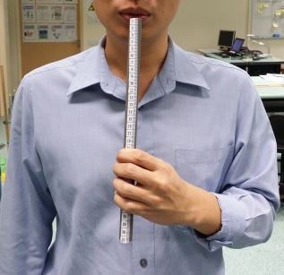
- Blow into the straw with steady stream of air to produce a consistent tone.
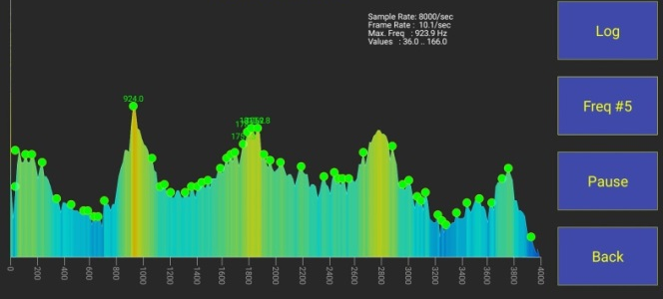
- Tap the app to pause the recording.

- Record the fundamental frequency of the straw (i.e. lowest frequency seen on the app) and the second harmonics (second lowest frequency seen on the app).
- Given the speed of sound in air is 340 m s⁻¹, calculate the respective wavelength of the sound wave.
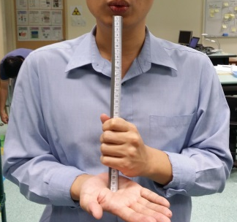
- Repeat step 3 to 6 with your hand placed on one end of the straw.
- Repeat steps 3 to 7 with different pipes
- By plotting graphs or otherwise, suggest the relationship between the properties of the pipes and
  - the longest wavelengths of the sound wave for open pipe.
  - the longest wavelengths of the sound wave for closed pipe.
  - the second longest wavelengths of the sound wave for open pipe.
  - The second longest wavelengths of the sound wave for closed pipe.

- By considering the relationship you found in step 9, could you deduce what causes the difference in sound when you closed the end of the pipe?
Post-lab discussion: http://iwant2study.org/ospsg/index.php/interactive-resources/physics/04-waves/02-general-waves/111-standing-waves-in-a-pipe
Task 7c: Resonance in pipe (Model deployment)
Challenge: As a class you have to perform the song “Twinkle Twinkle Little Star” using only the apparatus given
Apparatus: Each group is given only a single straw*, ruler and scissor.
*Class will get a total of 6 straws. Some groups may get more straws if there’re less than 6 groups.
Reminder: Present your workings clearly on your white board.

Note | Frequency / Hz
C | 1047
D | 1175
E | 1319
F | 1397
G | 1568
A | 1760
B | 1976

"Twinkle" music notation in the key of C
CC GG AA G
FF EE DD C
GG FF EE D
GG FF EE D
CC GG AA G
FF EE DD C

Extra challenge: Try performing the pipe with one end closed instead of both end open. Explain what you hear.

