Electromagnetic Induction Inquiry Learning using ICT
When a magnet is moved in and out of a coil, a voltage is detected in the coil. Let us find out more about the factors that affect this induced voltage.
Let the magnet length be 0.050 m throughout the activities.
Website: http://www.phy.ntnu.edu.tw/ntnujava/htmltag.php?code=users.sgeducation.lookang.MagnetFallingltlxmlcoil_pkg.MagnetFallingltlxmlcoilApplet.class&name=MagnetFallingltlxmlcoil&muid=14019

Activity 1
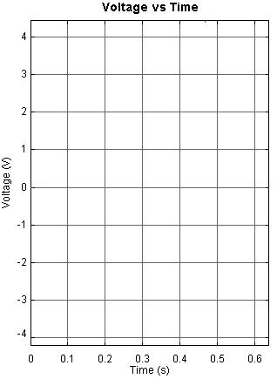
- Click (at the bottom right of the screen) to drop the magnet of strength 2.5 T.

- Sketch the voltage vs time graph as shown on the screen.
Label this graph 1.

- Click to reset.

- Replace the magnet with a non-magnetic object by changing the magnet strength to zero.
Press the Enter key.
- Click to drop the non-magnetic object.

- Sketch the voltage vs time graph as shown on the screen.
Label this graph 2.

- Conclude what have you discovered from this experiment?

Possible responses from students:
When a magnetic object falls through the coil, variation in voltage is observed.
When a non-magnetic object falls through the coil, there is no voltage observed.

- Click
Activity 2
    - Change the “magnet strength” to
5.0 T.
Press Enter.

    - Drop the magnet at the same height.
Click

    - Sketch the voltage vs time graph as shown on the screen.
Label this graph 3.

    - (i) Compare the peak voltages of graph 1 (magnet strength = 2.5 T) and
graph 3 (magnet strength = 5.0 T).

Possible responses from students:
The peak voltage of graph 3 is higher than that of graph 1.

(ii) What can you conclude about the relationship between the “magnet strength” and the peak voltage?

Possible responses from students:
As the “magnet strength” increases, the peak voltage increases.

(e) Click

Activity 3
- Double the release height of the magnet to 0.500 m.
(Magnet position = 0.500 m)
Press Enter.

- Drop the magnet.
Click

- Sketch the voltage vs time graph as shown on the screen.
Label this graph 4.

- Explain how the release height affects the speed of entry of the magnet into the coil.

Possible responses from students:
When the release height increases, the speed of entry of the magnet into the coil increases.

- (i) Compare the peak voltages of graph 3 (release height = 0.250 m) and graph 4
(release height = 0.500 m).

Possible responses from students:
The peak voltage of graph 4 is higher than that of graph 3.

(ii) What can you conclude about the relationship between the speed of entry and the peak voltage?

Possible responses from students:
As the “speed of entry” increases, the peak voltage increases.
(e) Click

Activity 4
- Increase the length of the solenoid to 1.0 m.
(Solenoid Length = 1.0 m)

- Position the solenoid at -0.500 m.
(Solenoid position = -0.500 m)

- Raise the magnet to a height of 1.00 m.
(Magnet position = 1.00 m)

- Drop the magnet.
Click

- Sketch the voltage vs time graph as shown on the screen.

- Describe what you observe about the voltage when the magnet is falling inside the solenoid.

Possible responses from students:
While the magnet is falling inside the solenoid, there is no voltage in solenoid.

- Discuss with your classmates and attempt these questions.

(i) Explain why there is no voltage when the magnet is inside the solenoid.

Possible responses from students:
Voltage is only produced when the magnet is entering or leaving the solenoid.

(ii) What are the factors that affect the voltage of the coil?
Strength of the magnet
Speed of entry of the magnet into the coil.

